New International Manual

Of Braille Music Notation

by

The Braille Music Subcommittee

World Blind Union

Compiled by

Bettye Krolick

ISBN 90 9009269 2

1996

Contents

Preface 6

Official Delegates to the Saanen Conference: February 23-29, 1992 8

Compiler’s Notes 9

Part One: General Signs 11

Purpose and General Principles 11

I. Basic Signs 13

A. Notes and Rests 13

B. Octave Marks 16

II. Clefs 19

III. Accidentals, Key & Time Signatures 22

A. Accidentals 22

B. Key & Time Signatures 22

IV. Rhythmic Groups 25

V. Chords 30

A. Intervals 30

B. In-accords 34

C. Moving-notes 38

D. Stem signs 40

VI. Slurs and Ties 42

A. Slurs 42

B. Ties 49

C. More Slurs and Ties For Use in Section-by-section Formats 52

VII. Tremolos 55

A. Repetition 55

B. Alternation 56

VIII. Fingering 58

A. Keyboard Instruments 58

B. String Instruments 60

1. Left Hand 60

2. Right Hand 62

IX. Bar Lines & Repeats 64

A. Bar Lines 64

B. Print Repeats 65

C. Braille Repeats 68

1. Part-measure repeats 68

2. Full-measure repeats 76

3. Braille Segno 81

4. Parallel Motion 83

5. Sequence Abbreviation 84

D. Variants 85

X. Nuances 88

XI. Ornaments 94

XII.Theory 105

A. Chord Symbols 105

B. Figured Bass and Harmonic Analysis 113

1. Figured Bass 113

2. Harmonic Analysis 118

C. Brackets 124

XIII. Modern Notation 127

A. Notes with Unusual Shapes 127

B. Tone Clusters 131

C. "Fan-shaped" Rhythmic Groups 132

D. Other Signs 134

Part Two: Instrumental and Vocal 137

XIV. General Organization 137

A. Preliminary Pages 137

B. General Features on Music Pages 138

XV. Keyboard Music 143

A. Piano 143

1. Organization and Use of Hand Signs 143

2. Piano Pedalling 149

B. Organ 154

1. Organ Pedals 155

2. Registration 157

XVI. Vocal Music 162

XVII. String Instruments 168

A. General Signs 168

B. Bowed Instruments 175

C. Plucked Instruments 176

XVIII. Wind and Percussion Instruments 182

A. Wind Instruments 182

B. Percussion 185

XIX. Accordion 191

XX. Instrumental Scores 197

Authorities for this Work 204

National Signs of 16 Countries 206

National Signs of Australia 207

National Signs of Brazil 208

National Signs of the Czech Republic 209

National Signs of Denmark 210

National Signs of Finland 211

National Signs of France and Switzerland (French) 212

National Signs of Germany and Switzerland (German) 213

National Signs of Italy and Switzerland (Italian) 214

National Signs of The Netherlands 215

National Signs of North America (Canada and USA) 216

National Signs of Poland 217

National Signs of Russia 218

National Signs of Spain 219

National Signs of the United Kingdom 220

Index of Signs in Standard Braille Order 221

Tables of Signs 253

Table 1. Basic Signs 255

A. Notes and Rests 255

B. Octave Marks 256

Table 2. Clefs 257

Table 3. Accidentals, Key & Time Signatures 258

A. Accidentals 258

B. Key & Time Signatures 258

Table 4. Rhythmic Groups 260

Table 5. Chords 261

A. Intervals 261

B. In-accords 261

C. Moving Notes 261

D. Stem Signs 261

Table 6. Slurs & Ties 262

A. Slurs 262

B. Ties 263

C. More Slurs and Ties for Use in Section-by-Section Formats 263

Table 7. Tremolos 264

A. Repetition 264

B. Alternation 264

Table 8. Fingering 265

A. Keyboard Instruments 265

B. String Instruments 265

1. Left Hand 265

2. Right Hand 265

Table 9. Bar Lines & Repeats 266

A. Bar Lines 266

B. Print Repeats 266

C. Braille Repeats 266

D. Variants 267

Table 10. Nuances 268

Table 11. Ornaments 270

Table 12. Theory 272

A. Chord Symbols 272

B. Figured Bass and Harmonic Analysis 272

C. Brackets 273

Table 13. Modern Notation 274

A. Notes with Unusual Shape 274

B. Tone Clusters 274

C. “Fan-shaped” Rhythmic Groups 275

Table 14. General Organization 276

Table 15. Keyboard Music 277

A. Piano 277

B. Organ 277

Table 16. Vocal Music 279

A. Prefixes for Parts 279

B. Slurs 279

C. Breath Signs 279

D. Text Signs 280

Table 17. String Instruments 281

A. String Signs 281

B. Positions or Frets 281

C. Barrés 281

D. Other Signs 282

Table 18. Winds & Percussion 283

A. Wind Instruments 283

B. Percussion 283

Table 19. Accordion 284

A. General Signs 284

B. Registration Signs 285

General Index 286

## Preface

This New International Manual of Braille Music Notation is the result of many years of consultations within the Subcommittee on Braille Music Notation, World Blind Union (WBU).

It is continuing the series of manuals published after the conferences of Cologne, 1888, and Paris, 1929 and 1954. This new manual summarizes the resolutions and decisions of the WBU subcommittee’s conferences and workshops held between 1982 and 1994. Unification was reached above all in the following areas: clef signs, figured bass, guitar music, chord symbols, modern music and many other single signs. This manual also contains material of eastern European countries that were not present at the conference of 1954. It benefits in several details from manuals published in Moscow in the seventies and eighties.

Important discussions took place at the conferences of Moscow, 1982, (where Dr. Jan Drtina was elected Chairman); Prague, 1985; Marburg (Germany), 1987; and Saanen (Switzerland), 1992. All signs and rules compiled in this manual were adopted by the delegates of the Saanen Conference, mostly by a large majority. Voting delegates to this conference are listed below.

We are most grateful that Bettye Krolick was willing to compile the new manual and in the same year sent a first draft to members of the committee. Critical and constructive comments were gathered and presented to the experts in a second draft. This corrected version was unanimously verified and was the basis for the final work. Most all of the delegates contributed suggestions and/or material for the final version.

An editorial group consisting of Vera Wessels (Netherlands), David McCann (United Kingdom), Leif Haal (Denmark), and Ulrich Mayer-Uhma (Germany) helped finish the book.

But it was Bettye Krolick who did the main work. Thanks to her highly qualified competence, she showed perseverance where the process seemed to stop and conciliation where diverging opinions collided. I want to express my most grateful thank you to her.

Likewise I thank the SVB in Amsterdam for publishing and distributing the print edition and the SBS in Zurich for printing and distributing the braille edition, giving the blind user the possibility to study the material carefully.

We all hope that the signs and rules listed in this book, according to our majority agreements, will be rigorously used in braille music publications. Therefore, we ask the different countries to provide translations into their native language and to use it for future music publications. In cases of doubt, the original English version has the status of major authority. This is the only way to realize the goal of the delegates to improve the exchange of braille music publications between countries.

As with most agreements, results could not be reached without compromises. We are aware that some traditional signs of one country or the other were not accepted in the voting. We ask the responsible experts to respect the new decisions, even if they concern signs and rules which are not yet familiar to them.

This manual does not include ethnic music from Africa and Asia. The experts of these regions are asked to consider providing signs for the printed music of native instruments not yet covered in braille music.

With this manual the work on unification of Braille Music Notation cannot be at its end. It will be our future task to reach decisions on formats and specific signs for special cases. We will be grateful for all proposals coming from blind musicians, transcribers and other experts.

Meanwhile we wish that the use of this book will be wide spread. We thank all participants of the former conferences for their good cooperation and ask them to join the future work in this field.

Subcommittee on Braille Music Notation, WBU,

Ulrich Mayer-Uhma, Chairman.

## Official Delegates to the Saanen Conference: February 23-29, 1992

Australia Tom Macmahon

Czech Republic Dr. Jan Drtina

Denmark Erik Kiørbye

Finland Paavo Konttajärvi

France Louis Ciccone

Germany Ulrich Mayer-Uhma

Italy Giulio Locatello

Japan Toshikazu Kato

The Netherlands Vera Wessels

North America Bettye Krolick

Poland Andrzej Galbarski

Russia Gleb A. Smirnov

Spain Juan Aller Perez

Switzerland Christian Waldvogel

United Kingdom David McCann

## Compiler’s Notes

1. With kind permission, most of the examples in this book have been copied from existing manuals of braille music notation. Many of them appear in publications of more than one country. Between countries, the examples are usually similar but not identical, because of differing local practices. Selections here show varying possibilities and demonstrate the more common methods of braille transcription around the world using the internationally accepted braille music signs.
2. When "national" signs are to be used in music, i.e., for plus sign, minus sign, etc., the signs should be listed in the front of the publication. National signs from the Braille Authority of North America are used in this manual. The signs are as follows:

=+= Plus

=-= Minus

=7 7= Parentheses

=/= Oblique stroke

=,= Capitalization

=;= Letter sign

=.= Italics

1. In the braille edition, isolated music signs are surrounded by full cells. For consistency, key and time signatures are centered above the examples except in very short items where the signature can be included on the same line with the music. Each braille example ends with a final double bar =<K=, whether or not a double bar is shown in the print example. All other details match the print.
2. Details that differ among music examples include the following:

A. Some examples start at the margin with runover lines beginning in cell three, some start in cell 3 with runover lines beginning at the margin, and others have all lines blocked beginning in cells one or three.

B. Some formats require an octave mark for the first note of every line; others do not require octave marks for this purpose. Examples of both kinds appear in the book.

C. Some keyboard examples have an octave mark for the first note of every measure; some do not.

D. Some countries group the smaller values more extensively than other countries. Examples of both kinds occur.

E. Some countries require the use of clef signs more extensively than other countries. Examples appear both ways.

1. Details of specific formats in use throughout the world do not appear in this manual of signs.
2. Because of strong international statements that braille music should follow the print as closely as possible, this practice is followed in all examples. This includes the use of periods after abbreviations, presence or lack of accent signs in foreign words, etc.
3. Excerpts from the Tables of Signs are placed in boxes throughout the text, before examples in which they will be used.
4. The words "usually" and "generally" appear when it is known that at least one country does not follow the practice. The two words are used interchangeably. The words "must" or "should" indicate international agreement.

Bettye Krolick

**New International Manual of**

**Braille Music Notation**

# Part One: General Signs

## Purpose and General Principles

A-1. The purpose of this manual is to record the international agreements made at the Braille Music Conferences of 1982 (Moscow), 1987 (Marburg/Lahn, Germany), and 1992 (Saanen, Switzerland); based on the International Conferences of 1888, 1929, and 1954. Most of these agreements concern braille music signs with their meanings. The internationally approved signs are presented here, showing common applications in a variety of formats.

A-2. The braille music signs shown in this manual have been agreed upon internationally and should be used wherever possible in preference to locally-developed signs.

A-3. It has also been agreed internationally that musicians can successfully use these signs in a variety of formats.

A-4. Publishers of braille music are requested to use no contractions or short-form words in the literary portions of music material. Print wording, including abbreviations, should be used.

A-5. "Follow print as closely as possible, respecting the needs of the blind braille user" is the general philosophy making these international agreements possible. These include new agreements in the areas of guitar fingering, chord symbols and harmony, modern music, etc. This philosophy can help guide decisions as countries work to internationalize their music codes and to meet future challenges in braille music.

A-6. When braille signs must be added to a braille score, i.e., a rest or a sharp to an in-accord part, dot 5 must precede that sign to indicate that it does not appear in print.

A-7. When national signs are used for items such as the plus and minus signs, those signs should be listed in the front of the publication. North American signs used in this edition are found listed in item 2 of the Compiler’s Notes.

A-8. Doubling is a device commonly used in braille music. When a feature is doubled, it is written twice on its first occurrence and is not written again until its last occurrence. At that point the feature is written once again, and the doubling ends unless there is an indication of redoubling.

A-9. A braille sign representing a specific print symbol can be considered for use in a different context. Examples occurring in this manual include the print thumb sign that is used for cello while playing with a bow and also for a "Bartok" pizzicato; similarly, ornaments that are identical in print but are executed differently according to the wishes of the composer.

## I. Basic Signs

**(Table 1)**

### A. Notes and Rests

1-1. The characters for the notes are formed from dots 1, 2, 4, & 5. The absence or presence of dots 3 and/or 6 determines the note values. Each note or rest has two value possibilities.

Signs from Table 1 A.

**C D E F G A B Rest**

=Y z & = ( ! ) m= Wholes or 16ths

=N o p q r s t u= Halves or 32nds

=? : $ ] \ [ w v= Quarters or 64ths

=D e f g h I j x= 8ths or 128ths

=;<1= Prefix for 256th notes, i.e., =;<1yz&== (etc.)

=<1= Distinction of values

=^<1= Larger values; 8ths and larger

=,<1= Smaller values; 16ths and smaller

=Y^cy= Brevis, i.e., =z^cz= (etc.)

=m^cm= Brevis rest

* * *

1-2. For dotted notes, dot 3 represents each print dot following a note. It is placed immediately after the braille note. No other sign comes between the note and its dot(s). Dotted rests are treated the same as dotted notes. Example 1-2 is in four-four time. The measure ends with a double bar sign: =<K=.

Example 1-2.

d'ydm'nd''n?<k

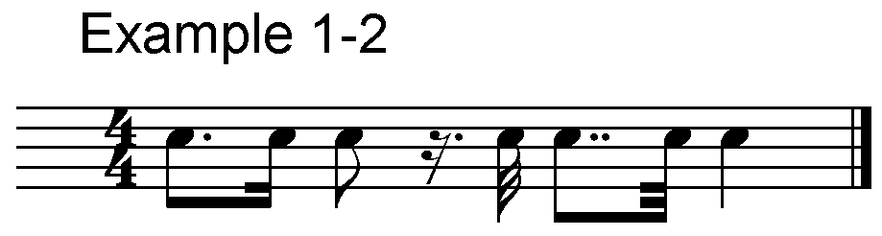

1-3. The sign for 256th notes is used as a prefix and is followed by 16th notes or rests. When a note or rest of different value intervenes, the prefix is repeated before the next 256th note.

1-4. When the value of a note is not apparent from the number of notes and rests in the measure, the general sign for distinction of values or specific signs for small and large value are used. Example 1-4 is in four-four time; a space is a bar line. In (a), the distinction of value sign is placed between a half note and the four 32nd notes that follow it. In (b) the specific sign for smaller value is used.

Example 1-4.

(a) n<1onopgfe y<k

(b) n,<1onopgfe y<k

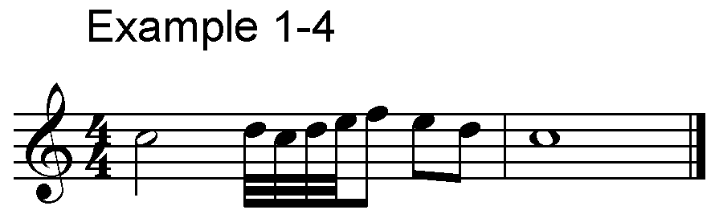

1-5. One of the uses for the smaller value sign occurs when it is not clear whether the first note of a piece has a smaller or larger value. Example 1-5 begins with an anacrusis to the four-four measures.

Example 1-5.

,<1y dxjxdxex fxgxo<k

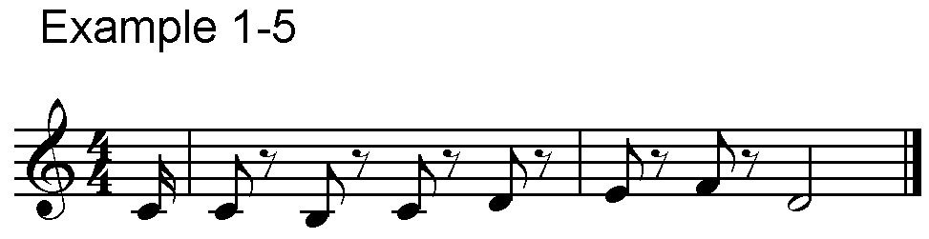

1-6. Large and small value signs are especially useful in cadenzas. They should be used whenever a combination such as half notes and 32nd notes occur either in a cadenza or a passage of measured music.

Example 1-6.

^<1r,<1ontsrqpo<k

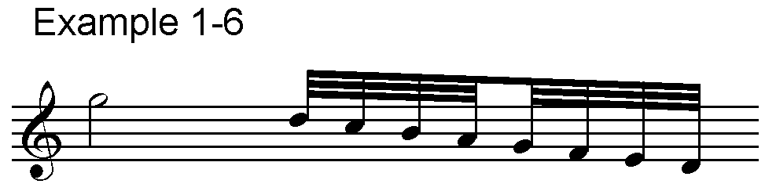

1-7. The whole rest is used for a complete measure of rest in any time value. For two or three consecutive measures of rest, use form (a) below. For four or more measures of rest, use form (b). When the square (brevis) rest appears in print, use form (c).

Example 1-7.

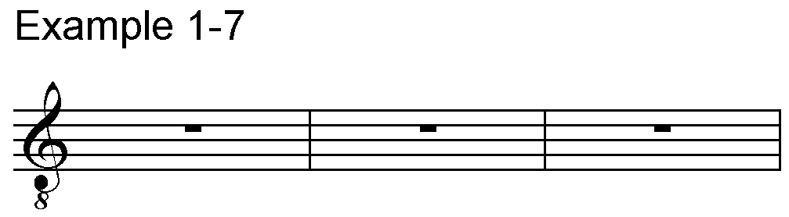

(a) MMM

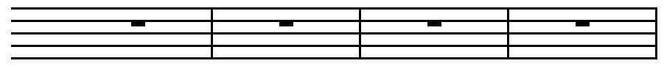

(b) #DM



(c) M^cM

### B. Octave Marks

1-8. Octave marks, rather than clefs on a staff, indicate specific pitch locations in braille music. Octaves are numbered from one to seven, beginning with the lowest C on the normal, seven-octave piano. Each octave begins on C and includes all the notes up to, but not including, the next C above. The fourth octave begins on the "middle C" of the piano. (Because of the number of "signs" in this manual, the original term, "mark," is used for the many references to octave marks throughout the manual.)

1-9. The octave mark is placed immediately before the note to which it applies with no intervening signs. Example 1-9 shows the octave marks from 1 to 7 placed before quarter-note C.

Example 1-9.

@? ^? _? "? .? ;? ,?

@@[ A below first octave

,,? C above seventh octave

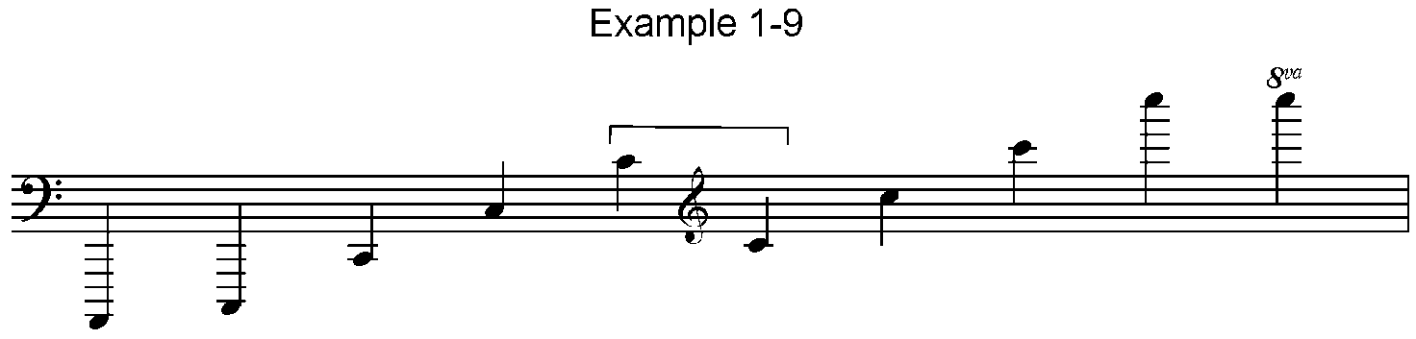

1-10. The first note of a piece must be preceded by its octave mark. For the succeeding notes the following rules apply:

(a) if the next note forms an ascending or descending second or third, it does not receive an octave mark even if it is in a different octave.

(b) if it forms an ascending or descending fourth or fifth, it only receives an octave mark if it is in a different octave from the preceding note.

(c) if it forms a sixth or more, it must always have its own octave mark.

1-11. These rules are illustrated in the following example from the "Cologne Key" of 1888.

Example 1-11.

#D4

.P:? [.O? W.P: N]$ :R]

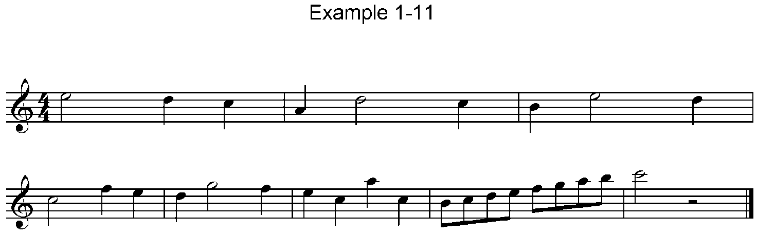$?.[.? JDEFGHIJ NU<K

1-12. The example above contains a time signature on the first line consisting of a number 4 in normal cell-position followed by a number 4 in lower-cell position to represent 4/4 time. Each measure of four beats is separated by a space, representing the print bar-line.

1-13. When the print contains "8va" and "loco" the first note of the "8va" (or "8ba") should receive two octave marks, the first showing its position on the print staff and the second showing its actual sound. Any octave marks necessary during the passage must show the actual sound. The first note after the end of the passage is given a double octave mark to show that its position on the staff corresponds to its actual sound. Example 1-13 illustrates this technique for transcribing "8va" and "loco".

Example 1-13.

#B4 _Y^(&Y^@Y^^Y&( _?V<K

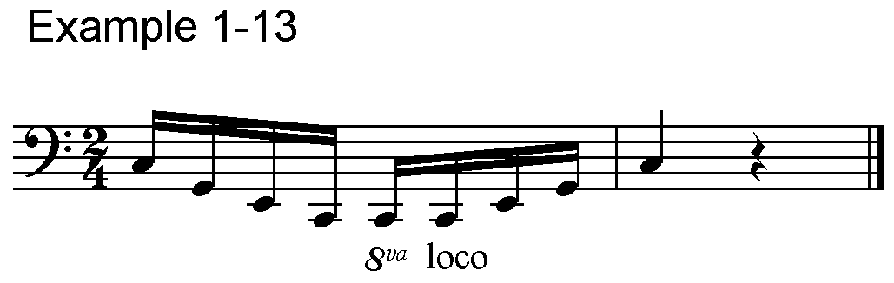

## II. Clefs

(Table 2)

Signs from Table 2.

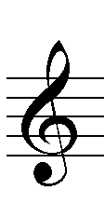

=>/l= G clef; treble

=>/k= G clef in the left hand part

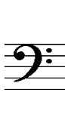

=>#l= F clef; bass

=>#k= F clef in the right hand part

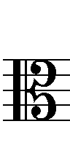 =>+l= C clef; alto clef for viola or high clef

for bass

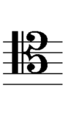 =>+"l= C clef on fourth line; tenor clef

=>/l#h= G clef with small 8 above

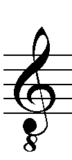 =>/l#8= G clef with small 8 below

* * *

2-1. Although clef signs do not determine pitches of notes in braille as they do in print, a knowledge of clef signs is vital to a complete understanding of print music. In print, a clef sign appears at the beginning of every staff of music. In braille, when clef signs are used, they generally appear only at the beginning of pieces unless there is a change of clef.

2-2. Some countries use clef signs with all braille music except keyboard music. Others omit them for an instrument, such as violin, that always plays in the same clef. When an instrument such as the cello changes clefs, the clef sign information is important in teaching materials.

2-3. The note following a clef sign must have an octave mark.

2-4. Dot 3 must follow a clef sign if the next character contains dots 1, 2, or 3.

2-5. When a treble clef sign is printed in the bass staff or a bass clef sign is printed in the treble staff, the forms above, =>/K= and =>#K= are especially useful to teachers of sighted students. See Example 15-14.

Sign from Table 14.

="= Hyphen for unfinished measure

* * *

2-6. Clef signs can appear on any line of the staff. In order to show the line on which the clef sign is placed, its final character, dots 1-2-3, is preceded by an octave mark as follows:

Example 2-6.

#D4

>#L^J)Z()Z(>+"L"JZ)>#L"

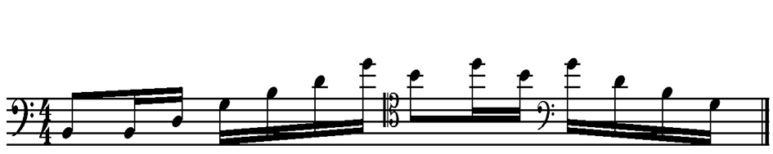 "(EJH<K

2-7. A clef sign with a small 8 below indicates that the notes should sound one octave lower than written. Similarly, a clef with an 8 above the sign indicates that notes should sound one octave higher than written; a 16 above or below a clef sign indicates that notes should sound two octaves higher or lower. Example 2-7 is music for lute. The clef sign indicates that the notes will sound one octave lower, but the pitches are transcribed as printed.

Example 2-7.

<<#C8

>/L#8"JZYZ) D*"F%G<K

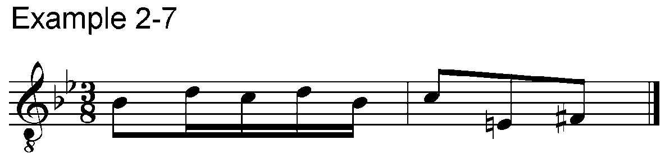

## III. Accidentals, Key & Time Signatures

(Table 3)

### A. Accidentals

Signs from Table 3 A.

=%= Sharp

=<= Flat

=%%= Double sharp

=<<= Double flat

=*= Natural

=,% ,<= Accidental above or below the note

* * *

3-1. The sharp, flat and natural signs are placed before the notes, intervals or other features to which they belong. They must not be separated from notes by anything other than octave marks.

3-2. If an accidental appears above or below a note in print, it is preceded by dot 6 in braille.

3-3. Quarter-step alterations of an accidental are discussed under Modern Notation. See Par. 13-16.

### B. Key & Time Signatures

3-4. Key signatures reflect the number of flats or sharps, not the actual pitches as in print. If there are four or more accidentals in a key signature, the number sign is used. See Example 3-8.

3-5. The next note following a key signature must have an octave mark. If it is not followed by a time signature, it must be followed by a space.

3-6. When time signatures consist of an upper and a lower number in print, the braille uses upper- and lower-cell numbers with a number sign only at the beginning of the combination. An upper-cell number is used for a single-digit time signature. In other types of signatures as well, the print is followed closely.

Signs from Table 3 B.

=.c= C or “common” time



=_c= Barred C or “cut” time

=#d4 #ab8= Time signatures with two numbers

=#d= 4 (or other number). Time signature with single number

* * *

3-7. A time signature must be followed by a space, and the next note following it must have an octave mark.

3-8. The key and time signatures are combined with or without one space between, according to the practice of the nation.

Example 3-8.

=% #c4= One sharp, three-four time

=#d<#d4= Four flats, four-four time

* * *

3-9. When there is a change of key and/or time signature, the print must be followed exactly. Such a change is placed between spaces and the next note must have an octave mark.

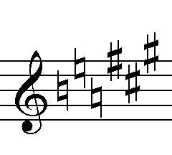Example 3-9.

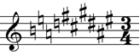=***%%%=

=#d*#f%#c4=

3-10. When a note appears in a time signature, C is used for the note name, it is shown with its time value, and it is preceded by the music prefix, dots 6, 3. See Example 13-18.

3-11. Some other unusual time signatures are shown in Example 13-19.

## IV. Rhythmic Groups

(Table 4)

4-1. In print, smaller notes are often joined by one or more horizontal beams into beats or portions of beats. Eighth notes are joined by one beam, 16th notes by two beams, 32nd notes by three beams, etc. Braille duplicates that practice within certain constraints.

4-2. Three or more 16ths or smaller-value notes may be "grouped" in braille. The members of the group will all be in the same beat or portion of a beat and have the same value. When "grouped," only the first note of the braille group contains dots 3 and/or 6 as necessary. The other notes in that group are written as if they were 8th notes.

Example 4-2.

#D4 "YEFG(IJDZDJI(GFE<K

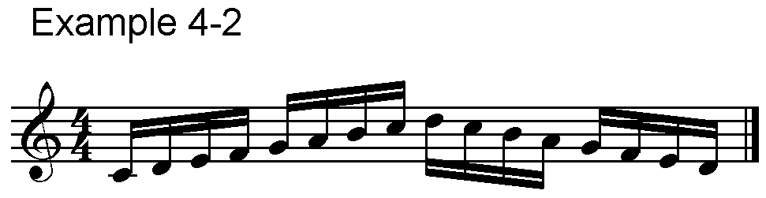

4-3. Because a group ends with notes that look like 8ths, if an 8th note or 8th rest follows in the same measure and is on the same braille line, all of the notes in the group must be written in their normal form.

Example 4-3.

#D4

"YEFG\&=(!HF EG(GFENEFGRIJD"

JH .Y<K

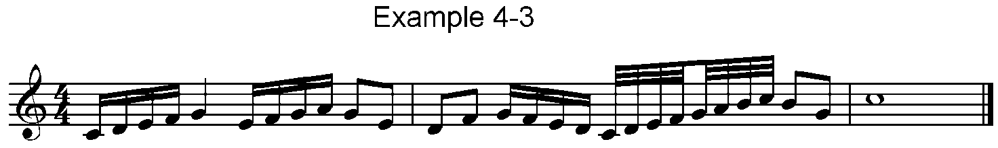

4-4. Grouping may be used if a rest of the same value is at the beginning of the group. It must not be used if a rest appears in any other position in the group.

Example 4-4.

#C4 M"FGHMGHIMHIJ<K

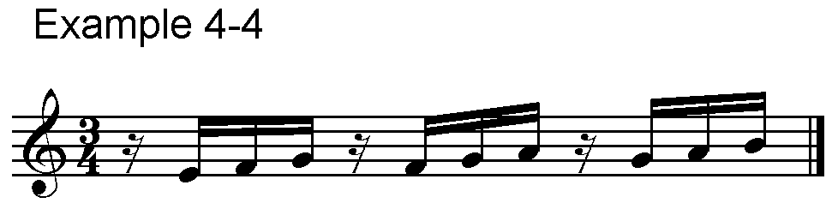

4-5. Grouping is based on the time signature, i.e., in two-four, four-four, etc. 16th notes appear in groups of four; in three-eight, six-eight, etc. 16th notes appear in groups of six. In general, 16ths are grouped by fours in time signatures with a lower number of two or four; they are not grouped by four when the lower number is eight or 16. Thirty-seconds and smaller notes are generally grouped by fours or sixes in rhythmic portions of beats.

4-6. Grouping may not be used if the group cannot be completed on the same braille line.

Example 4-6.

#C8

"YEFGHI RIHG$ QHGFZDEF =&"

=(!) ?'<K

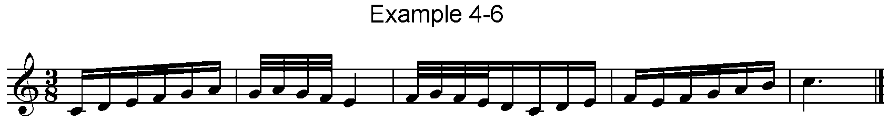

Signs from Table 1.

=^<1= Larger values; 8ths and larger

=,<1= Smaller values; 16ths and smaller

=<1= Separation of rhythmic groups

* * *

4-7. In a case where syncopated 8th notes might be mistaken for a group of 16ths, the larger-value sign is added for clarity.

Example 4-7.

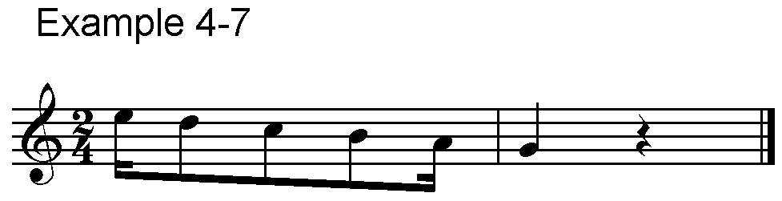#B4 .&^<1EDJ! \V<K

4-8. When 8th notes are grouped across a bar line in print, the sign =<1= may be used to show the separation of rhythmic groups. This same sign is also used in some countries to show distinction of value between groups.

Example 4-8.

#C4 X.DJIH<1I HGF<1GFE<K

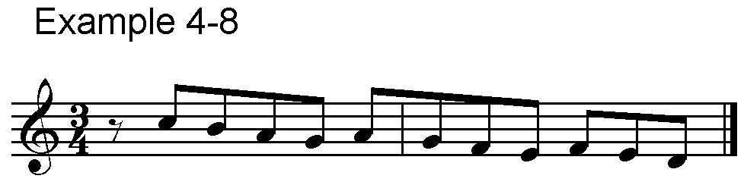

4-9. In addition to beams, numbers are also printed above groups of triplets, sextuplets, etc. In braille, these numbers precede the first note of each group and are written as in Table 4.

Signs from Table 4.

=_2'= Group of two

=2= Triplet

=_3'= Group of three; triplet

=_6'= Group of six

=_10'= Group of ten, etc.

* * *

4-10. There are two forms to the triplet sign. The single-cell sign is used when there are no other specially marked rhythmic groups. The three-cell sign is used for a triplet within a triplet and for passages where there are a number of other marked groups such as duplets, sextuplets, etc.

Example 4-10.

.C .?2FGH2G_3'&=&E?<K

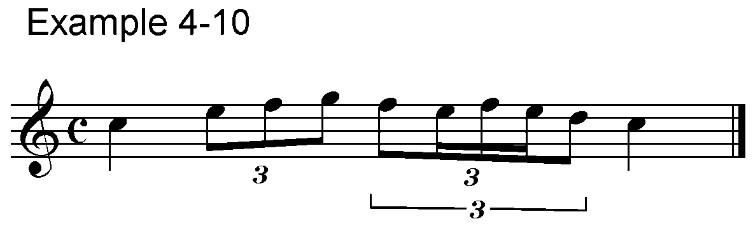

4-11. Grouping signs may be doubled, but in the case of the three-cell grouping signs it is unnecessary to use dot 3 after the first of the doubled signs.

Example 4-11.

%#D4

_7_7'"&HJDEDJ!DFGHGF"

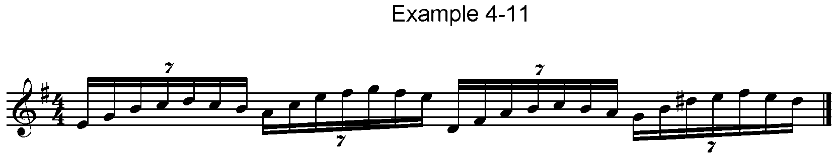"ZGIJDJI_7'(J%EFGFE<K

4-12. When the print does not include appropriate numbers for triplets, sextuplets, etc., there are two schools of thought:

1. the number of notes in each group should be inserted as above; or
2. put the sign =<1= between groups.

## V. Chords

(Table 5)

### A. Intervals

Signs from Table 5 A.

=/= Second

=+= Third

=#= Fourth

=9= Fifth

=0= Sixth

=3= Seventh

=-= Octave

* * *

5-1. "In chords in which the notes are of equal value, one note only is written. The others are indicated by their intervals from that note. In chords which belong to the upper series of notes – soprano, alto, violin, viola, right hand for piano, organ and harp – the upper note is written and the lower notes are expressed by descending intervals.

"In the lower series – tenor, bass, violoncello, and left hand for piano, organ and harp – the lowest note is written and the others are expressed by ascending intervals."

(**Musical Notation for the Blind**, British and Foreign Blind Assoc., London, 1888.)

5-2. The quotation above, from the document known as the "Cologne Key," established the directions for reading and writing intervals; and the meeting itself established the tradition of the international work that continues today.

Signs from Table 15 A.

=.>= Right hand part

=_>= Left hand part

Example 5-2

#D4

.>.Y/ Y+ Y# Y9 Y0 Y3 Y-<K

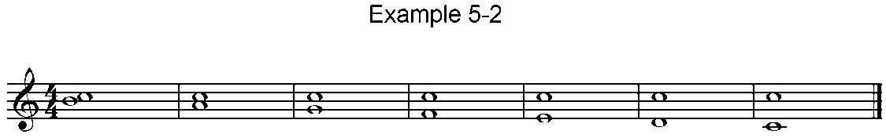

_>_Y/ Y+ Y# Y9 Y0 Y3 Y-<K



5-3. Intervals larger than an octave are written with the same series of signs plus an appropriate octave mark. A ninth is shown with the interval of a 2nd in the new octave, a tenth is a third in the new octave, etc.

Example 5-3.

#C4

.>.\_0\_3]_9 P'"+<K

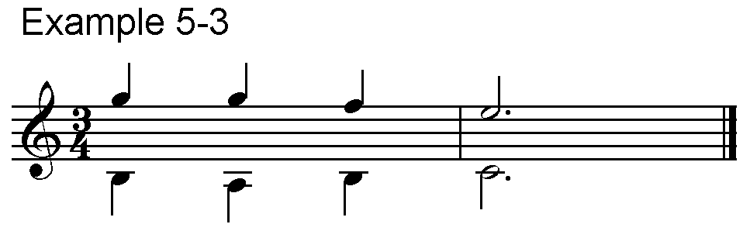

5-4. A prime or unison is written by preceding the sign for an octave interval with the octave mark showing that it is sounded at the same pitch as the note itself.

Example 5-4.

%%#B4

>/L":X';="0 ]"0X'"Z"- O"-<K

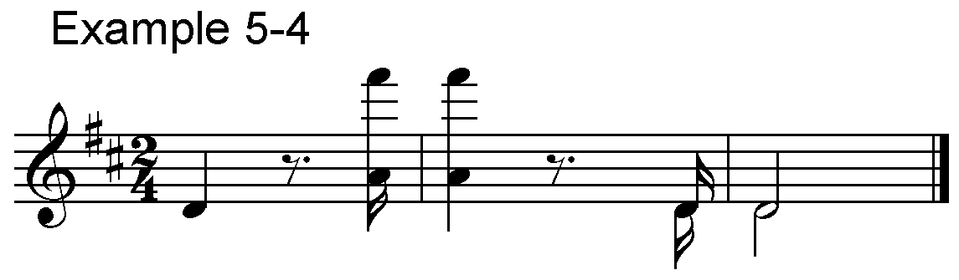

5-5. If more than one interval follows the written note, no octave mark is necessary unless two adjacent intervals are an octave or more apart.

Example 5-5.

#C4

>/L.\-#0\9+3]+39 P'+0+<K

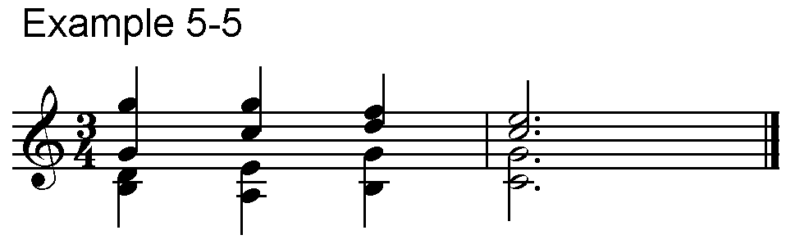

5-6. When written notes of chords are dotted, the dots are placed immediately after the notes as in Examples 5-3 and 5-5. Intervals have the same value as written notes.

5-7. The melodic intervals of the written notes determine whether or not an octave mark is necessary before each chord.

Example 5-7.

%% #D4

_>_:+9-^E'-Z-:-V<K

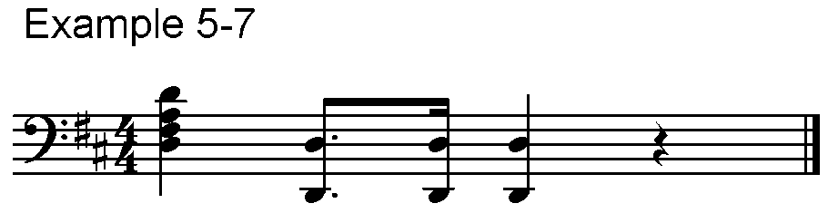

5-8. If there are more than 3 identical intervals in a row, they may be doubled. The interval sign is written twice after the first note. The following notes of that series are written without intervals, and the series is closed by writing its interval or intervals once after the last note. An accidental before any doubled interval except an octave makes it necessary to interrupt the series.

Example 5-8

(a)

%%#D4

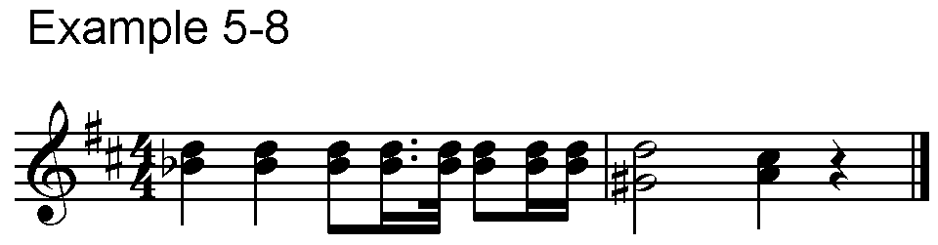>/L.:<++:EZ'OEZZ+ O%9?+V<K

(b)

#C4

_>^W00?W [[%0?0 T'0<K

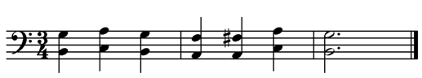

5-9. In a passage of doubled octaves the doubling need not be interrupted by the occurrence of accidentals at the interval of an octave. In some countries, accidentals are not included before an octave interval, only before the written note of an octave. Other countries mark all accidentals as they appear in print.

Example 5-9.

#C4 _>_D--<FE<JIH-<K

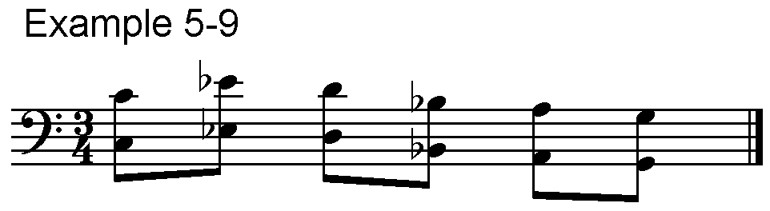

5-10. A change of clef within a part or voice should not cause a change to the direction in which intervals are written.

### B. In-accords

Signs from Table 5 B.

=<>= Full-measure in-accord

="1= Part-measure in-accord

=.k= Measure division for part-measure in-accord

* * *

5-11. When all of the harmonic parts do not change at the same time, they are shown by dividing the measure into voices of like value and presenting two or more sections of the measure "in-accord" or "with" each other. When the entire measure is divided, the full-measure in-accord is used.

5-12. The octave mark must be shown for the first note after an in-accord and at the beginning of the next measure, whether or not that measure contains an in-accord.

5-13. The order in which the parts are written is the same as the direction of intervals. In treble parts the top voice is written first; in bass parts the bottom voice is written first.

Example 5-13

(a)

#D4

.>.Y<>"$:$] ")<>"\]$:<K

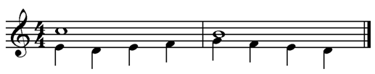

(b)

%#C4

_>_O'<>_[+\<+*]+ _R'<+<K

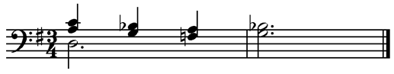

5-14. In some formats intervals may be doubled in an in-accord part, and the doubling may be carried over into the same voice of succeeding measures as long as the same number of voices continues.

Example 5-14.

#E%#C4

_>_O'@C<>"?'++J*[

_O'<>_['HW+<K

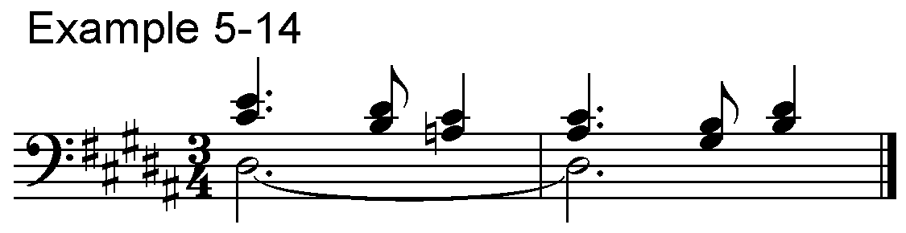

5-15. Accidentals in one voice do not carry over to the in-accord part. Most countries feel they must be re-marked in the other part and preceded by dot 5 to indicate the accidental does not appear in the print copy.

Example 5-15.

#D4

.>'X.E<F%GH<J[<>.?'E"<$'"%G<K

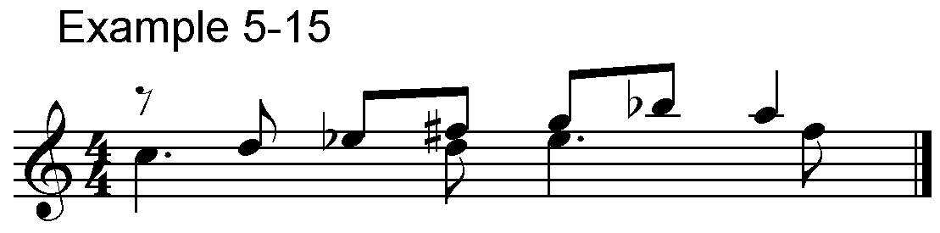

5-16. Rests must occasionally be added to an in-accord part. These also should be preceded by dot 5.

Example 5-16.

#D4

.>"[+H+X\GX<>"?'"X?'"X<K

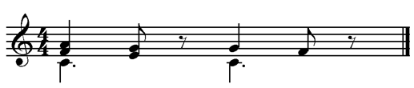

5-17. If only part of a measure needs an in-accord, the part-measure in-accord sign is used along with a sign to show which section of the measure is affected by the in-accord.

5-18. As with the full-measure in-accord sign, the first note following either of these signs must have an octave mark. If the in-accord occurs at the end of the measure, the first note of the next measure also must have an octave mark.

Example 5-18.

#D4

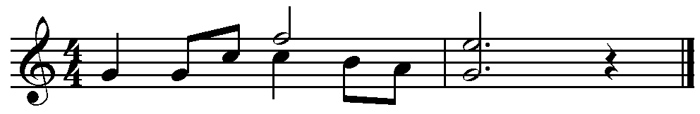>/L"\H.D.K.Q"1.?JI .P'0V<K

5-19. As with the full-measure in-accord, accidentals or rests must be re-marked (and preceded by dot 5) if they occur in another in-accord voice.

5-20. Some measures may require more than two in-accord parts.

Example 5-20.

<<#C4

>#L_Q'<>"V_S<>V"$'*F<K

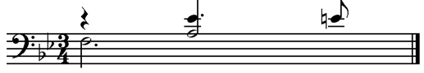

5-21. Full- and part-measure in-accords may be used in the same measure.

Example 5-21.

#D4

>/L"HF.K"I'(G&=(GFE"1

"DI"E'YJ!)<>_(<K

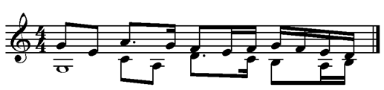

### C. Moving-notes

5-22. Another way of showing interval changes that do not occur in all parts at the same time is through the use of moving-note signs.

Signs from Table 5 C.

=,= Moving-note sign for one interval

=;= Moving-note sign for two or more intervals

* * *

5-23. When two, or at most three, notes of equal value move below or above a longer note, they can be written as intervals separated by dot 6.

5-24. In the following example the first two intervals represent half notes and the remaining intervals represent quarter notes.

Example 5-24.

#D4 .>.(+,9 R'+,#,9V<K

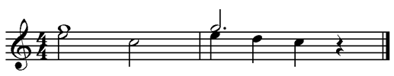

5-25. The moving-note sign can also be used when two or more intervals move together in a similar manner, but in this case dots 5-6 are substituted for dot 6.

Example 5-25.

#D4 .>.(+9;9+ R'+9;#-;9+V<K

Signifies:

#D4 .>.(<>.P+N0 .R'"1.$+:9"

?0.KV<K

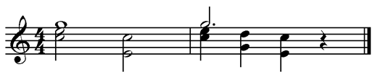

5-26. The use of octave marks in the moving part is governed by the rules for intervals, par. 1-10. Compare (a) and (b) below.

Example 5-26.

(a)

<<<#F8

>/L.]'-,<+,-$'0,+,*9<K

(b).

<<<#F8

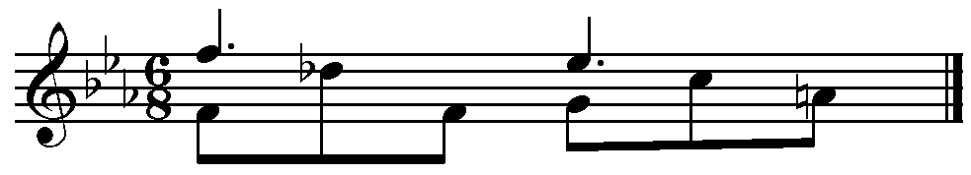>/L.]'$'<>"G<.E"GH.D*I<K

5-27. When an accidental modifies a moving note, the appropriate moving-note sign precedes the accidental as in Example 5-26 (a).

5-28. The moving-note sign may be useful to vocal conductors. When there are complications of fingering, phrasing, and nuances, it becomes unsuitable for instrumental and keyboard music.

5-29. Tone clusters are discussed under Chapter XIII, Modern Notation.

### D. Stem signs

5-30. An additional stem placed on a note or chord may indicate a prime or unison (Example 5-4), one voice that becomes an in-accord (Example 5-20) or a note to be held while a rhythmic pattern continues. In the last case, when an in-accord is not satisfactory, stem signs are used to indicate value. When a note has two stems of different value, the smaller value is written as a note, and the larger value is written as a stem sign.

Signs from Table 5 D.

=_'= Whole “stem”

=_k= Half stem

=_a= Quarter stem

=_b= 8th stem

=_l= 16th stem

=_1= 32nd stem

* * *

5-31. Stem signs are placed after the notes to which they belong and may not be separated from them by the music hyphen. These signs may be dotted in the same way as written notes, and they may be modified by slurs, ties and nuances.

Example 5-31.

%%%.C

_>'2_G_KI_A'"E?2*_G_KI_A'"F"

%: 2_F_KI_A'"G$"

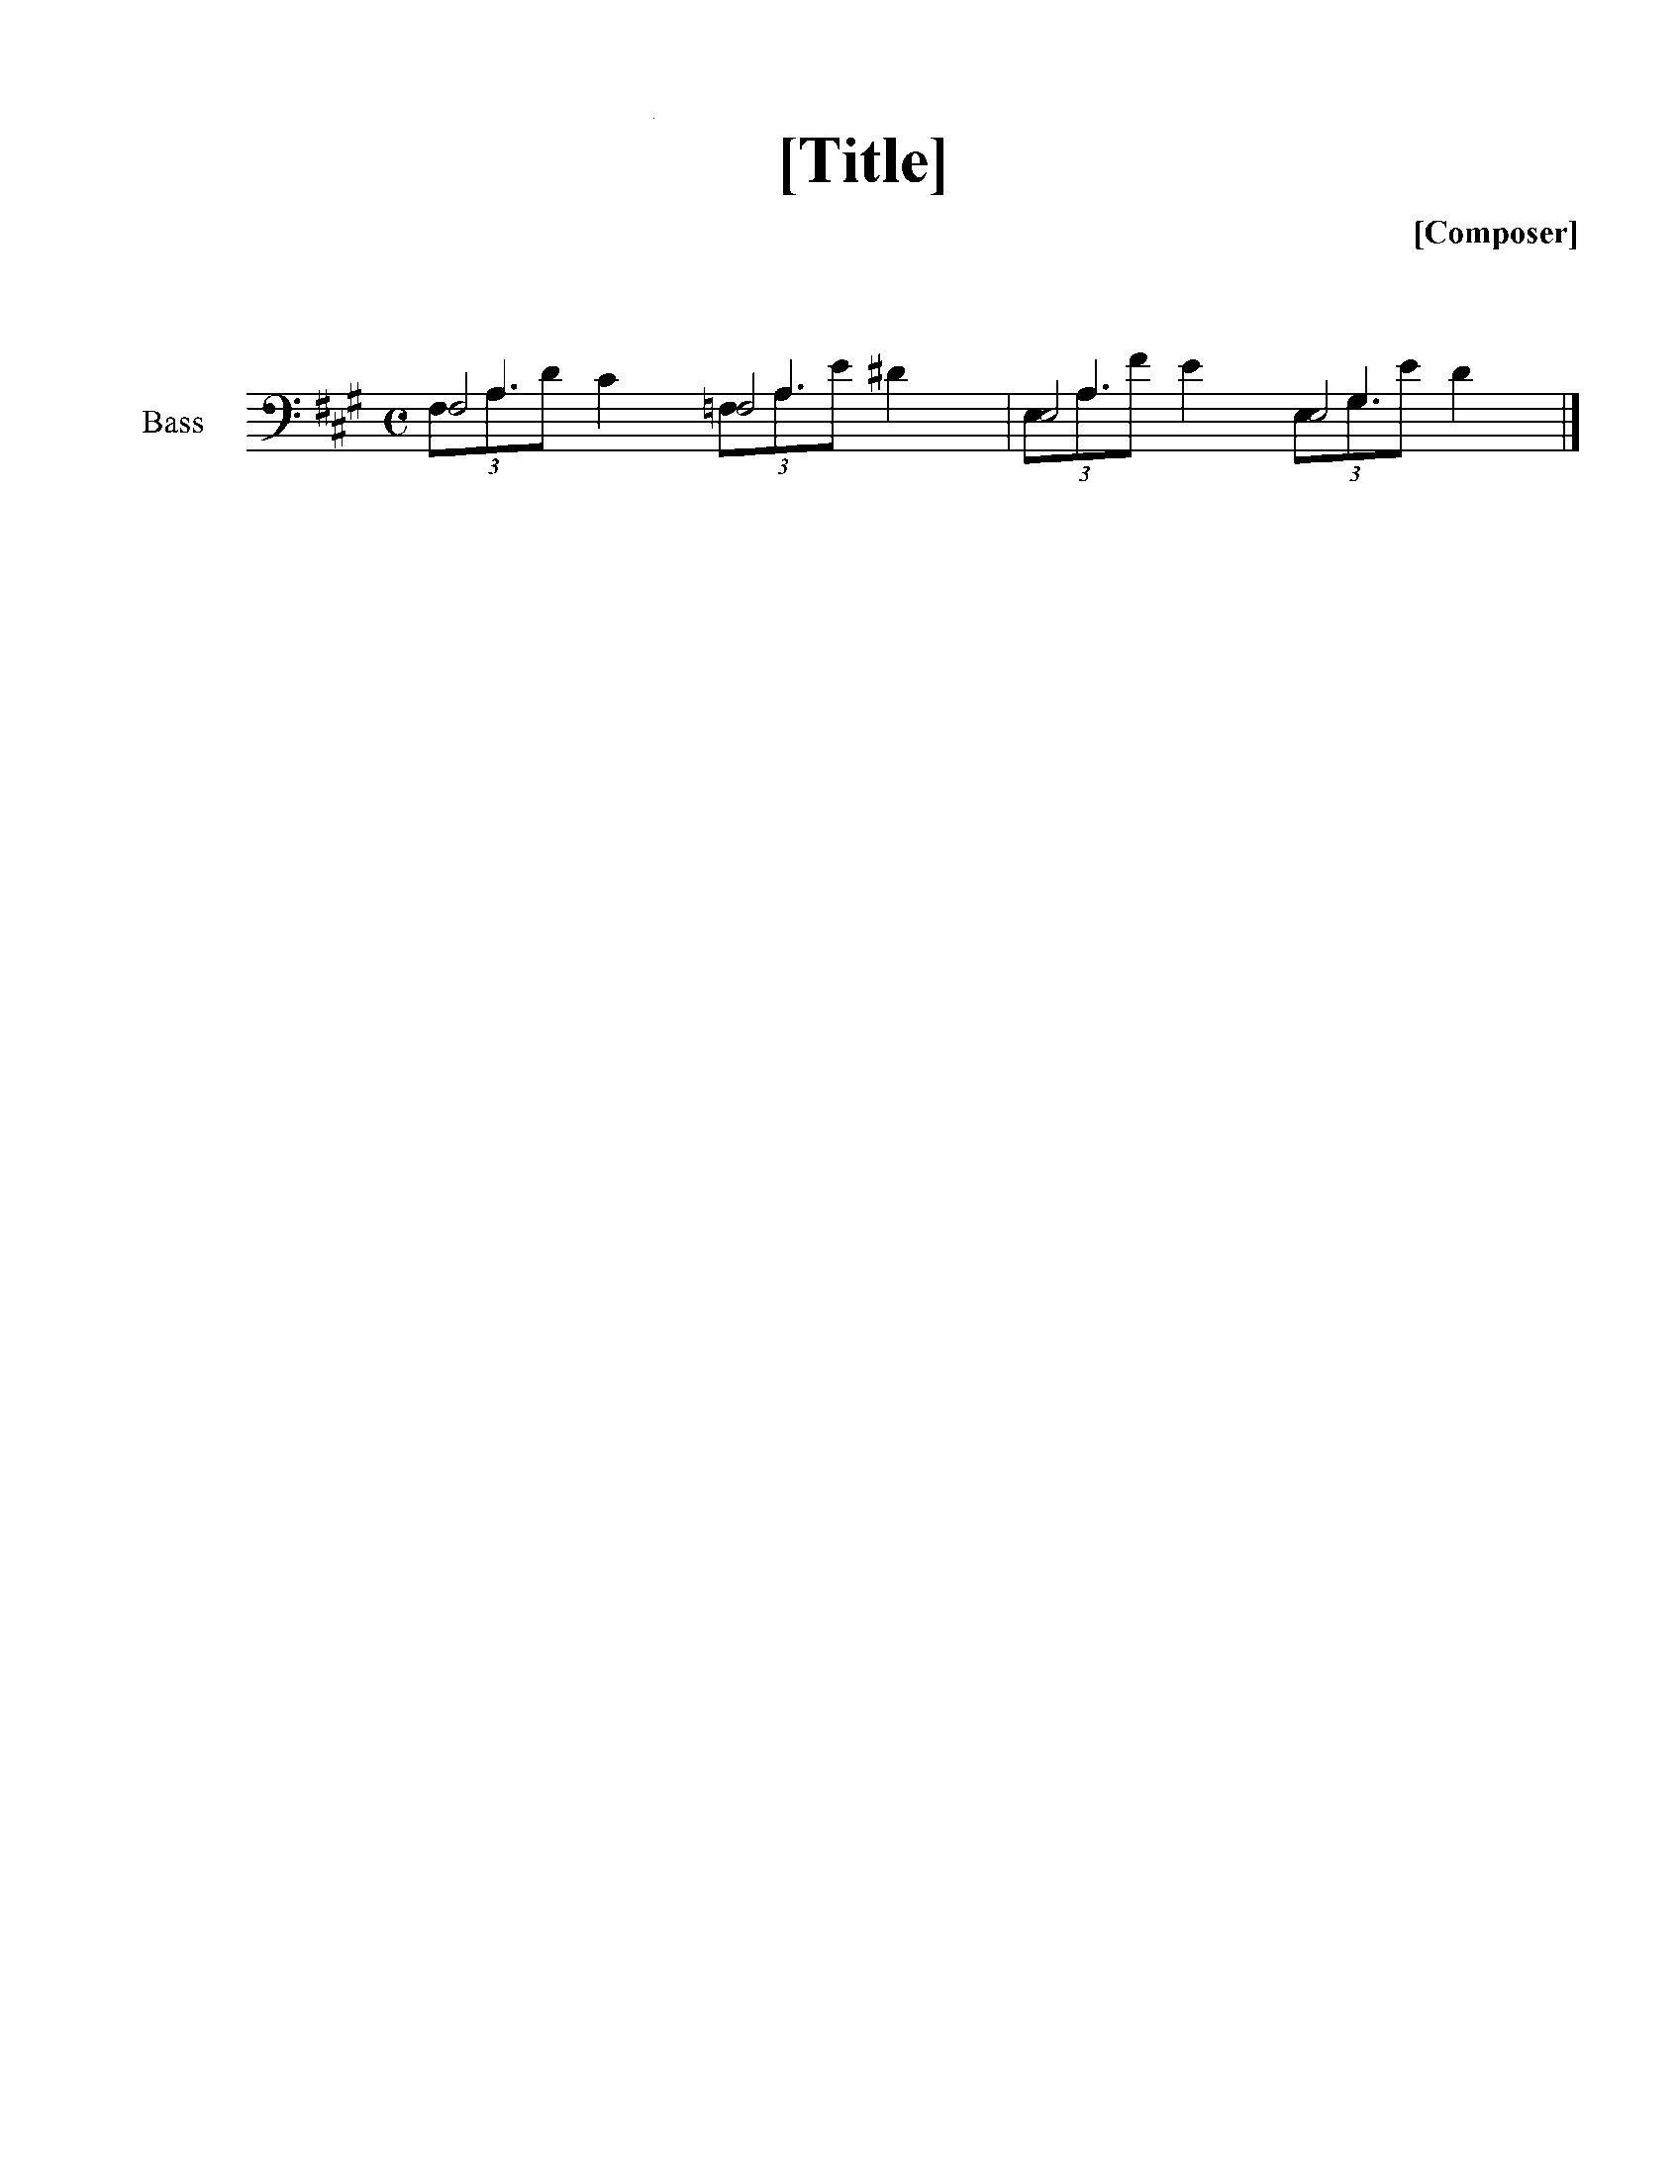 2_F_KH_A'"F:<K

## VI. Slurs and Ties

(Table 6)

### A. Slurs

6-1. In print, all slurs and ties are identical except for length and slight variations in shape. All of the braille signs listed in Table 6 have been approved internationally for use, but their use is not mandatory. Practice between countries varies widely, i.e., some countries regularly use signs to indicate whether a slur or tie is "going to" or "coming from" a different in-accord or staff; some countries use these indications only in complex music, and some countries never use a "from" sign. The examples in this Chapter are provided to demonstrate the meanings and possible use of slur and tie signs that are used according to the decisions of local nations.

Signs from Table 6 A.

=C= Slur between two notes or chords

=Cc c= Phrasing slur over more than four notes or chords

=;b ^2= Phrasing slur over more than four notes or chords

=;b^2= Beginning and end of phrasing slur on one note

=,c= Beginning and end of short slur on one note

=_c= Slur from one in-accord part to another

="c= Slur from one staff to another

=@l= Straight line between staves for voice leading

=[.@l](mailto:.@l)= End of straight line

="lc= Slur added by an editor in print

=;c= Slur that does not end on a note

=;c= Slur for short appoggiatura; “grace note” slur in some countries

* * *

6-2. The sign, =C=, is used for a slur of no more than four notes. It is placed after each note of the phrase except the last.

Example 6-2.

#C4

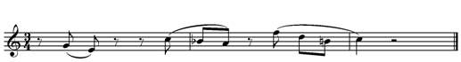X"HCFXX.DC <JCIX.GCEC*JC ?U<K

6-3. When a slur extends for more than four notes, there are two possible slurs for use.

(a) The =C= sign is doubled after the first note of the phrase and repeated in its single form after the next to last note of the phrase as in Example 6-3 (a).

(b) The sign =;B= is placed before the first note of the phrase and the sign =^2= is placed after the last note of the phrase as in Example 6-3 (b).

Example 6-3

(a)

#B4

"\CCIJ ?EF ]FE $CDX<K

(b)

#B4

;B"\IJ ?EF ]FE $D^2X<K

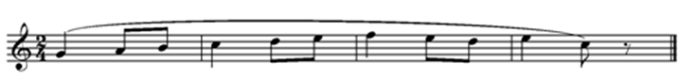

6-4. When there are two sets of slurs in print, the second form above is used for the longer slur.

Example 6-4.

#D%#C4

;B"W'CHCJC.F \'CGCFCE

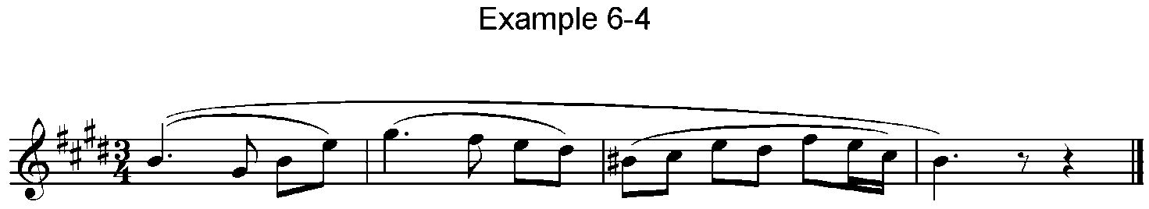%JCCDFEG&CY W'^2XV<K

6-5. When one slur ends and another begins on the same note, there are two possibilities.

Example 6-5

(a)

#D4

;B_YEFG(IJDZFED)DJI

;B^2HJEJH"EGE JHGE?^2V<K

(b)

#D4

_YCCEFG(IJDZFED)DJI

H,CCJEJH"EGE JHGEC?V<K

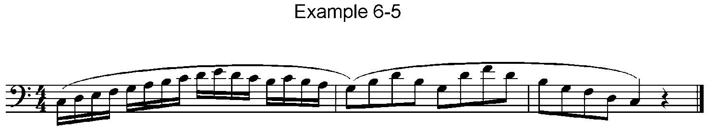

6-6. When a slur passes from one in-accord part to another on the same staff, the slur sign preceded by dots 4-5-6 is used. In example (a), the fact that the slur will go to a different in-accord is indicated immediately. In (b), the indication does not appear until the point of transfer. Example 6-21 (a) shows the same music with the addition of "from" signs.

Example 6-6.

(a)

#B4

.>'X"F_CDCJC XZ_CC&=FED<>

_C_S M;B"EFG(IHG<>_C_T "P+^2<K

(b)

#B4

.>'X"FCDCJ_C XZCC&=FED_C<>

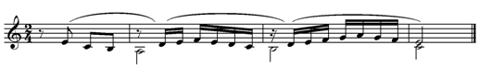_C_S M;B"EFG(IHG<>_C_T "P+^2<K

6-7. When a slur passes from one staff to another, it is preceded by dot 5 as in example (a) below. The doubled form of the slur is used in (b) because there are more than four notes in the phrase to be slurred. The other form of phrasing slur is used in (c). This example includes tracker dots, used only in bar-over-bar format. Example 6-21 (b) shows the addition of a "from" sign to clarify that the slur ends in measure 2.

Example 6-7

(a)

%%#C4

.>'"[C]C:"C V.:C0?C0 O'0<K

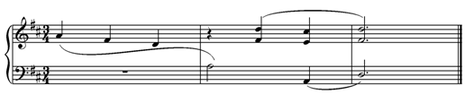_>'M "C_S^[C _O'<K

(b)

%%#C4

.>'"I"CCHGFED V.:C0?C0 O'0<K

_>'M _W"C[^[C _O'<K

(c)

%%#C4

.>';B"IHGFED"C V.:0C?0C O'0<K

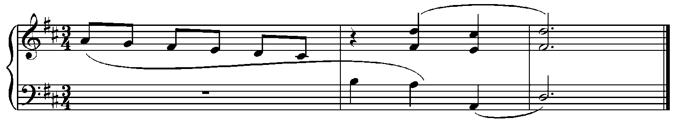_>'M ''''''''' _W[^2^[C _O'<K

6-8. Another difference in practice between countries occurs in the way slurs are written with chords. In Example 6-7 (a) and (b), the slurs are placed after the written notes of the chords and before the interval signs. In Example 6-7 (c), the slurs are placed after the complete chords.

6-9. In Example 6-9, the voice moving from hand-to hand is indicated in print with a straight line, to indicate voice-leading, rather than as a slur. The =@L= sign is used for a straight voice-leading line. The sign for the end of this line is also included, although some countries limit the use of the "ending" sign to more complex situations.

Example 6-9.

%%#C4

.>'"[]:@L V.:0?0 O'0<K

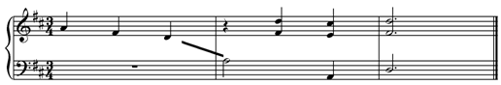_>'M .@L_S^[ _O'<K

6-10. Example 6-10 contains two editorial slurs and a standard slur in music for cello. The slurs added by the editor are printed with dotted lines, so the sign ="L= is used. That sign is also used for other editorial markings such as dynamics, pedalling, etc.

Example 6-10.

<#C4

_YB"LC&A"LC!"LCYF'"LCY"

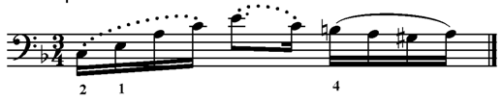 *)1CIC%HCI<K

6-11. A slur that does not end on a note or the "slur into nowhere" =;C= is illustrated for guitar in Example 17-38 and for percussion in Example 18-16.

6-12. A special indication that a slur is associated with a short appoggiatura is illustrated in Example 11-7. Some countries use =;C= as a "grace note slur" and other countries use the normal slur, dots 1-4, for all appoggiaturas, as in Example 11-6.

### B. Ties

Signs from Table 6 B.

=@c= Single-note tie

=.c= Chord tie

* * *

6-13. In print, a tie is notated exactly the same as a slur. With few exceptions, tie signs are used when the print ligature appears between two identical pitches. The sign for a single-note tie is placed immediately after the first of the two tied notes, or after any slur, fingering or tremolo indications connected with this note. It follows the dots in the case of dotted notes.

6-14. When a note inflected by an accidental is tied over a bar line and is not re-marked in print, it is handled in three different ways according to national codes.

(a) If the new measure falls on a new braille line, the accidental must be re-marked;

(b) follow print, re-marking the accidental only if it appears in the print copy;

(c) the second note must always be re-marked. Example 6-14 is written here according to (b), as it appears in print.

Example 6-14.

#C4

.?@C ?W<W@C W[<[@C [\<IG P<K

6-15. If only one note is tied between two chords, the single-note tie is placed immediately after the appropriate written note or interval.

Example 6-15.

#D4

>/L"W+@CD#E@C0:3@CD0X<K

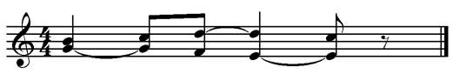

6-16. If one or more of the notes of two identical chords are repeated while the others remain tied, the single-note tie sign must be used for each tied note or interval.

Example 6-16.

#D4

>/L.N@C#0-@CN#@C0@C- Y#0-<K

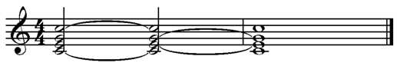

6-17. If two chords are tied in a succession of chords written with doubled intervals, the doubling need not be interrupted.

Example 6-17.

#F8

.>.D##00.C DJI.CIH.G.C

GFE?#0<K

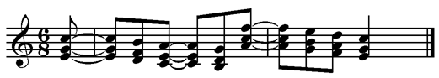

6-18. In some countries the chord tie sign may be doubled as: =.CC=.

Example 6-18.

#D4

>/L.N#0.CC N#3T+0 T#0S+9

 "S+3.CR@C/0 R+9<K

6-19. A repeat does not include a tie on the last note or chord of the passage. See Examples 9-25 (a) and 9-26.

6-20. The accumulating arpeggio is written as follows:

Example 6-20.

>/L'55_P^C%"R%.N5P)93+_9<K

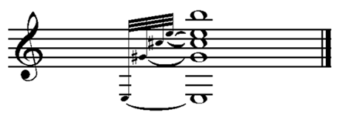

### C. More Slurs and Ties For Use in Section-by-section Formats

Signs from Table 6 C.

=._c= Slur from another in-accord part

=."c= Slur from another staff

=_@c= Single-note tie between in-accord parts

=."@c= Single-note tie from another staff

=._@c= Single-note tie from another in-accord

="@c= Single-note tie between staves

* * *

6-21. The signs in part (C) of Table 6 are used more widely in music written in sections. Dots 4-6 added to a slur or tie sign clarifies that it is "coming from" another in-accord or staff. Examples 6-21 (a) and (b) are from the same music as Examples 6-6 (a) and 6-7 (b) respectively.

Example 6-21

(a)

#B4

.>'X"F_CDCJC XZ_CC&=FED<>

._C_S M;B"EFG(IHG<>._C_T

"P+^2<K

(b)

%%#B4

.>'"I"CCHGFED V.:C0?C0 O'0<K

_>'M _W."C[^[C _O'<K

6-22. As with a slur, dots 4-5-6 before a single-note or chord tie sign indicates that the tie is held into a different in-accord part. In Example 6-22, the sign =._@C= clarifies that the tie in the second in-accord part definitely pertains to the note F.

Example 6-22.

#F4

.>.?W\]_@CW?<>"P?:._@C]$<K

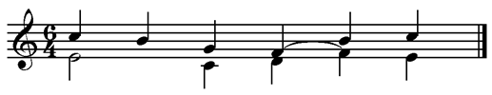

6-23. As with slurs, dot 5 indicates a change of staff and again, dots 4-6 indicate that a sign is coming from an in-accord or a staff. In Example 6-23 an F from the left hand is tied to the same note to be held by the right hand in the next measure. The special tie sign is repeated before the F in the right hand. Because the sign occurs immediately after an in-accord sign, it is apparent that it must be "coming from" so the sign with dots 4-6 is not used.

Example 6-23.

#F4

.>'#D< *.$'*Z&G<F*O<F*E<>

*"T?@CN<W .?@CD*ZY*J*!)"

?@CD<)<!HI<>"@C"Q\Q$@C<K

_>'#D< _R[JI\?<>*":\]@CQ'"@C

_Q9?*"/^Q"9_?-<K

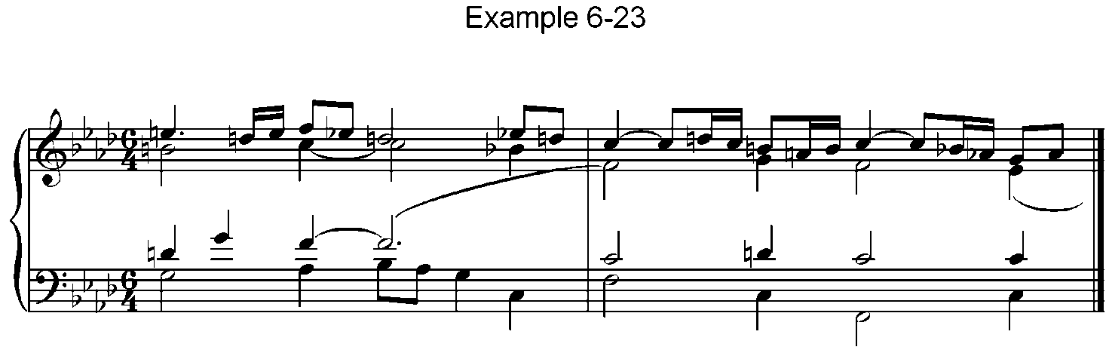

6-24. In Example 6-24, the sign for a closing tie falls between a note and its interval. In order to clarify that the change-of-staff tie sign is "from," dots 4-6 precede that sign in the right hand part.

Example 6-24.

#F4

.>"R'@CR@C\<>*"$]*:."@C*#"

*P@C/+@C$+<K

_>_?9*:*9"@C^\_?'J<IH<>

"N_]R'<K

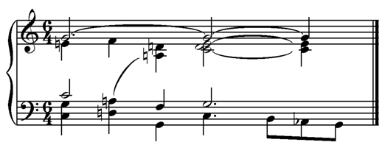

## VII. Tremolos

(Table 7)

7-1. There are two different types of print notation labelled "tremolo" by musicologists. One indicates a repetition of notes or chords; the other indicates alternation between notes of parts of a chord.

### A. Repetition

7-2. Here are the most commonly used signs from Table 7 A for the repetition-type of tremolo:

Example 7-2.



=^b= Repetition in 8ths

=^l= Repetition in 16ths

=^1= Repetition in 32nds

* * *

7-3. When one or more slashes cross the stem of a note, the note is to be divided and repeated as 8ths (one slash), 16ths (two slashes), 32nds (three slashes), etc. For string players this indicates measured, or unmeasured, bowed tremolo; for wind players it may indicate fast tonguing; for percussionists it indicates measured or unmeasured rolls at different speeds; etc.

7-4. The tremolo sign is placed after the note or chord and fingering, if present. The repetition sign may be doubled by repeating the 2nd half of the sign.

7-5. In Example 7-5, the notes have three slashes, so they are to be repeated as 32nds. If the word "tremolo" or its abbreviation appears in print, that text is brailled in addition to the use of the tremolo sign. In that case, the repetition is very fast and unmeasured.

Example 7-5.

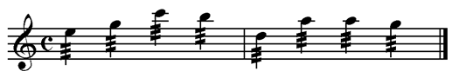.C .$^11\;?W .:[[\^1<K

### B. Alternation

7-6. In keyboard music, the word tremolo usually refers to the alternation of notes or chords. The most commonly used signs from Table 7 B for the alternation-type tremolo are shown below.

Example 7-6.

=.b= Alternation in 8ths

=.l= Alternation in 16ths

=.1= Alternation in 32nds

* * *

7-7. The signs are placed between the notes or chords to be rhythmically alternated. Both members of the unit to be alternated usually have the same note values in print, and this must be accurately reflected in braille. Example 7-7 appears to have too many beats in the measures because the members of each unit have full value as notated in print. Signs for this type of tremolo may not be doubled.

Example 7-7.

#D4

>#L^D-_Y(N'.LR' N'.LR'?.L_[

^)+.L_(<K

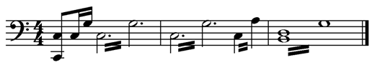

## VIII. Fingering

(Table 8)

### A. Keyboard Instruments

Signs from Table 8 A.

=A= 1 First finger

=B= 2 Second finger

=L= 3 Third finger

=1= 4 Fourth finger

=K= 5 Fifth finger

=C= Between fingering, change of fingers on same note

=,= Omission of first fingering when 2 sets are given

='= Omission of second fingering when 2 sets are given

* * *

8-1. Fingering is placed immediately after the note or interval to which it belongs. If a note is dotted, the fingering is placed after the dot or dots.

8-2. A change of fingers on one note or interval is shown by placing dots 1-4 between the two finger signs. The slur usually appears in print as well as in braille.

Example 8-2.

%%#D4 >/L"?.?KCA;?.?ACK "Y<K

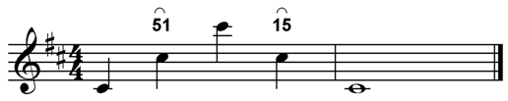

8-3. When the same finger plays two adjacent notes, it is marked after both notes or intervals.

Example 8-3.

#D4 .>.RK#L0B-A/A?L0V<K

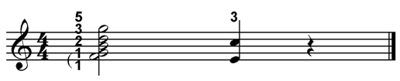

8-4. In keyboard music, alternative fingerings are indicated by placing the two finger signs after the note or interval. The order of these signs is immaterial, but once that order is established, it must be strictly maintained.

8-5. If in such a passage one of the fingerings is omitted for any note(s), its place must be filled by dot 6 for the first fingering or by dot 3 for the second fingering. This applies to keyboard music only.

Example 8-5.

%%#B4

"]BA[AB .:,1]1K ]1L$LB<K

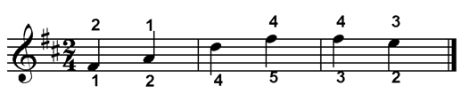

### B. String Instruments

#### 1. Left Hand

Signs from Table 8 B.

=*k= Thumb

=A= 1 First finger

=B= 2 Second finger

=L= 3 Third finger

=1= 4 Fourth finger

=K= 0 Open string

=C= Between fingering, change of fingers on same note

* * *

8-6. Left hand fingering signs are used as explained in paragraphs 8-1 to 8-5 with an important difference. Passages with alternative fingerings must be rewritten with in-accords or variants. See Example 9-57.

8-7. Especially in method books, finger signs are sometimes followed by lines of continuation. These are shown by placing dot 3 after the finger sign at the beginning of such a line. At the end of the line the finger is re-marked after the note, preceded by dot 6. It is because of this use of dots 3 and 6, that when two sets of fingering are given, each set must be rewritten.

Example 8-7.

#D4

;B22"JA'DB'EL'F1EF"

EFE2FE,LD,B T,A^2U<K

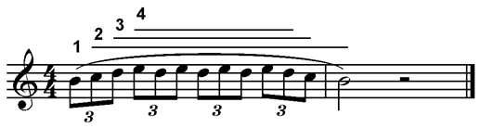

8-8. According to international agreement, thumb signs, like other fingering signs, should follow the note.

Example 8-8.

<<#C4

>+"L'8_Z"GACHLCGA8_=*K"GCHCG"

8_)*K"GCHCG<K

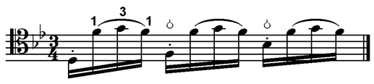

8-9. When the symbol for a thumb is used for another purpose, such as a "Bartok" pizzicato, the braille sign remains the same.

Example 8-9.

#C4

VV.8%.G<I \>59.\*K\*K<K

>59 BEDEUTET EIN STARKES

PIZZICATO1 BEI WELCHEM DIE SAITE AUF ,GRIFFBRETT AUFSCHLAGT4

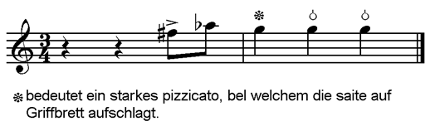

🟔 bedeutet ein starkes pizzicato, bei welchem die saite auf Griffbrett aufschlagt.

#### 2. Right Hand

Signs from Table 8 B.

=P= Thumb **pulgar**

=I= Index finger **indice**

=M= Middle finger **major**

=A= Ring finger **anular**

=C= Other single letters; braille as printed

=X= Little finger **chiquito** if ch is printed

* * *

8-10. Instruments that are plucked, such as guitar and banjo, characteristically indicate right hand fingering with the letters p i m and a. Braille uses the printed letters if the print has one letter per note. In print the letters may appear above or below the notes. In braille the letters are usually placed below the notes. If two letters, such as "ch" for the little finger are printed, the letter "x" is used in braille.

Example 8-10.

%#D4

>/L'*.?A*EB"IAWDA"HK<>_I"FB"

M M I MM I

]L_HL%"EA$B<K

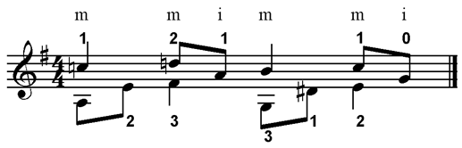

8-11. Rarely, print dots are used instead of letters to represent the "pima" fingering. In that case, letters are used in braille. In Example 8-11, a plus sign represents the "p," one dot above the note equals the "i," two dots represents the "m," etc.

Example 8-11.

#D4

>/L.&D"H.D7=E"I.E7<>"??_]]<K

AM I M P

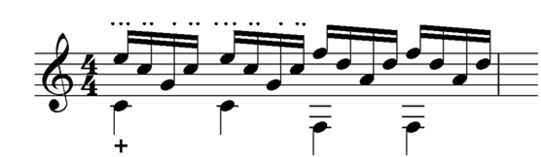

## IX. Bar Lines & Repeats

(Table 9)

### A. Bar Lines

Signs from Table 9 A.

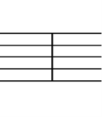

(space) Bar line

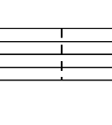=L= Braille bar line for special uses

=K= Dotted bar line

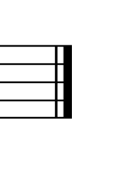=<k= Double bar at end of composition

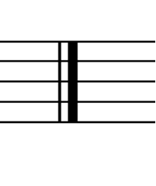=<k'= Double bar at end of bar or section

* * *

9-1. In addition to having a space for a bar line, a tactile bar line, =L= may be used. When a braille character is used for a bar line, it should be preceded and followed by a space. Example 17-14 (b) illustrates its use in guitar music, and Example 12-33 illustrates its use in a theory textbook.

9-2. When a bar line in print has a dotted or dashed line in place of a solid line, dots 1-3 are used as in Example 13-5.

9-3. The first note after a double bar usually has an octave mark.

9-4. If a measure continues after a double bar, the music hyphen follows the double bar.

Example 9-4.

#D4 .>;P.+<K'" X.GFE<K

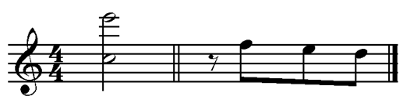

### B. Print Repeats

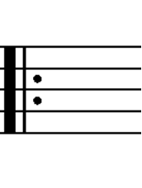Signs from Table 9 B.

=<7=

=<2=Double bar followed by dots; beginning of repeat

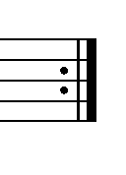

Double bar with dots preceding; end of repeat

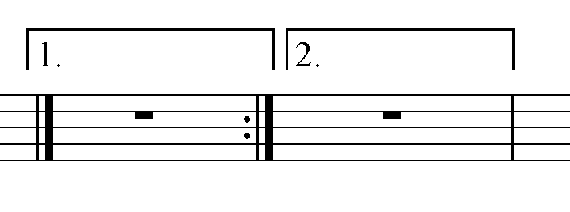=#1 #2= First, second ending (volta)

=+= Print segno sign

=+l= Print coda sign

* * *

9-5. The sign for a dotted double bar indicating the ending of a print repeat is placed without an intervening space after the measure in which it appears. If it occurs in a measure that is afterwards completed on the same braille line, it must be followed by the music hyphen and a space.

9-6. The signs for the beginning of a print repeat and signs for numbered endings are placed without an intervening space before the first sign of the repeated material.

9-7. When additional endings or unusual numberings occur, braille follows the print.

Example 9-7.

#1-3'M<2 #4'M<K

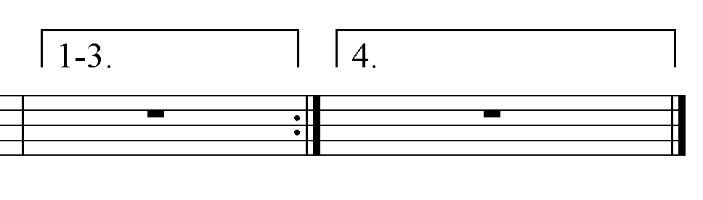

9-8. The first note following any of the above signs must have an octave mark, and the first or second endings signs must be followed by dot 3 before signs containing dots 1, 2, or 3.

9-9. The signs for print segno and coda should appear where they do in print; they are preceded and followed by a space. Exception: in some countries the coda sign is preceded but not followed by a space.

9-10. When the print uses text such as "D.S." or "a la Coda," this must be transcribed exactly as printed.

9-11. Example 9-11 is a typical scenario showing the order in which segno signs generally appear along with double bars usually associated with this type of music.

Example 9-11.

''' + #HM<K' +L #HM>D'S'<K

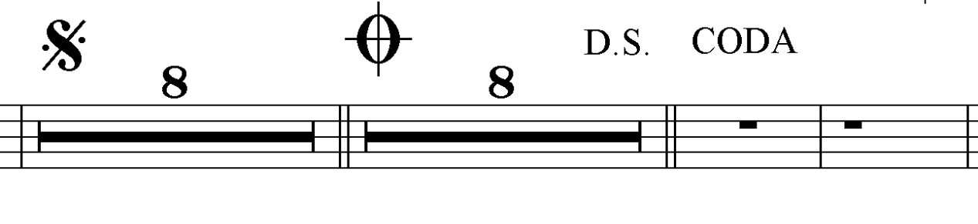>CODA'MM<K

9-12. The next note after a segno passage must have an octave mark, and any doubling in effect must be re-marked if it is to be continued.

9-13. In braille, segnos can be created as a form of repetition. See Par. 9-47.

### C. Braille Repeats

9-14. A major difference between braille music and its print counterpart is the introduction of repeat signs that do not appear in the print. Repeats that are used judiciously can help ease reading, assist memorization and save space.

Signs from Table 9 C.

=7= Full- or part-measure repeat

='= Separation of repeats with different values, i.e., =7'7=

=.7= Repeat beginning in fifth (or other number) octave

=7#d= Repeat four (or other number) times

=*7= Beginning of repeat in cadenza or unmeasured music

=#h#f= Count back and repeat measures

=#d#d= Repeat the last four (or other number) measures

=#d= Repeat the last four (or other number) measures

=#9-16= Repeat specific measures

=#b9-16= Repeat specific measures from a numbered section (i.e. repeat measures 9-16 from Section 2)

* * *

#### 1. Part-measure repeats

9-15. The sign =7= is used to show a repeat within a measure. It applies to what immediately precedes it. Its use involves the exercise of good judgment and musical knowledge.

9-16. In Example 9-17, the repeat sign is used for single notes or chords in differing parts of measures, following musical beats.

9-17. A part-measure repeat must not be the first beat of a measure or the first beat on a new braille line. (The repeat sign cannot be used for the first beat of measure 4 even though it is identical to the last beat of measure 3.)

Example 9-17.

#D4

>/L.D"HIJ7 ??#0:+97 F+"H77"

.=E"H.E =Z"(.ZF'+0&+07E+9X<K

Signifies:

#D4

>/L.D"HIJD"HIJ ??#0:+9:+9

F+"H.F+"H.F+"H.=E"H.E

=Z"(.ZF'+0&+0F'+0&+0E+9X<K



9-18. Repeats should not "cross the beat" except in the most obvious and simple cases. In measure 3 of the example above, the two repeats would have been incorrect had they begun on the second half of the first beat, but the following example is normal and musical in appearance.

Example 9-18.

%#C4

>/L.\--:'H<>X":+7E+

.G'(['H-<>X":/7E/<K

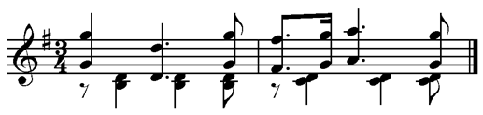

9-19. Two or more repeats following one another are of the same value. When it is desirable to have repeats of different values, they must be separated by dot 3.

Example 9-19.

#D4

>#L^DD9-+77'77 D9-+7'77"

D0/%#7<K

Signifies:

#D4

>#L^DD99--++DDDDDD DDDDDD9-+"

^D0/%#D0/#<K

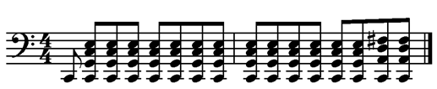

9-20. For Example 9-19, some countries use the following form of repeat within a measure; others reserve this form for a full-measure repeat.

Example 9-20.

#D4

>#L^DD9-+7#F ^D9-+7#E"

^D0/%#7<K

9-21. The use of the slur in combination with the part-measure repeat requires some caution. The following examples should be studied carefully.

9-22. The use of a part measure repeat on the second and fourth beats of the following example would have given the reader incorrect information about the slurs.

Example 9-22.

#D4 "FCHCFCHGCHCGCH<K

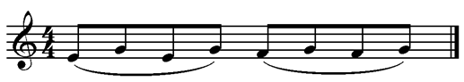

9-23. When slurred as follows, the repeats may be used.

Example 9-23.

#D4 "FCH7GCH7<K

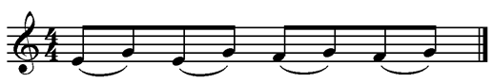

9-24. There are two types of long slurs. Care must be taken that repeats are clear.

Example 9-24.

(a)

#D4

"YCCFHFYFHCFYCCFHF7C ?VU<K

(b)

#D4

;B"YFHFYFHF^2;B7 ?^2VU<K

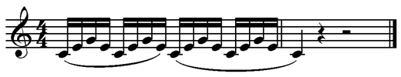

9-25. The next two examples are correct.

Example 9-25.

(a)

#D<#B4

.>.F+7CI+97C F+7CD+7.C D+XV<K

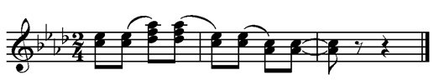

(b)

#D4

"YFCHCFC7C7C7C ?VU<K

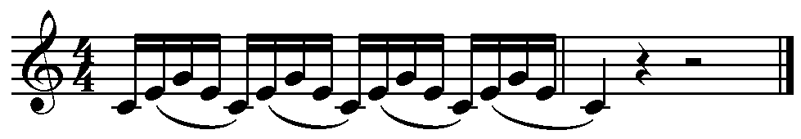

9-26. A repeat does not include a tie on the last note or chord of the passage, so tie signs must be added. In some countries a tie sign is not placed at the end of a measure. It is placed before the first note of the next measure, especially if that measure is on a new line or is separated from the original repeat by an in-accord part. Other countries do place a tie at the end of a measure as in Example 9-35.

Example 9-26.

#D4

.>.YFED@C7@C7@C7<>

"[\%]*] @C.?0VU<K

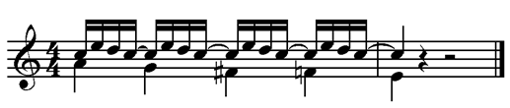

9-27. The part-measure repeat sign may be used for repeating a passage in a different octave from the original. The octave mark at the beginning of the repeated passage is used, even if part of the notes are in a different octave. It is placed immediately before the repeat sign.

Example 9-27.

#D4

"YFHJ.7;YIHF.7 "?VU<K

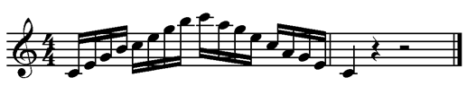

9-28. Care must be taken in the doubling of intervals, etc. in connection with repeats.

Example 9-28.

#D4

>/L"&++GHG+77!0EH0G+ &+<K

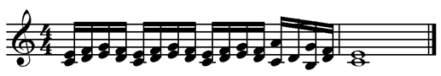

9-29. Doubling may be continued through a repeat if it is still in effect afterwards. In Example 9-28, the doubling ended with the repeat, so it ended in braille before the repeat sign.

9-30. Care must also be taken with nuances and other details. The second beat of the following example should not be written as a repeat.

Example 9-30.

#D4

>SF.YIHJYIHJ77 NU<K

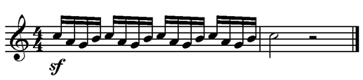

9-31. When part of a measure is fingered and is followed immediately by an exact repetition without fingering, the repeat sign may be used.

Example 9-31.

#D4 "YAEBFLG1(KGFE7<K

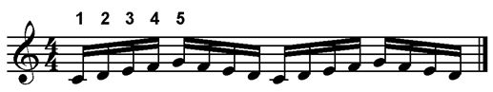

9-32. The repetition of passages in cadenzas or unmeasured music is made possible by the use of the sign, =*7=. It is placed before the first note of the passage to be repeated. That sign is not actually a repeat sign. It is used to identify the beginning of a fragment that will be repeated. The dotted half note chords in Example 9-32 are tied over to the next measure.

Example 9-32.

#E<

.>;B*.;T'+93.C,<1TRPN"

*7_>'*..T.>.RPN"7_7"

_>'*^T*7R.>'*^T*OQ_7"7.7<K

_>'*_R'+9%3.C<K

Signifies:

#E<

.>;B*.;T'+93.C,<1TRPN"

_>'*..T.>.RPN_>'*"T.>"RPN"

_>'*_T.>_RPN_>'*^TR.>'*^T"

*OQ_>_R.>'*_T*OQ_>"R"

.>'*"T*OQ_>.R.>'*.T*OQ<K

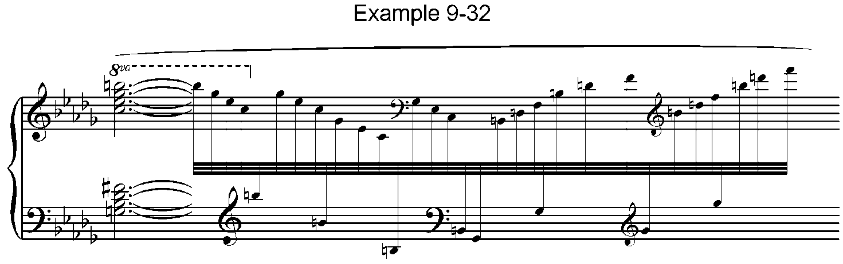_>'*_R'+9%3.C<K

#### 2. Full-measure repeats

9-33. The =7= sign may also be used for the repetition of a complete measure. In this case, it is brailled with a blank space on either side. The rules for part-measure repeats apply in general when the full-measure repeat is used. The following examples illustrate the main points.

9-34. In Example 9-34 both forms of the long slur are shown.

Example 9-34

(a)

#D4 "DCCEFGHGFCE 7 7 NU<K

(b)

#D4 ;B"DEFGHGFE^2 7 7 NU<K

Signifies:

#D4 "DCCEFGHGFCE DCCEFGHGFCE

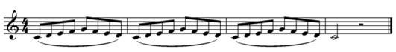"DCCEFGHGFCE NU<K

9-35. Repeats with single-note and chord ties are illustrated below. In the longer illustrations the initial notes of runover lines may or may not start with octave marks. Different format practices are illustrated throughout this manual.

Example 9-35.

#D4

>#L_?\$?@C 7@C ?VU $"?_\$@C

7 ]VU !+0.C 7 \#0VR#0.C 7.C

R#0R+9<K

Signifies:

#D4

>#L_?\$?@C ?\$?@C ?VU

$"?_\$@C $"?_\$ ]VU !+0.C

!+0 \#0VR#0.C \#0VR#0.C

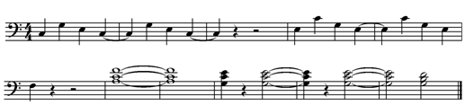R#0R+9<K

9-36. When a measure is repeated three or more times, the appropriate number, with numeral prefix, follows the repeat sign without an intervening space. The first note after a numeral sign usually has an octave mark.

Example 9-36

(a)

#C8 ;B.E<FD 7#D^2<K

Signifies:

#C8

;B.E<FD E<FD E<FD E<Fd

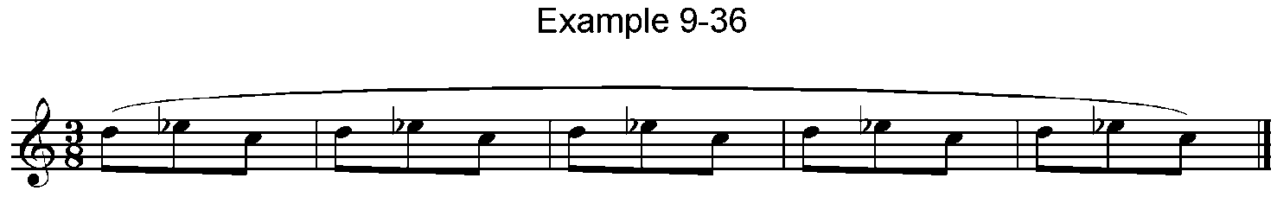E<FD^2<K

(b)

%%#C8

.>.:'0- .C7#C .C.E0-XX<K

Signifies:

%%#C8

.>.:'0-.C 7.C 7.C 7.C

 E0-XX<K

9-37. The full-measure repeat may be used with an in-accord as long as the repetition stays in the same voice.

Example 9-37.

#B4

>/L.FE%DE<>"R+ .E*DJD<>7

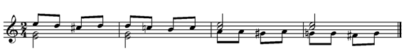.P+<>"II%HI 7<>*"HH%GH<K

9-38. Another method of repeating one or more measures consists of writing two numbers together between blank spaces, the first showing how many measures must be counted back and the second showing how many of those measures are to be repeated.

9-39. If the two numbers are identical, some countries write only one number. However, if the time signature of the piece consists of only one number, it is recommended that two identical numbers be used for the repeat rather than a single number that could be interpreted as a change of time signature.

9-40. The first note following this type of repeat must have an octave mark.

Example 9-40.

%#D4

"\'G$\ ['H]: P]'G ( #D#D<K



9-41. This repeat may be combined with the slur as long as the phrasing is completely clear.

Example 9-41.

(a)

#C4

.?CC"\.?@C ?JIW #B#A@C

.?JICW<K

(b)

#C4

;B.?"\.?@C ?JIW #B^2<K

Signifies:

#C4

;B.?"\.?@C ?JIW ?"\.?@C

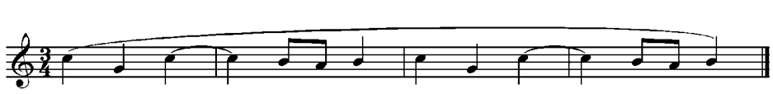?JIW^2<K

9-42. When measures are numbered in the braille text or in the print, those numbers can effectively be used for repeats. The numbers of the first and last measures of the passage to be repeated, preceded by the numeral prefix and separated by a hyphen are written as follows:

#1-8

9-43. The first note after a repeat with a numeral prefix must have an octave mark.

9-44. In the course of a piece, if some bars are repeated in a higher or lower octave, the numbers indicating this repetition are written, preceded by the octave mark in which the repetition starts.

.#1-8

9-45. Similarly, if several bars are to be repeated with a different expression mark, the numbers indicating the repetition are preceded by the characters indicating the dynamic change. Double bars or dotted double bars may also be added to repeats of various types.

>F'#1-8

9-46. A common form of repeat in music written by sections consists of a section number followed immediately by measure numbers in the lower-cell position. The example indicates a repeat of measures 9-12 in the second section of the transcription.

#B9-12

#### 3. Braille Segno

More signs from Table 9 C.

=+a= Braille segno A (or B, etc.)

="+a= Repeat back to segno A (or B, etc.)

=*= End of segno music to be repeated

=+l= Coda sign

=-= Parallel motion

=-= Sequence: Continue pattern

* * *

9-47. Another form of repeat that is useful when the section to be repeated is at some distance from the original passage is a braille segno. The music is analyzed and treated as if segno signs appeared in print. A braille segno sign that includes a letter such as A, B, or C is placed at the beginning of the passage to be repeated. The letters reflect a position as the first, second, third, etc., segno in the piece. The end of the passage to be repeated is shown by dots 1-6, =*=, and is followed by a space.

9-48. At the point of repetition, the sign, ="+=, (with its appropriate letter) is used. This sign is sometimes followed without an intervening space by a number showing the number of measures to be repeated.

9-49. The next note after a segno passage must have an octave mark, and all doubling must be re-marked.

Example 9-49.

%#C4

": +A "\W: W\\ [DJIH ]::

\JIHG $?$ :\]* "RJD :"

JDEF :?W ?IJDE ?W[ WHIJD

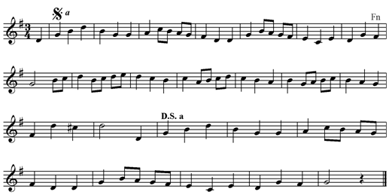W[\ ].:%? O": "+A "RV<K

#### 4. Parallel Motion

9-50. In keyboard music when one hand moves parallel with the other at the distance of one or more octaves, the writing of the second part may be abbreviated by substituting for its notes a single octave interval (with an appropriate octave mark where the two hands are more than one octave apart). This device may also be used in a score when one part moves parallel to another.

Example 9-50.

%%_C

.>'"W#0:+9:#:+9<K

_>'-<K

Signifies:

%%_C

.>"W#0:+9:#:+9<K

_>_:+0\+9[#\+9<K

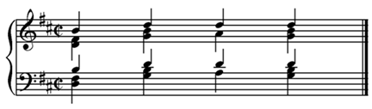

9-51. When parallel motion extends over more than two measures, the octave interval is followed without intervening space by a number, with numeral prefix, indicating the number of measures contained in the passage.

Example 9-51.

<<#D4

.>'>#K_N@CDF<IJ >/L"D<I"FJ.7

;D.HJ<I\%GX X%GHG%FG2IH<F

F'Z2GFE:V<K

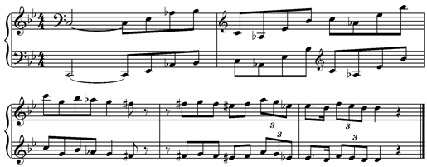 _>'-#E<K

#### 5. Sequence Abbreviation

9-52. In technical studies where a melodic figure is repeated sequentially many times, it is possible to abbreviate the passage in braille by use of the sign with dots 3-6,

=-=. The figure to be abbreviated is written once or twice. For succeeding figures, only the first note is written, and it is followed by this sign.

Example 9-52.

#D4 "YEFDZ-&-=-<K

Signifies:

#D4 "YEFDZFGE&GHF=HIG<K

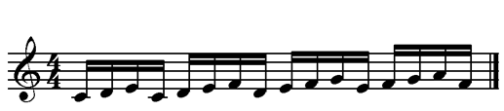

9-53. The repetition must be exact with no modifications of fingering, accidentals, etc. It is generally restricted to technical studies and should be used only where correct execution is absolutely clear.

### D. Variants

Signs from Table 9 D.

=5= Variant of measure (sign precedes and follows)

=5#b= Variant of two (or other number) measures

=#b5= Second (or other number) variant of measure

=#a5#c= Numbered variant, followed by number of measures (i.e., Variant 1, for 3 measures)

* * *

9-54. When an alternate passage is provided in the print music, it can be placed as a footnote on the braille page or (in the case of very short passages) it can be joined to the measure with the in-accord sign.

9-55. Especially for longer passages, variant signs may be used. The variant sign =5= is preceded by a space or a number and is followed by the number of measures in that variant. No space is left between the variant sign and the music. The first note of each variant must have an octave mark. Each variant ends with an unspaced variant sign =5=. The first note of the music following the variant(s) must also have an octave mark.

Example 9-55.

#D% _C

"FCDFCD_HC"DFCD ECJECJHCJ"

ECJ 5#B2.FD"H2FD_H2^H_H"D"

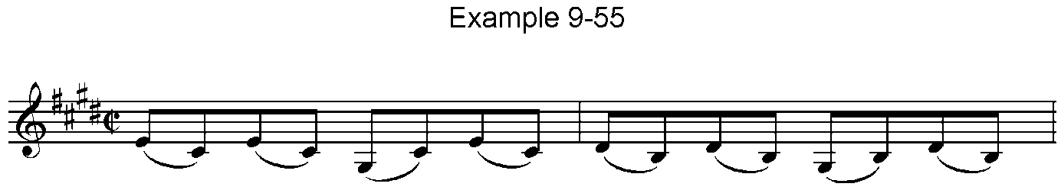&H.DF 2EJH2EJH2^H_HJZHJE5

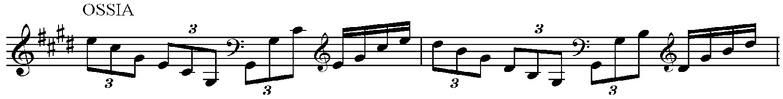

9-56. If there are two or more variants, these are numbered preceding the variant sign. If a passage had three variants they would be preceded respectively by the following signs.

Example 9-56.

#A5#B #B5#B #C5#B

9-57. In Example 9-57 four sets of fingering are to be practiced with the same notes. There are three numbered variants in addition to the original, and each is two measures long.

Example 9-57.

#D4 "?A<:B?A*:B ?A<$B?A*$B

#A5#B"?B<:L?B*:L ?B<$L?B*$L5

#B5#B"?L<:1?L*:1 ?L<$1?L*$15

#C5#B"?1<:K?1*:K ?1<$K?1*$K5<K

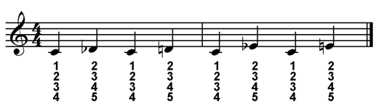

9-58. If the alternate or variation appears in small print, the small-type sign, =,5= (Table 1) should be used.

## X. Nuances

(Table 10)

10-1. Text and symbols are used to add expression to music. When words or abbreviations appear, they should be transcribed as text rather than substituting symbols. The braille should not contain contractions.

10-2. Literary material is always preceded by a word sign, =>=. This includes single letters, abbreviations, whole words and groups of words.

10-3. Dynamics and abbreviations are preceded by the word sign and placed without any intervening spaces where they occur in the music. The first note following such nuances must have an octave mark.

10-4. Dot 3 represents the period or dot following an abbreviation. Dynamics such as p or f are followed by dot 3 if the next sign contains dots 1, 2, or 3. If two dynamics follow each other, each must have its word sign, but dot 3 is not necessary between them unless it represents a period.

i.e., =>P>C'=

10-5. The opening signs for crescendo or decrescendo when printed as diverging or converging lines are placed before the affected notes. The closing signs are placed after notes where termination occurs (and after all other signs normally following those notes). See Example 10-17.

10-6. The ending signs should not be included if another dynamic follows immediately.

10-7. For indications of one or two words, use a word sign before every word or abbreviation. Do not leave a space before or after a single word or a short group.

Example 10-7.

"?DD>A>TEMPO"DD?<K

10-8. For longer literary indications, the word sign is placed before the first of the group of words and after the last. This is followed by a space, and the next note must have an octave mark.

10-9. When longer literary expressions start within a measure, the measure is interrupted with a music hyphen followed by a space. It resumes after the space that follows the final word sign.

Example 10-9.

"?DD" >POCO A POCO CR'> "?<K

10-10. When there are no parentheses in print, there should be no parentheses in braille. When parentheses do occur, they follow the word sign in braille, i.e., =>7DOLCE7= (dolce).

10-11. The signs in Table 10 are given common names, but other terms are used for the same print symbols, i.e., the dot may indicate spiccato; the short line may indicate louré or tenuto, etc. The descriptions in the parentheses are more dependable than the names.

Signs from Table 10.

=8= Staccato (dot)

=,8= Staccatissimo (pear-shaped dot)

="8= Mezzo-staccato (dot & line)

=_8= Agogic accent (short line)

=.8= Accent (horizontal “V” pointing to the right)

=@8= Reversed accent (horizontal “V” pointing to the left)

=;8= Martellato (thick “V”)

* * *

10-12. An octave mark is not required for the note following one of these articulations. When a nuance begins with a word sign, i.e. , =>C=, an octave mark is required for the next note.

10-13. Expression marks represented by symbols that appear directly above or below notes in print are usually placed before the notes in braille. The exceptions are the fermata signs; they follow the note. Most of the signs may be doubled if they apply to four or more notes in succession. Music commas, fermatas and swells may not be doubled.

10-14. Example 10-14 shows doubled staccatos with in-accords. These signs affect only the in-accords where they appear. In some formats doubling may continue from one measure to another if it continues in the same in-accord part.

Example 10-14.

#C4

>/L'VX.HC%GCH 8[\*] 8$8:8?<>

VX"FCECF "T'<>88"]:\

.N'<>"$:8?<K

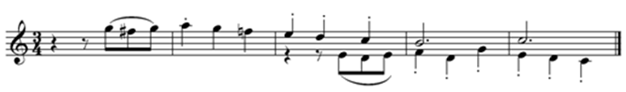

10-15. When two or more signs are combined, an order similar to that in the next example is recommended:

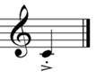Example 10-15.

>/L'8.8"?<K

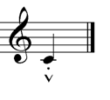

>/L'8;8"?<K

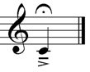

>/L.8_8"?<L<K

More signs from Table 10.

=''= Beginning of first line of continuation

=>'= End of first line of continuation

=--= Beginning of second line of continuation

=>-= End of second line of continuation

* * *

10-16. The next note following the beginning or ending of a line of continuation must have an octave mark.

10-17. The next two examples illustrate a variety of dynamics as well as lines of continuation.

Example 10-17

(a)

#D<#D4

>C"[[ W>3'*"EFGFIJ N>C.??

*.:>3'%"GH>CRESC'"IH.DE

>C'*.P>F.]>D'<.F'>DIM'<.Z

.:?:D') W[\I'( >PIU>P"\"

"\\I'(<K

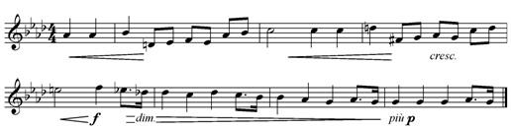

(b)

#D4

>RIT' E DIM''> .?JI\$

"Q>PERDENDOSI--":'J>'

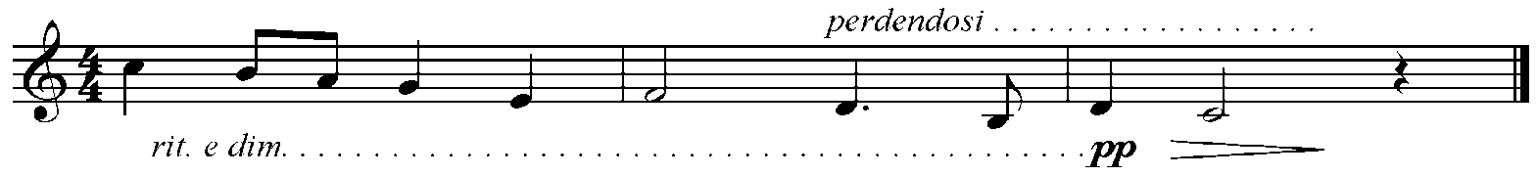>PP>D":N>-V<K

10-18. Dynamics and words of expression are generally placed in the right hand part of keyboard music unless they specifically apply to the left hand.

10-19. When dynamics occur during the course of sustained notes, an in-accord is used in braille to reflect the changes accurately.

Example 10-19.

#D4 >P>C_Y<>"U>F"U<K

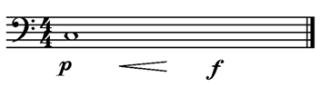

10-20. Repeats may be used with nuances if the change of nuance is clearly indicated.

Example 10-20.

#D4 >F"YEFG(IJD>P'7<K

Signifies:

#D4 >F"YEFG(IJD>P"YEFG(IJD<K

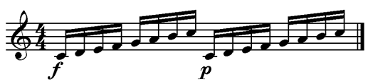

## XI. Ornaments

(Table 11)

Table 11

=6=  Trill [It. trillo; F. cadence, tremblement; G. Triller; Sp. trino]

="5=  Appoggiatura [It.] [F. port de voix; G. Vorschlag; Sp. apoyadura]

=5=  Short appoggiatura [formerly: grace note]

=4=  Turn [It. fioritura; F. double, cadence, double cadence; G. Doppelschlag; Sp. grupito] between notes

=,4=  Turn above or below a note

=4l=  Inverted turn between notes

=,4l=  Inverted turn above or below a note

=,=  Before an accidental, inflected lower note of ornament. Ex. = ,%4 ,*4=

="6=  Short trill [short shake, pralltriller, inverted, i.e., upper, mordent]

=;6=  Extended short trill, shake or pralltriller

="6l=  Mordent [It. mordente; F. mordant (pincé, pincement); Sp. mordiente]

=;6l=  Extended mordent

=>k= Arpeggio up

=">k=  Upward arpeggio through two or more staves

=>kk= Arpeggio down

=">kk=  Downward arpeggio through two or more staves

=@8888=  Bebung

* * *

11-1. Ornaments are placed before the notes or intervals to which they apply. No special octave mark is required for such notes.

11-2. In Table 11, ornament names are given in several languages to aid recognition. The braille signs refer to the print symbols that appear in the print edition of this manual. Performers should be aware of multiple possibilities, and transcribers should include all information regarding meaning and/or performance that may be included in print. During the Baroque period and the years since that time, different composers have given different names to the same ornaments, different ornaments have been given the same names, and there is little agreement concerning specific performance details. For example, the "New Grove" *1 shows the print symbol for a trill (dots 2-3-5) with the following definitions, each followed by its "Guide to Use or Source".

[*1 The New Grove Dictionary of Music and Musicians (London: MacMillan Press Limited, 1980), Vol.13, p. 863.]

1. Trill; Ubiquitous Fr. and Ger. from 17th century: the correct usage
2. Double mordent; Loulié
3. Appoggiatura-prepared lower mordent; ?Locke, Purcell
4. Prepared trill; L’Affilard
5. Ascending trill; Gottlieb Muffat
6. Vibrato; Mace

(g) Tremolo; L’Affilard

Each of the following examples in Chapter XI illustrates the first, (a), listing by the "New Grove".

11-3. For the sign =6=, most performers will use the ubiquitous meaning, trill, but performances will vary according to the tempo, the style of the music, and other factors. The print symbol does not indicate whether the trill is prepared or whether it ends with a turn; performers may include those features if appropriate.

11-4. If two notes of a chord are to be trilled, both notes must be so marked.

Example 11-4.

#B4 6.P6+<K

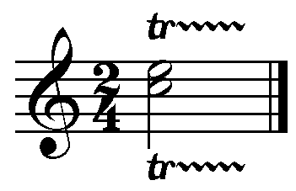

11-5. When only one trill symbol appears, followed by a wavy line across several notes, a line of continuation (Table 10) may be used as in Example 11-5.

Example 11-5.

#B4

6''.N@C >D'7@C 7@C >PP'7>'

@C.N<L<K

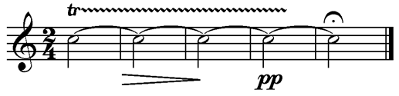

11-6. The most common print symbol for appoggiatura in modern editions is a note printed in very small type. When this small note has an oblique stroke through its stem, a very quick, short appoggiatura is indicated. Two or more appoggiaturas before a normal note must also be executed quickly.

Example 11-6.

#D4 5")C5YC5ZCN5GC$V<K

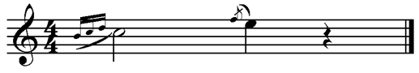

11-7. When an appoggiatura does not have the stroke or is not part of a group, the normal sign for appoggiatura should be used. The length of the ornament will depend upon the style of the music.

Example 11-7.

%%#D4

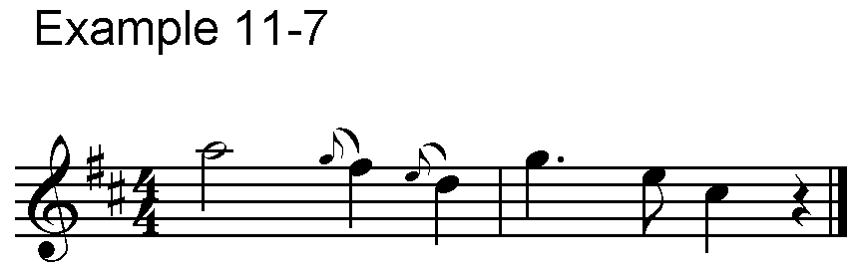.S"5H;C]"5F;C: \'F?V<K

11-8. If possible, appoggiaturas are written on the same line as the notes which they embellish. The sign for a short appoggiatura may be doubled.

Example 11-8.

#D%#C4

;B"T'55%Y)%!5)^2 .FC*E"

.EC%DDCJ<K

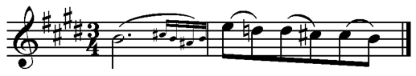

11-9. In each of the next examples, an ornament is followed by the realization or effect of that ornament sign. Exact rhythmic details may vary according to the musical style. These examples are provided by Association Valentin Haüy pour le Bien des Aveugles, Paris. Example 11-9 shows a turn between two notes in print. In braille the turn sign precedes the first of the two notes.

Example 11-9.

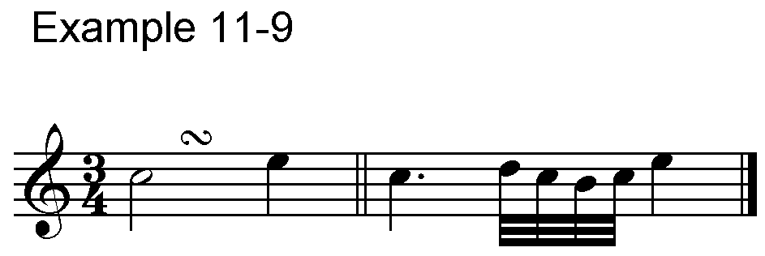#C4 4.N$<K' .?'ONTN$<K

11-10. In Example 11-10, the dot 6 preceding the turn sign indicates that the turn sign appears directly above a note in print. In braille, the sign precedes that note.

Example 11-10.

#B4 ,4.?$<K' .ZDJD$<K

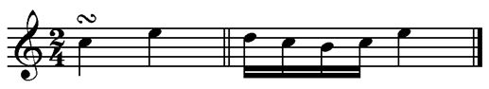

11-11. When dots 1-2-3 follow the turn sign, an inverted turn, =4L=, is indicated. Example 11-11 (a) shows the sign between two notes in print, and (b) shows it directly above a note.

Example 11-11.

(a)

#C4 4L.N$<K' .?'TNON$<K

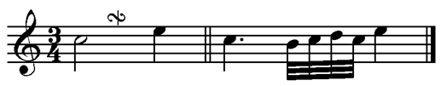

(b)

#B4 ,4L.?$<K' ")DED$<K

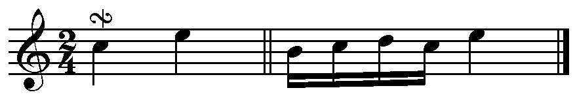

11-12. Accidentals printed above or below an ornament symbol precede that sign in braille. If the accidental appears below the symbol in print, it is preceded by dot 6 in braille. Example 11-12 (a) shows a sharp for the lower note of the turn, and (b) indicates accidentals for both of the auxiliary notes. This method of marking accidentals applies to any type of ornament.

Example 11-12.

(a)

#d4 ,%4"R.?V<K' "\'SR%QR.?V<K

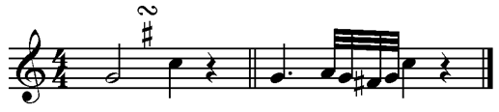

(b)

#d4 <,%4"R.?V<K' "\'<SR%QR.?V<K

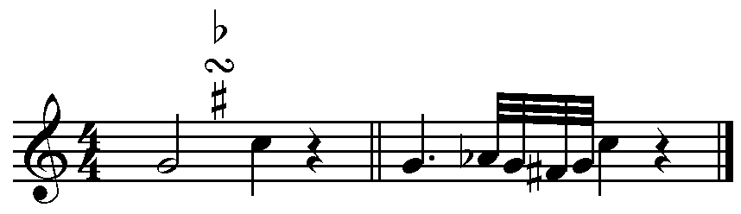

11-13. Trills are usually indicated in print with letters such as "tr" or a wavy line with "v-shaped" points. A very short wavy line with only two or three "v’s" was called an upper mordent in some earlier braille manuals. That name is now called "a misappropriation". *2 The ubiquitous name for the ornament is **trill**. This is not a continuous trill as with dots 2-3-5. It uses the upper auxiliary note once or twice and is executed quickly.

[*2 **Ibid.** 13:864.]

Example 11-13.

#B4 "6.?V<K' .NOD'V<K

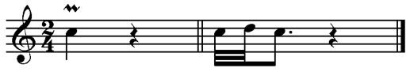

11-14. The sign =;6= indicates an extended short trill or short shake. As with all ornaments, the exact speed and rhythmic combination varies with the performer’s interpretation after considering the composer and the period of the composition.

11-15. The print symbol for a mordent is the same as the print symbol for a short trill with the addition of a short, vertical or diagonal line through it. In the execution of a mordent, as in (a), the lower auxiliary note is played once or twice. For an extended mordent, as in (b), the lower auxiliary is played a few more times.

Example 11-15.

(a)

#B4 "6L.?V<K' .NTD'V<K

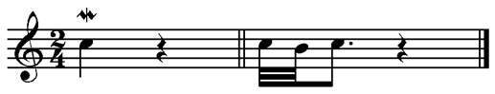

(b)

#B4 ;6L.?V<K' .NTNTDV<K

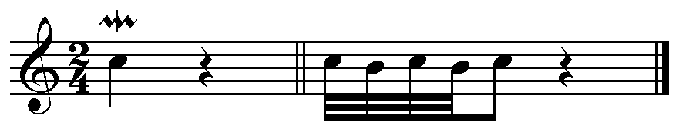

11-16. When fingering appears with an ornament, the ornament sign is placed before the note or interval and the fingering follows immediately after it.

Example 11-16.

#D4

.>'6"RL1L+@C5%=5(.?0V

,%,4W1LB+:*0"\+V<K

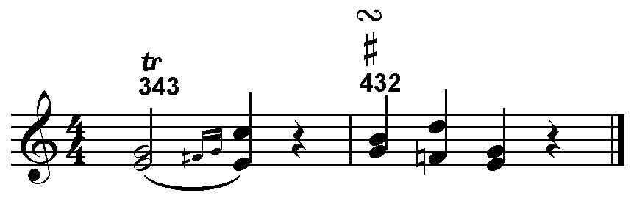

11-17. Interval doubling may be used with ornaments providing the doubling continues through the ornament.

Example 11-17.

#B4 .>.Y++EDE5Y5ZFZY+<K

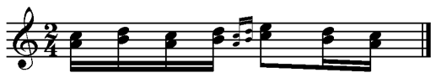

11-18. The doubling must be stopped for the short appoggiatura in Example 11-18.

Example 11-18.

%#C8

.>.Z++).FE+ 5EY++)DE+<K

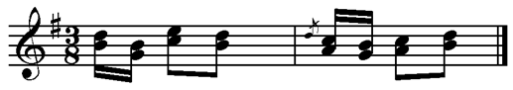

11-19. Some print symbols indicate a combination of ornaments such as a trill with a circular twist at the end to indicate a turn or an inverted turn. In this case a combination of braille signs may be used. A trill sign followed by the appropriate turn can convey appropriate information to the braille reader.

11-20. The arpeggio up sign, =>K=, is placed before a chord in one part. When an in-accord is necessary, the sign appears before all notes or chords that are part of the arpeggiated chord. When the arpeggio extends through more than one part, the sign =">K= is used before notes or chords in all parts affected. Also see Examples 17-36 and 17-37.

Example 11-20.

<<#B4

.>">K.?/9?+9<>">K"D*E<$<K

_>">K^]93]93<>">K_]GH<K

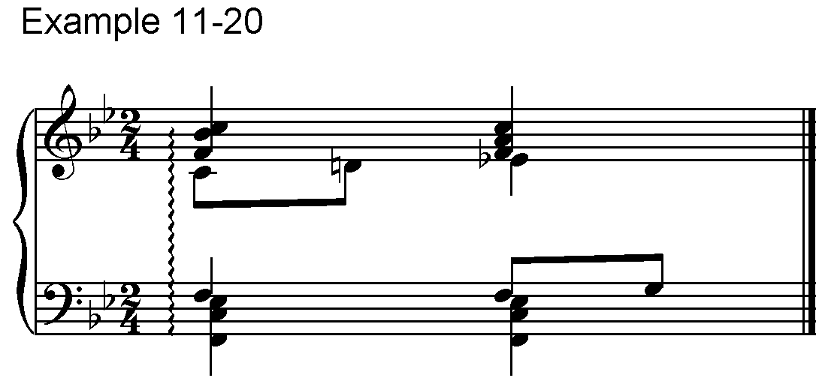

11-21. The number of dots (staccatos) in the braille bebung should equal the number of printed dots in that ornament.

## XII.Theory

(Table 12)

12-1. The international decision to follow print, putting text material into braille text rather than braille signs, has enabled general agreement on theory notation. This agreement is particularly helpful when blind and sighted musicians are studying or working together.

### A. Chord Symbols

12-2. Many types of music publications from hymns to general song books to fake books (words only) and other popular music now include chord symbols as a routine practice. Some of these are very simple indications such as "G" or "D7" and others are very complex. Most can be written in literary braille with the addition of music signs for pitch alteration and the following signs from Table 12 A that have international approval.

Example 12-2.

=3>= Prefix for a chord symbol part

=4= Small circle

=4'= Small circle bisected by a line

=0= Small triangle

=0'= Small triangle bisected by a line

=.#g= Italicized 7 for a specialized seventh chord

* * *

12-3. The signs for plus, minus, parentheses, oblique stroke, capital and lower case letters, and italics are part of the literary code of each country and should be listed in each publication. Those used in this publication are shown below:

Example 12-3.

=/= Oblique stroke /

=7 7= Parentheses ()

=+= Plus sign +

=-= Minus sign or literary hyphen -

=;= Lower case letter d

=,= Capital letter D

* * *

12-4. The standard music signs are used for accidentals; dot 3 is used for periods.

12-5. Numbers are preceded by the numeral sign and written in normal, upper-cell position. If printed vertically, the numerals are brailled from lowest to highest.

12-6. The following is a representative list of possible chord symbols using the international signs.

Example 12-6.

Dm =,dm=

Dmaj7 =,dmaj#g=

Fdim7 =,f%dim#g=

F°7 =,f%4#g=

C7sus =,c#gsus=

Dm(7) =,dm7%#g7=

B7-9 =,b#g-#i=

Gmaj7+9 =,gmaj#g+#i=

C 7 =,c0#g=

C 7 =,c0'#g=

G6/D =,g#f/,d=

* * *

12-7. In bar-over-bar formats, chord symbols are aligned beneath the text lines or beneath the music. No prefix is used; the placement is enough to identify these as chord symbols. Example 12-7 shows popular or folk music when song text is given only with chord symbols in a "lead sheet" for use with guitar, other plucked instruments or improvised on a keyboard. In print, the chord symbols are aligned above the text; in braille they are aligned below.

Example 12-7.

,HAPPY BIRTHDAY TO YOU1

,F ,C#G

HAPPY BIRTHDAY TO YOU4

,F

**F C7 F**

Happy birthday to you, happy birthday to you.

12-8. When a melody is also provided, it is added as a third line to the parallel. Some countries always place the text above the melody; others place it below. When chord symbols are aligned with text, the text is spaced, if necessary, to accommodate the chord alignment. Example 12-8 (a) has the text above and (b) has the text below the melody. In both cases, the chord symbols are aligned with the text. In (a), dots 3-6 are added as a filler for spaces in the text, but they are not filled in (b). Neither version fills spaces between chord symbols. At least one space must be left between each chord symbol.

Example 12-8.

(a)

<#C4

,HOW CAN --- ,I EVER

,F ,FMAJ#G ,F#G ,B<

"??? :]"

FORGET YOU1

,F

"W S' Q'<K

(b)

<#C4

"??? :]"

;2 ,HOW CAN ,I EVER

,F ,FMAJ#G ,F#G ,B<

"W S' Q'<K

;2 FORGET YOU1

,F

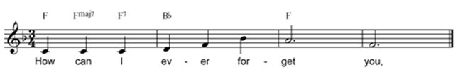

12-9. When chord symbols are aligned with the text, it is also possible to indicate chords that precede or follow a word. This is done by placing the chord symbol at least 2 cells to the left of a word or one cell to the right. Punctuation is ignored when counting spaces after a word.

Example 12-9.

,ALL THROUGH THE NIGHT4 ,WHEN

,G#G ,C ,B#G ,EM

"T?: Y U"\<K

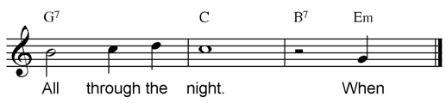

12-10. When chord symbols are placed below the melody, they may be aligned with specific notes or with the beginnings of the appropriate measures. In Example 12-10 the chord symbols are aligned at the beginning of the measures, and a space is left between each chord symbol.

Example 12-10.

,ALL ALONE1 ,I'M ALL ALONE2

% .D:J@CWW IWH@C\V<K

,D#G ,G ,B#G ,EM

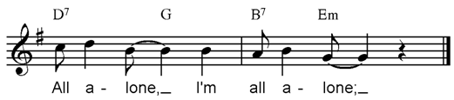

12-11. If chord symbols are included with the piano accompaniment, they are placed below the left hand part and are usually aligned with beginnings of measures. The "tracker" dots (dot 3) below are part of the bar-over-bar formats only.

Example 12-11.

%_C

.>_J'Y%D'ZF'*YG'0Z R0U<K

_>^H'!%I')?: ''''' ^\E@H@C\V<K

,G ,C ,D#G ,G

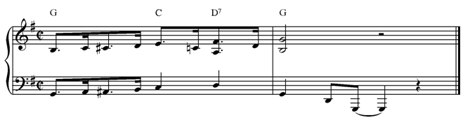

12-12. The chord symbol prefix is used in section-by-section formats. Example 12-12 is the same music as 12-11. In (a), the literary symbols are placed in the chord symbol part after the prefix =3>=. There are no spaces between chords; a space is a bar line. Stem signs may follow chord symbols to show value when the chords do not have the same time value. Signs for repeats, prima and seconda volta, etc. may be used as usual. Rests (preceded by dot 5) can be used to show measures or beginnings of measures with no chord symbols. In (b) the bass line is repeated after each chord symbol in order to show exact location.

Example 12-12.

(a)

%_C

.>_J'Y%D'ZF'*YG'0Z R0U<K

_>^H'!%I')?: ^\E@H@C\V<K

3>,G_K,C,D#G ,G<K

(b)

%_C

.>_J'Y%D'ZF'*YG'0Z R0U<K

_>^H'!%I')?: ^\E@H@C\V<K

3>'>,G^H'!%I')>,C_?"

>,D#G_: >,G^\E@H@C\V<K

12-13. Other local or national methods may be used to indicate note value with chord symbols.

12-14. Some print symbols, such as the small circle (diminished) and small circle with a line through it (half-diminished), have standard meanings. Others have different meanings in different publications; i.e., the small triangle and the italicized 7 have been used to indicate major sevenths and also diminished sevenths according to different composers. All explanatory material will, of course, be included in the transcription. In examples (a) and (b) below, the symbols are used to indicate major seventh chords. In both cases, the meaning of the chord symbol was explained at the beginning of the print publication. The prefix from Table 15 for the right hand part when intervals read up is used in these examples. In 12-14 (b), the "notes" are merely an indication of rhythm for a jazz guitarist.

Example 12-14. (Intervals read up)

(a)

.C

.>>_[+0 <[/0 R+90<K

_> _: ^\ _N<K

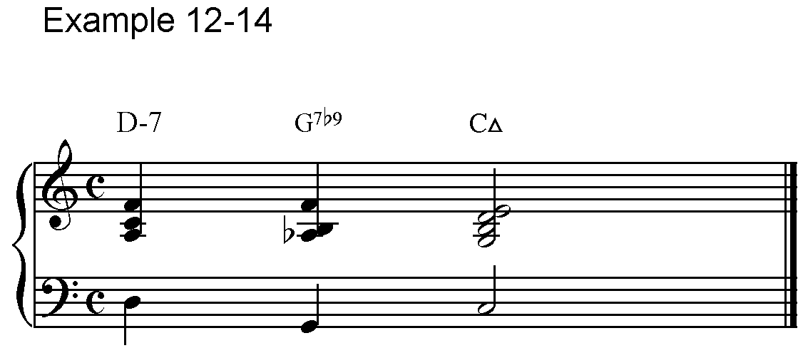 ,D-#G ,G#G<#I ,C0

(b)

#AB8

"JJJJJJ" W'V'<K

,GM ,C#G ,F.#G

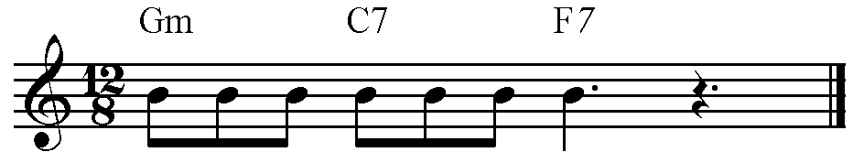

### B. Figured Bass and Harmonic Analysis

Signs from Table 12 B.

=;>= Prefix for a figured bass part

=#6 #35= Numbers

=#%k #<k= Isolated accidentals

=#'= Omitted figure in a string of figures

=#a= A line of continuation

=#aa= Two lines of continuation

=#;6= Figure (any number) that is crossed in print

=#/= Oblique stroke

=-= Separation of signs

* * *

#### 1. Figured Bass

12-15. Figured bass consists of numbers, accidentals and other "figures" printed beneath specific notes in vertical columns. In braille, the figures follow the specific notes. A number sign must indicate the beginning of every column of figures, even if the "figure" is an accidental, an oblique stroke, or other feature.

12-16. Numbers are written in the lower part of the cell.

12-17. The lowest figure of a column, in terms of placement in print rather than numerical sequence, is placed first after a note and is followed by the succeeding figures reading upwards.

12-18. Accidentals precede figures to which they apply.

12-19. An isolated accidental (indicating inflected third) is followed by dots 1-3 except at the end of a bar.

12-20. A figure that is "crossed" (indicating that it is raised) is preceded by dots 5-6.

12-21. In a string of figures, an omitted figure is represented by dot 3.

12-22. When more than one column of figures appears under a single bass note, each column begins with a number sign in braille. Example 12-22 illustrates the features listed in paragraphs 12-15 through 12-21. Version (a) is in section format; version (b) is bar-over-bar. Some countries who use section format write the left hand notes with the figured bass as in (b) of this example, rather than writing a separate left-hand part as in (a).

Example 12-22.

(a)

<<.C

#18-19 .>'*"WECJN<><"[\\[<>

"]]$'E .?C*WN<>"R#R+<K

_>_ECD*JCH_?] HCGCH^H_N<K

;>_E#<5;6D*J#56H_?]#<K57#''6

H#45GH#*K^H_N<K

(b)

<<.C

AH .>'*"WECJN<><"[\\[<>"]]$'E

;>'_EC#<5;6D*JC#56H_?"

_]#<K57#''6

AI .>.?C*WN<>"R#R+<K

;>_HC#45GCH#*K^H_N<K

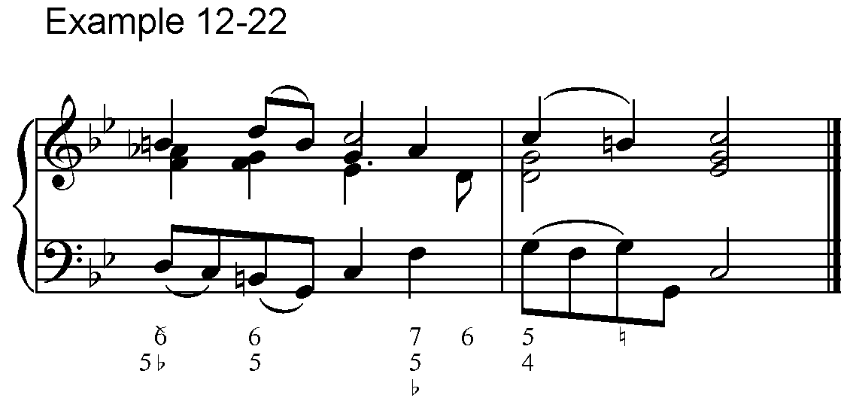

12-23. Dot 1 represents a print line of continuation. The number of dot 1’s equals the number of continuation lines. In Example 12-23, where there are two numbers in a column, both numbers are followed by a print line of continuation in the next column.

Example 12-23.

%#B2

_$$?#6?#A W#46W#AA[#56[#AA<K

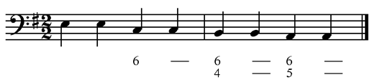

12-24. If it is necessary to indicate the rhythm of a change of figures on one note, the figures should be followed by a stem sign showing the value of the chord represented by each column of figures. This should only be used where essential and where the print is quite clear as to the intended rhythm.

Example 12-24.

#D4

.>'%"G(!R]<K

;>'_Z#%K#4_K#%K<K

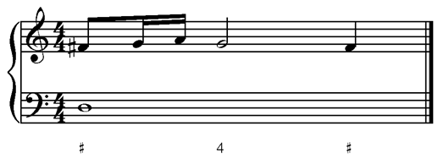

12-25. When notes with figures are followed by other musical signs (i.e., staccato) the sign with dots 3-6, =-=, separates the figured bass signs from the music signs. At the beginning of a measure, as in Example 12-25, the separation sign is not necessary.

Example 12-25.

8^H#4-8H#3<K

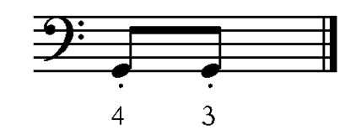

12-26. If other notes appear on the staff with the bass line and figures, these notes are usually written separately, after an in-accord sign. If small notes are used in the print, they should be written using the small-note sign in braille (Table 1).

Example 12-26.

;>'%_H#6F:#%46<>_J#%(!W<K

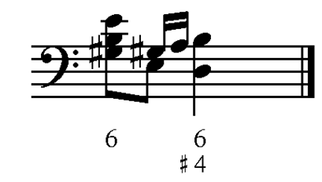

12-27. An oblique stroke is represented by dots 3-4, preceded by the number sign.

Example 12-27.

;>_$#36]#/\#/<K

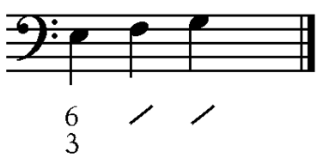

#### 2. Harmonic Analysis

12-28. When music is being used for harmonic analysis, it is common for the intervals of all parts to be written upward. A statement about the direction of intervals should appear in the transcription. If keyboard hand signs are being used, the sign for the right hand part should indicate that intervals read up, =.>>=, (Table 15).

12-29. Harmonic analysis uses roman numerals and letters in addition to the figures of figured bass.

12-30. Figures are written as in the preceding section of this chapter.

12-31. Roman numerals and letters follow print, using the capital or letter signs according to the normal literary usage in each nation. American capitals and letter signs are used in this edition.

12-32. Each chord symbol is separated by a space.

12-33. If the symbols need to be aligned with music, they are written on a line below the notes and the music is spaced so that the start of each note-group coincides with the first sign of the chord symbol. In this situation the sign =L= is used to represent a bar-line.

Example 12-33. (Intervals read up.)

#D<#C4

.>>":+ :+ ?*+ L N'#<K

_>'_:9 W- ?3 L ^Q'_+<K

,VI ,IV ,V#7% ,I

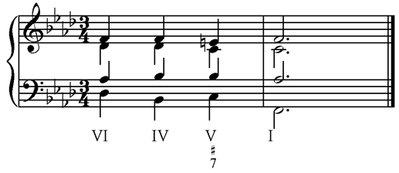

12-34. Example 12-34 is harmonic analysis from a theory textbook. Version (a) is in bar-over-bar format with each beat aligned; version (b) is in a section. Bar lines would be placed between measures. In both cases, the lettering and capitalization is transcribed as it appears in print.

Example 12-34. (Intervals read up.)

(a)

<<<#C2

.>>"S<# *S+ '''''' R*+<K

_>'_Q- %Q3 '''''' R9<K

;C3 ,N#6 ;VII4#7/,V ,V

(b)

<<<#C2

.>>"S<#*S+R*+<K

_>_Q-%Q3R9<K

;> ;C3 ,N#6 ;VII4#7/,V ,V

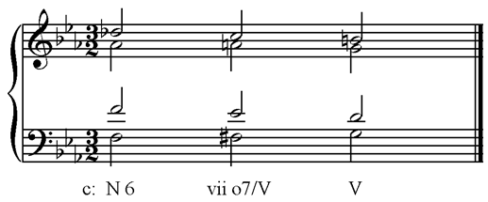

12-35. With this international system, unusual lettering and numbering can be accommodated. Again, the exact lettering and capitalization of the print is reproduced. Version (a) is bar-over-bar; version (b) is in a section.

Example 12-35. (Intervals read up.)

(a)

#D%.C

.>>"$PED<>"WID"Q@C L

_>'_N %S ''''''' L

,S#6 ,D#56

.>>"OT<>"Q'$@C<K

_>'^)@C<>V_WR<K

,DP ,TP#46

(b)

#D%.C

.>>"$PED<>"WID"Q@C L

"OT<>"Q'$@C<K

_>_N%S L ^)@C<>V_WR<K

;> ,S#6 ,D#56 L ,DP ,TP#46

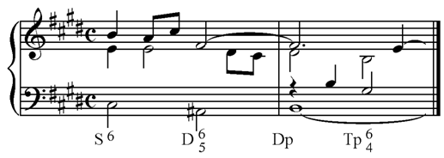

12-36. When letters represent passing notes, non-chord or auxiliary notes, suspensions, etc. (using x, n, a, s etc. in print), either the letters, with word signs, should precede the notes to which they refer or they should be placed with letter signs (rather than word signs), on the same line as the chord symbols, directly below the notes to which they apply. In Example 12-36, upper case roman numerals represent major chords, lower case represent minor chords, and Ic is an example of the I chord with lettering that represents 2nd inversion. In (a), the symbols above the staff in print precede the notes to which they apply and those below the staff are aligned below the notes to which they apply; in (b), all the signs are aligned below.

Example 12-36.

(a)

%#D4

;>"\ L \ ] F>X"GH>X"I L

,I ;VI ;III ,IV ;VI

;>"J>A.D[ \<L<K

,I;C ,V#7 ,I

(b)

%#D4

;>"\ L \ ] F G H I L

,I ;VI ;III ,IV ;X ;VI ;X

;>"J D [ \<L<K

,I;C ;A ,V#7 ,I

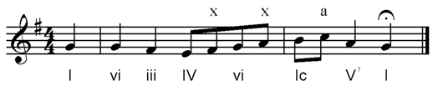

12-37. Chords are normally aligned vertically unless there can be no confusion, i.e., if the print has explained their position. In Example 12-37 the chords are not aligned. The print is the same as in Examples 12-36 (a) and (b).

Example 12-37.

%#D4

;>"\ \]F>X"GH>X"I

,I ;VI ;III ,IV ;VI

;>"J>A.D[\<L<K

,I;C ,V#7 ,I

12-38. When figured bass and roman numerals both appear in the bass, the roman numerals can be placed underneath. When spacing is needed in order to leave at least one space between each chord, the bar line sign is used.

Example 12-38.

%%#D4

;>_Q#6 R#56 L P#346"

,I#6 ,II#56 ,V#34

;>'%_O#356<K

,V#56 OF ,II

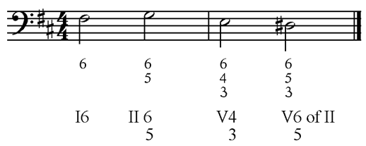

### C. Brackets

Signs from Table 12 C.

=,' ,'= Music parentheses (round brackets)

="' ,1= Vertical brackets surrounding notes or features

=;1 "2= Square bracket above the staff

=;1 "'= Square bracket above staff with unclear ending

=;11 ""2= Dotted square bracket above the staff

=;' ,2= Square bracket below the staff

=;' ,1= Square bracket below staff with unclear ending

=;'' ,,2= Dotted square bracket below the staff

* * *

12-39. The sign for music parentheses (round brackets) is used as follows.

Example 12-39.

%#D4

;>'*_Q#6P#7#6,'%,' O#<K"

:#2%?<K

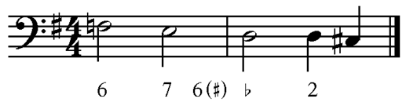

12-40. But if the symbol in print is a vertical square bracket, that distinction should be shown in braille.

Example 12-40.

%%%#C4

;>_[[? S#6\#6 @C\Q#7#"'%,16<K

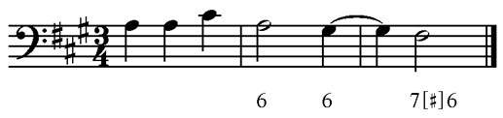

12-41. Brackets above and below the staff are found commonly in harmonic notation, such as Schenker Analysis. Wherever brackets occur, in any kind of music, the signs above that have received international approval are available.

12-42. Complete brackets consist of a horizontal line with a shorter line at each end, drawn at a right angle to the horizontal. If the bracket is above the line, the signs =;1 "2= are used, and if it is below, the signs =;' ,2= are used.

Example 12-42.

%%#D4

;1;ZFGF ;'Z.IGF,2Z"I"2GF<K

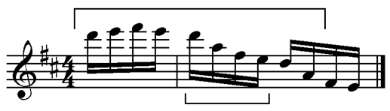

12-43. If the brackets are drawn with dashed or dotted lines, the sign for dotted brackets is used.

Example 12-43.

%#C4

_("F;11DF;''7,,2""2_(%"D%ID<K

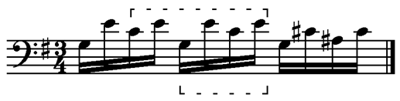

12-44. When a bracket does not have a right angle at the end, it is considered unclear where the exact ending occurs. In that case, the sign ="'= is used at the end if the bracket is above the staff, and =,1= is used if the bracket is below the staff.

Example 12-44.

%%.C

;1;ZFGF Z.IGFZ"I"'GF<K

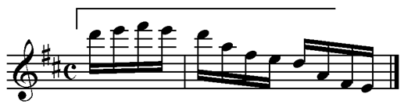

## XIII. Modern Notation

(Table 13)

13-1. Wherever possible, standard braille notation should be used in all kinds of music. When modern braille notation from this chapter is used, a transcriber's note of explanation should appear in the same volume.

### A. Notes with Unusual Shapes

Signs from Table 13 A.

=5a=  Black note head with no stem

=5b=  X-shaped note head

=5k= 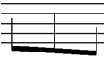 Vertical stems that designate quasi-notes

=5l=  Diamond- or triangle-shaped note head

=5'=  End of a slanting line to designate approximate pitch (quasi-note)

* * *

13-2. Print notation for modern music has not been standardized. A diamond-shaped note-head may indicate keys pressed silently on the piano, "breathy" notes on the flute or any number of other exotic things. Therefore, the braille notation indicates the shape of the note rather than its meaning. If a diamond-shaped note indicates an artificial harmonic in string music (par. 17-21), or if an X-shaped note in percussion music indicates a particular instrument (par. 18-16), the modern signs should not be used. The signs in this chapter are intended for unusual, modern print notation.

13-3. These signs may be doubled by repeating the second character of the sign, i.e., =5AA= is a series of black note heads.

13-4. When no specific note value appears, the value of an eighth note is used as in Example 13-5.

13-5. In Example 13-5, whole notes appear as well as black note heads. The whole notes do not receive the normal four beats of classical music. However, because the print symbols are identical to whole notes, the normal braille signs for whole notes are used. There is no key or time signature in this music for trombone; dotted bar lines are used (Table 9 A) and normal expression marks.

Example 13-5.

>#L'>P>C;B_85AA^FCG"

>GLISS'@A<^JC_F,C5A"D^2>3 K

;B%"Y@A5AAJ@A"G@AF@A"

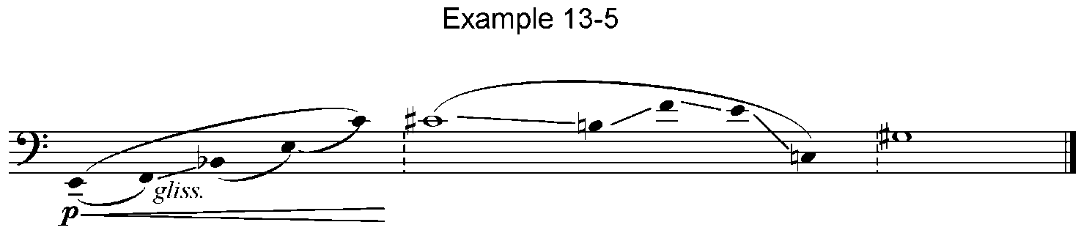5A*_D^2 K %(<K

13-6. Example 13-6 is for flute. There is no time signature. The first measure indicates flutter tonguing which is notated normally, as a repetition-type of tremolo. Measure three has diamond-shaped notes. Because of varying beats in each measure, grouping is not used for the 32nd notes, but the slurs accurately reflect the print grouping.

Example 13-6.

>/L'>PPP"]^1C<F^1 >PP,<18*;!77

>PPP;B5LL.PC@A%RC@AT"

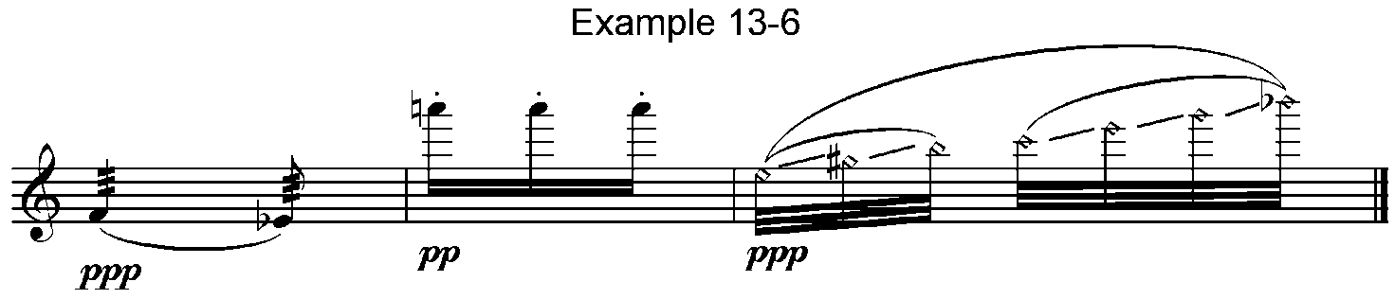 ;NC@APC@ARC@A5L<T^2<K

13-7. Example 13-7 from the same flute piece has X-shaped notes. According to the performance directions, these are "tapped-key" notes. All performance notes are, of course, included in transcriptions.

Example 13-7.

>SF'88.8.85BB.ZM>SF.YM"

>SF'<")M>SF'<"!M"

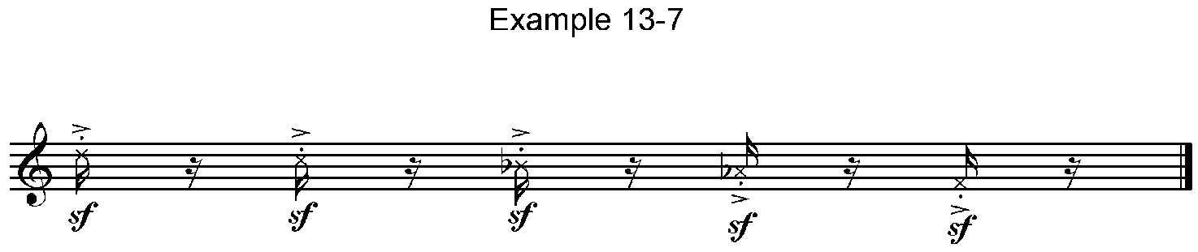 >SF'8.85B"=M<K

13-8. Example 13-8 has 20 stems obviously representing more than just the 14 possible half steps between the beginning and ending notes. By including some enharmonic notes, the transcriber conveys the idea without specifying which quarter-tones to use. That is up to the performer. A note in the transcription should make it clear that pitches in braille, as well as the stem signs in the print, are only approximate. The slanted line across the beginning of the group is a modern way of indicating short appoggiaturas.

Example 13-8.

>SPICCATO>MF>D'558;8<.H"

5KK%G*GF<F%E*E<E%D*DJ<J%I*I"

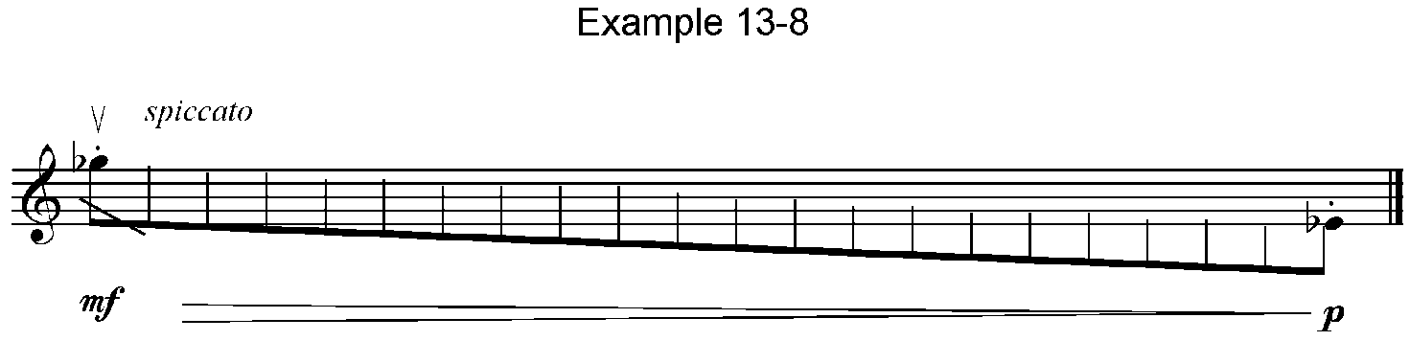<I%H*H<H%G*G5KF>P'58<"F<K

13-9. In Example 13-9 the end of the slanting line is indicated as a quasi-note, an approximate pitch. If a time value indication had been given, the length of the glissando could have been included as a value sign or with an indication in an in-accord part. This example includes a dotted bar line and clef signs. The small value sign precedes the 32nd notes in the absence of a time signature.

Example 13-9.

>#L'>D'5A_EC@A5A%D@A"

>GLISS' TR@ES LENT> 5'^G>4 K

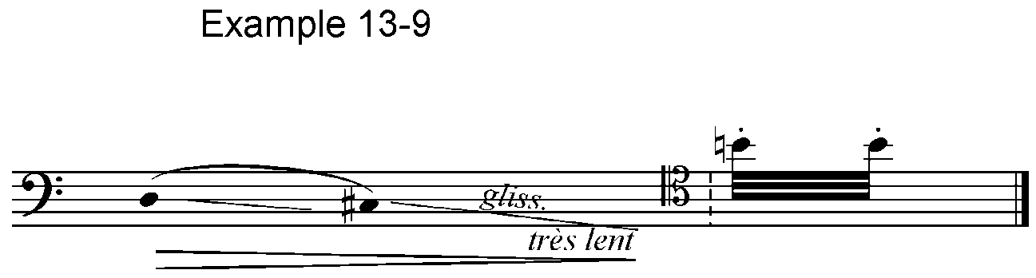>+"L,<18*"T8T<K

### B. Tone Clusters

Signs from Table 13 B.

=^*b= Tone cluster with natural sign

=^<b= Tone cluster with flat sign

=^%b= Tone cluster with sharp sign

=^5b= Tone cluster with no accidentals specified

* * *

13-10. In print, a tone cluster is a thick bar or other shape placed between two notes of a chord to indicate that all the notes between must be played simultaneously. Sometimes one or more accidentals are included. In braille, the tone cluster is treated as a chord, so the appropriate sign is placed between the written note and its interval. The tone-cluster sign has 3 parts. Dots 4-5, =^=, start the cluster followed by any printed accidentals; if there are none, dots 2-6, =5=, is inserted. The sign ends with dots 1-2, = B=.

13-11. A tone-cluster sign may be doubled by repeating the final character, i.e., =^<BB=.

13-12. In the next example, each tone cluster is notated differently in print. In (a), an arrow with a point on both ends is printed next to the stem between D and its fifth below. The symbols for both a sharp and a natural are printed just to the left of the arrow, so both accidentals appear within the cluster sign in braille. In (b), stem signs on both sides of the two F’s join to surround both F’s and the space between. This indicates the cluster. No accidentals appear in print or in braille. In (c), a thick vertical bar connects the two notes to indicate the cluster. A sharp precedes the 2nd octave A, and a natural precedes the 3rd octave A. Therefore, those alterations are shown with the specific notes rather than within the cluster sign.

Example 13-12.

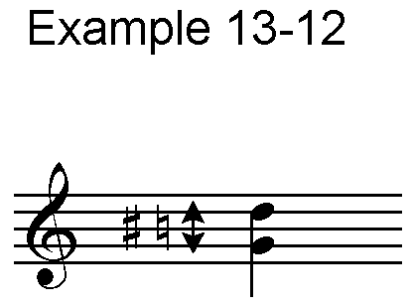

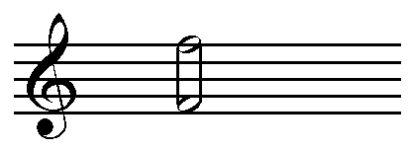 (a) .>.:^%*b9

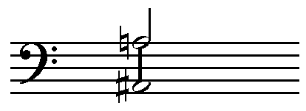(b) .>.q^5b-

(c) _>'%^s^5b*-

### C. "Fan-shaped" Rhythmic Groups

Signs from Table 13 C.

=^<1,<1= Accelerando within rhythmic group

=,<1^<1= Ritardando within rhythmic group

=,<1,<1= Steady rhythm

=;k= End of rhythmic group as shown in print

* * *

13-13. When the ligatures or beams of a rhythmic group are fan-shaped rather than parallel, the notes of the group are to be executed as an accelerando or a ritardando. Standard note values are used, but the group is preceded by the sign for accelerando or ritardando and followed by the termination sign. If the ligatures start together and fan outward on succeeding notes, an accelerando is indicated. If the fan-shape is reversed, a ritardando is indicated.

Example 13-13.

>MF>C^<1,<1_8^I_&=88SSSS;K"

X>F^<1,<1_I!SS;KX"

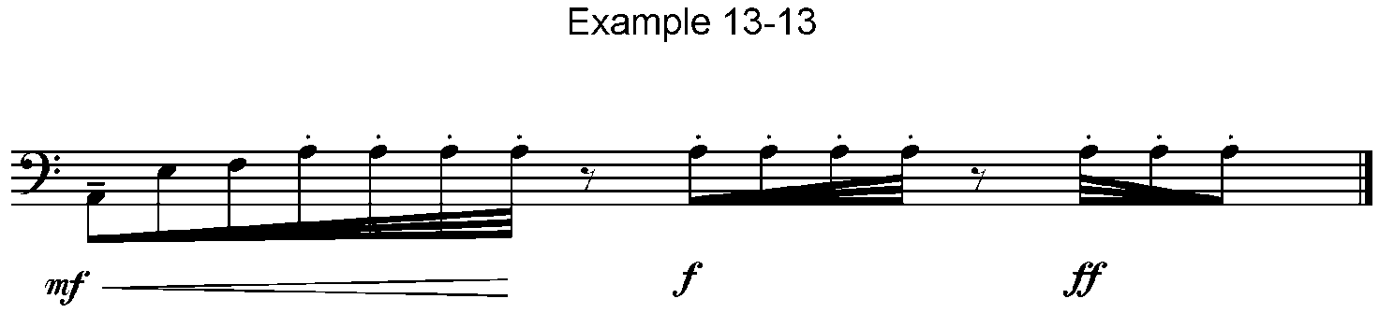>FF,<1^<1_S!8I;K<K

13-14. When the fan-shape changes within a rhythmic group before the ligatures end, the signs above are used where the changes take place. The sign for a steady rhythm is used if the ligatures become parallel rather than fan-shaped within the print ligature. Example 13-14 is from music for Bayan. Between the first and last chords, the print has stems only, so the sign for vertical stems is used and doubled.

Example 13-14.

>#L^<1,<1^F//++<##5KKF&&PPPPPP"

,<1,<1PPPPPPPPPPPP,<1^<1PPPP"

&&5KFF/+<#;K<K

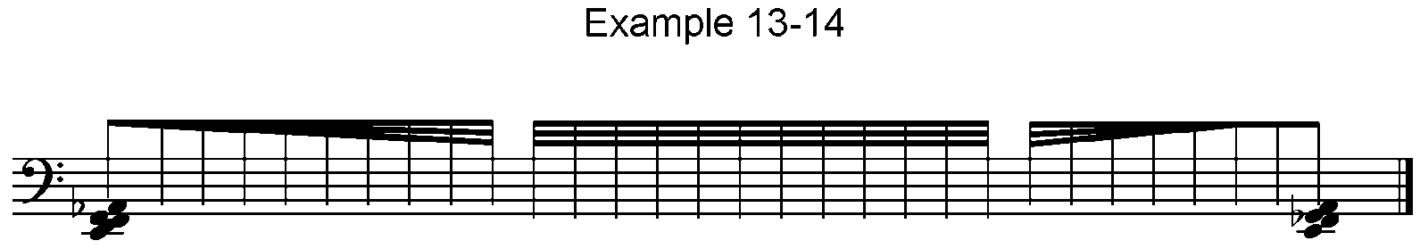

### D. Other Signs

Signs from Table 3 A & B.

=@% @<= 1/4 step alteration of pitch

=_% _<= 3/4 step alteration of pitch

=#d,'?= Time signature 4 over quarter note

=#c,'d= Time signature 3 over 8th note

* * *

Signs from Table 10.

=;<l= Fermata with square shape

=^<l= Fermata with tent shape

* * *

13-15. The signs in this section of the chapter are not restricted to modern music only. Although more commonly found in modern music, they should be used where ever the print signs are found.

13-16. Altering a pitch by one-quarter step is not a modern invention. It is included here because it appears more commonly in modern than in standard music. The print signs vary. Arrows pointing up or down, numbers indicating specific microtones and other means are used. One of the more common symbols for a 1/4 step higher is a sharp with only one vertical line. For 3/4 tone higher, a sharp symbol with three vertical lines is used. In that print system, the symbol for 1/4 tone flat is a flat printed backwards. Fortunately, these are usually accompanied by footnotes or explanatory notes that must be included in the transcription as well as an indication of the braille signs being used. In Example 13-16, the print uses small arrows plus the footnote to explain the meaning of the arrows. Music for a blind teacher should also include a description of the type of print indication that appears.

Example 13-16.

>59@<"EC@A@<Q''<K

>59 #A/D TONE LOWER

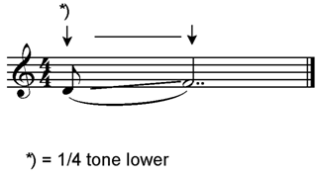

13-17. Composers do not agree on the meaning of unusual fermata signs. The fermata with a "square" shape has been used as "a very long pause" and also as "a short pause" by different composers. The same is true of the fermata with the shape of a "tent" or an "umbrella". Therefore, the shape, rather than the meaning, is included in braille. The initial sign for a fermata on a bar line, dots 4-5-6, or for a fermata between notes, dot 5, can be added to these signs as in the example below.

Example 13-17.

>#L'>MF>C'5^JCF";<L5ICF";<L"

5<JCF";<L5%GCF>D'5^HCF";<L"

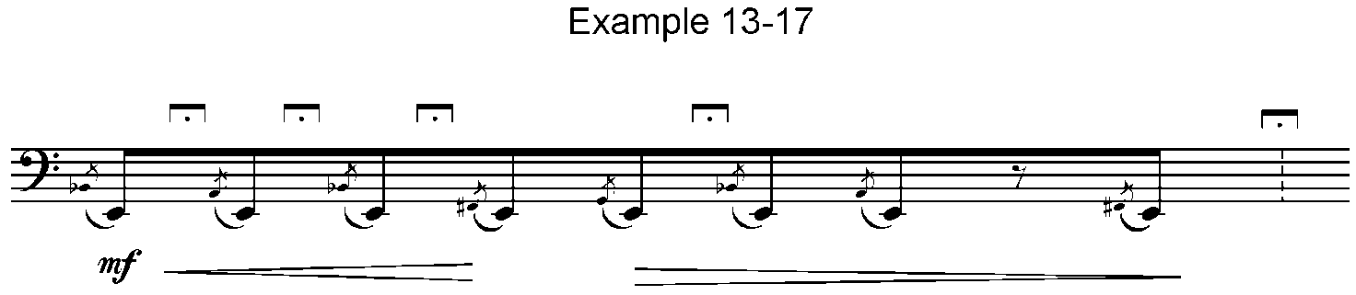5<JCF5ICFX5%GCF>4 K _;<L '''<K

13-18. When a note appears in a time signature, it is preceded by dots 6, 3. The note C is used to represent the value shown in print. The first time signature below is 3 over a dotted 16th note. The next is 4 over a dotted 16th. The music is from a solo for string bass.

Example 13-18.

#C,',<1Y'

>#L'*"Z'%='Z' #D,'Y' _8*"H'"

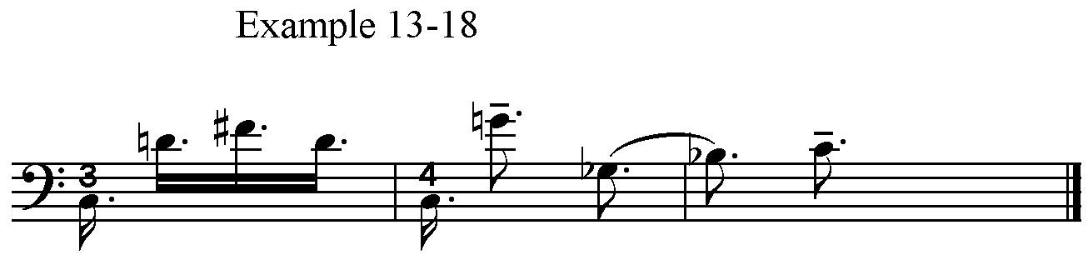<_H'C <J'_8D'<K

13-19. Other unusual time signatures include two time signatures side-by-side and signatures with more than one upper number. Sometimes these numbers are separated by a space, sometimes by a plus sign and sometimes by a hyphen. In general, print is followed. When plus signs are involved, each nation uses its own sign. Example 13-19 gives two illustrations. In the first, two time signatures are together in print and in braille. The second time signature is 4 plus 2 plus 3 over 8.

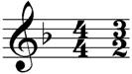Example 13-19.

=<#d4#c2=

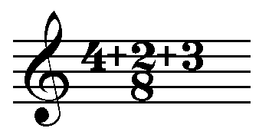

=#d+b+c8=

# Part Two: Instrumental and Vocal

## XIV. General Organization

14-1. Because of these successful international agreements and also because of continuing work on the development of data bases with listings of transcriptions prepared in different countries, the following general points may be helpful as the use of braille music also becomes more international.

### A. Preliminary Pages

14-2. Whether or not a country follows the agreement not to use contractions in literary braille, it is extremely important to have no contractions on the title page and on note pages. This applies to the name and address of the organization where the music might be obtained as well as to the title of the composition and the composer. Notes about national signs and special signs must be uncontracted.

14-3. If an ISBN number appears in print, it is very useful to librarians internationally. It is suggested that ISBN numbers be included on all braille title pages.

14-4. A note page or section should include:

A. Any signs not listed in this manual.

B. National signs for plus, minus, oblique stroke, italics, etc. if used in the transcription.

C. Signs for accented letters.

D. Descriptions of editorial markings, print indications such as arabic or roman numerals to mark position signs in string music, indications such as arrows or other unusual visual aids in print. These items are essential for blind teachers working with sighted students.

### B. General Features on Music Pages

Signs from Table 14.

=,'= Prefix for music; music parentheses

=;2= Prefix for literary material such as vocal text, instructions, or other literary information

=;2= Coincidence of notes in more than one part

="= Hyphen for unfinished measure

="3= Prefix for print pagination or print page turn

="l= Prefix for editorial markings

=>59= Music asterisk

=7= Equals sign in a metronome marking

* * *

14-5. The prefix =,'= indicates a line or section of music. It is used in different ways in different countries. Within a sentence it indicates a return to the music code. When it is within a line or section of music it indicates parentheses (round brackets). In that case, the sign precedes and follows notes, fingering or other features that are parenthesized in print.

14-6. In several countries, the prefix =;2= precedes every line or section of vocal text to distinguish between literary and music code. See Example 16-7. It is also used to indicate literary material in other settings.

14-7. When the sign =;2= appears within a measure of keyboard or instrumental music, it will be found in more than one part. In that setting, it indicates a coincidence of notes in two or more parts. Example 15-13 illustrates its use in keyboard music, but the coincidence sign is useful in any type of ensemble, i.e., it can be used to coordinate a vocalist’s note(s) in a modern ensemble piece.

14-8. When dot 5 is followed by a space it acts as a hyphen to indicate that the measure is unfinished. It is used at the end of a braille line, before a break in a measure for the insertion of text, and also at the end of a double bar in an unfinished measure that will be completed later as the piece continues.

14-9. The prefix ="3= indicates a print page turn. This may be used by itself or may be followed by the print page number. It will be found in different locations, i.e., at the beginning of a section of music, in any corner of the page of music, in the midst of the music itself, or centered in any margin of the page. Fortunately, most countries realize the value of including a reference to the print page numbers.

14-10. Both print and braille page numbers can be included at the beginning of a section or other location by using a combination of upper-and lower-cell numbers such as the following indication for page 13 in braille and page 10 in print. The order may also be reversed (print page first), and that order will remain constant throughout a publication.

#13AJ

14-11. Other uses for upper- and lower-cell number combinations include page number with staff number, section number with measure number, section number with staff number, etc.

14-12. An unfinished measure at the beginning of a piece or movement is numbered 0, zero. Measure numbers are followed by dot 3 if they come before the concluding part of an unfinished measure in the body of a piece. The numbers may appear in upper- or lower-cell position. The following indicates the section of a piece beginning with the anacrusis to measure 16 and ending in measure 32.

#AE'-CB

14-13. In keyboard music written bar-over-bar, measure numbers appear in the margin and are not preceded by number signs. The one number applies to all staves in that system, i.e., right hand, left hand, pedals. When an additional number (with no number sign) appears one cell before the left hand prefix, this indicates the system number on the print page. Example 14-13 shows the beginning of measure 16 at the beginning of the third staff on the print page.

Example 14-13.

Af .>'''

C_>'''

14-14. The inclusion of system numbers is an additional help to teachers of sighted students. They are often included in section headings, and many pieces are transcribed with one section of braille for each print system.

14-15. The sign ="L= precedes a musical feature added by the editor rather than the composer. A common editorial marking consists of writing slurs with dotted lines as shown in Example 6-10. Other examples of editorial markings are shown below where the crescendo and decrescendo are printed with dashed lines to indicate that they are editorial. In braille, each is preceded by the sign for an editorial marking. The ritard is also editorial, but it is printed in parentheses, so it is brailled as a word in parentheses.

Example 14-15.

%#C4

.>.O'@C<K

_>"L>C_W+C>7RITARD'7"\'C"L>D"FC<K

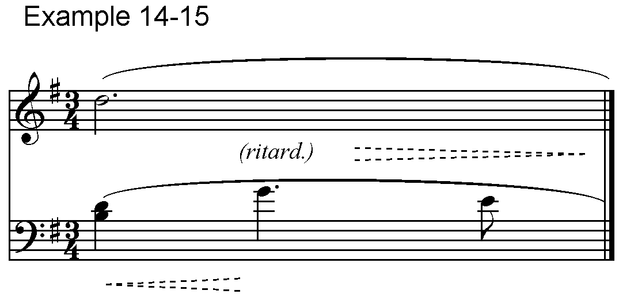

14-16. The international sign for an asterisk in music is =>59=. This sign precedes the music to be referenced, and it is repeated at the beginning of the footnote. See Example 8-9.

14-17. The international code for metronome markings uses dots 2-3-5-6 to represent the print equals sign and the note C to show note values. Any words included with the metronome marking must be included in braille. Example 14-17 shows several representative metronome markings including (c) which usually occurs between sections of music along with a change of meter.

Example 14-17.

(a) d7#gb-hj = 72-80

(b) circa ?7#ajf circa = 106

(c) ?7n =

14-18. A tempo or mood indication at the beginning of a piece or at the beginning of individual parts is followed by a period unless it is the only item on a braille line. The general order of initial items is mood, metronome marking, key and time signature.

14-19. Information at the end of a piece such as time of performance should be brailled with whatever abbreviations are used in print, i.e., "6 min. 30 sec." If symbols, rather than words or abbreviations, appear in print, the appropriate signs are used in braille.

Example 14-19.

#f min4 #cj sec4

## XV. Keyboard Music

(Table 15)

### A. Piano

#### 1. Organization and Use of Hand Signs

Signs from Table 15 A.

=.>= Right hand part

=_>= Left hand part

=">= Solo part to be accompanied

=.>>= Right hand part when intervals read up

=_>>= Left hand part when intervals read down

* * *

15-1. The signs in Chapter XV apply to music for keyed instruments such as harpsichord and clavichord in addition to piano. They also apply to electronic instruments with keyboards.

15-2. Hand or part signs are placed before the first sign of the passage to which they apply.

15-3. Hand or part signs must be followed by dot 3 if they are immediately followed by a sign containing dots 1, 2, or 3.

Example 15-3.

#D<#C4

.>'8"[0 W0C\0V<K

_>'V VV_]<K

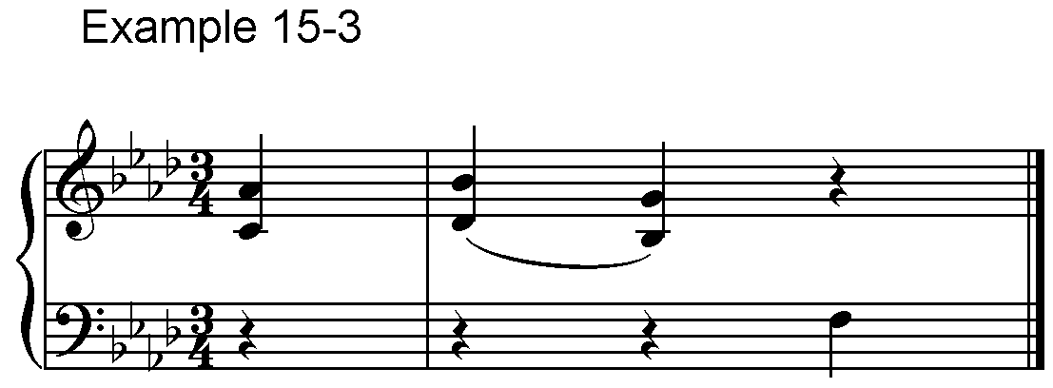

15-4. The first note following a sign from Table 15 A must have an octave mark.

15-5. Keyboard accompaniments include an outline or a duplication of the solo part using the prefix =">=.

15-6. When accompaniment or orchestral-reduction keyboard parts include annotations about instrumentation, the words are brailled as printed.

15-7. Passages played with alternating hands should, whenever possible, be written continuously in the part assigned to one hand. It is not always easy to decide which hand is the better for such a passage, but the general layout of the music is the best guide.

Example 15-7.

#D%#D4

.>"[ \]$.$<K

_>^:"1^)_G.>_IJ ^$]\%[<>

_>^)_F.>_HJ_>^)E.>_IJ"

_>^)_FHJ="D.>"FG<K

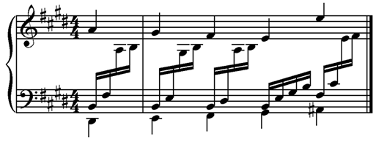

15-8. When a passage divided between the hands contains all the music, it is placed in one hand part as in Example 15-11.

15-9. The abbreviation "sim" may be added when the pattern of alternating hands is continued in exactly the same form. Dot 5 should precede any added abbreviation, i.e., =">SIM=.

15-10. A change of clef sign within a part does not affect the direction for reading intervals in that part.

Example 15-10.

<<<#C8

_>'<^Y<988<_(<90>/K'<"(<90"

>#L_(90^Y8_(<#0<>.8_$.8F<K

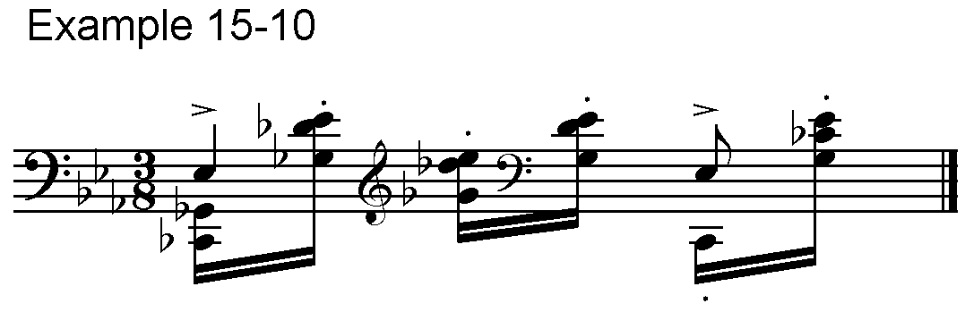

15-11. When it is desirable to change the direction for reading intervals, use the hand signs indicating a left hand part with intervals reading down or a right hand part with intervals reading up. Examples 12-33 to 12-35 show these hand signs in theory textbooks, and the example below shows the use of the right hand sign in a portion of an extended piano passage.

Example 15-11.

_C

_>^)++00.>>_)_>_Y.>>"Y"

">SIM'_Z"E_F"F_="G_F"F"

_Z"E_D"D+0<K

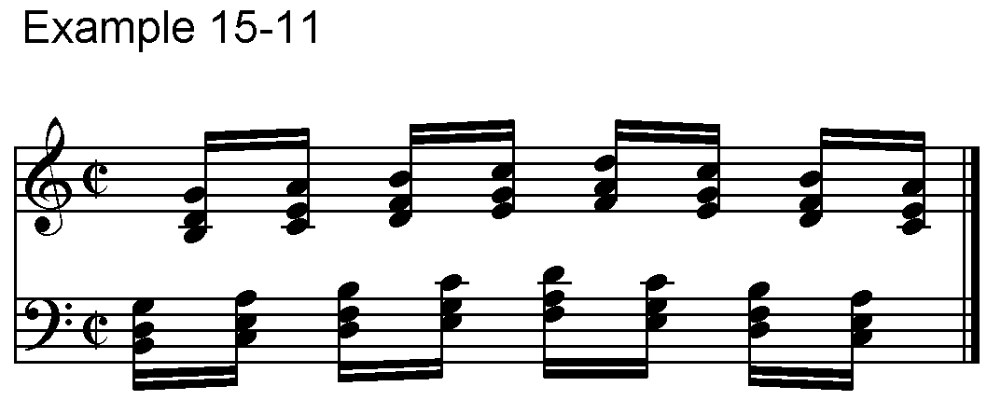

15-12. When occasional notes require in-accords, care must be taken to mark clearly the hand to which such notes are assigned.

Example 15-12.

#D4

.>.QFEDTIHG_>"PEDJ.>.RGFE"

.QFEDTIHG_>"PEDJ@C.K

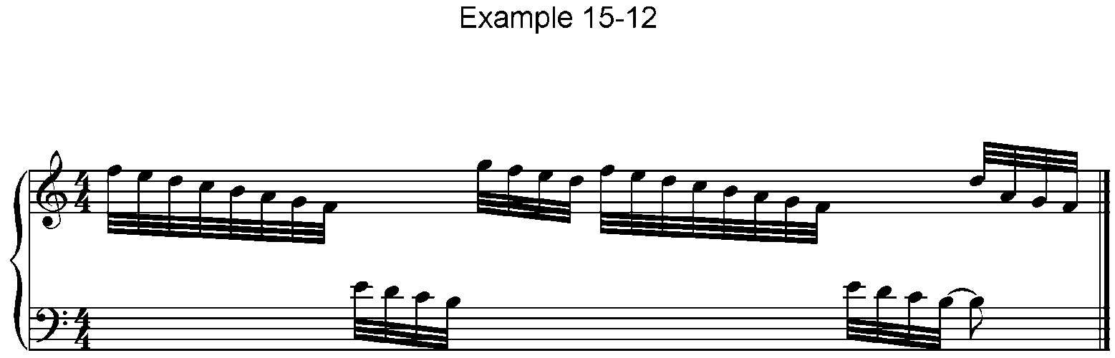 .>.O"IHG"1_>_J<K

15-13. In florid music of Chopin and other composers, it is sometimes necessary to use the coincidence notes sign =;2= in each part.

Example 15-13.

(a) (in bar-over-bar)

#E<#F4

C .>;B_22'.GA<HL*FB;2GAJ1*I<I"

;2*H<HLGF"

_>;B^J_G;2"EJ;2"G_G^2"

C'.>'<.F1*E<ED;2E1DL*JA;2DBGK"

*F<F^2<K

_>;B^J_G;2"F*_I;2"G_G^2<K

(b) (in section-by-section)

#E<#F4

.>;B_22'.GA<HL*FB;2GAJ1*I<I"

;2*H<HLGF;2<F1*E<ED;2E1DL*JA"

;2DBGK*F<F^2<K

_>;B^J_G;2"EJ;2"G_G^2"

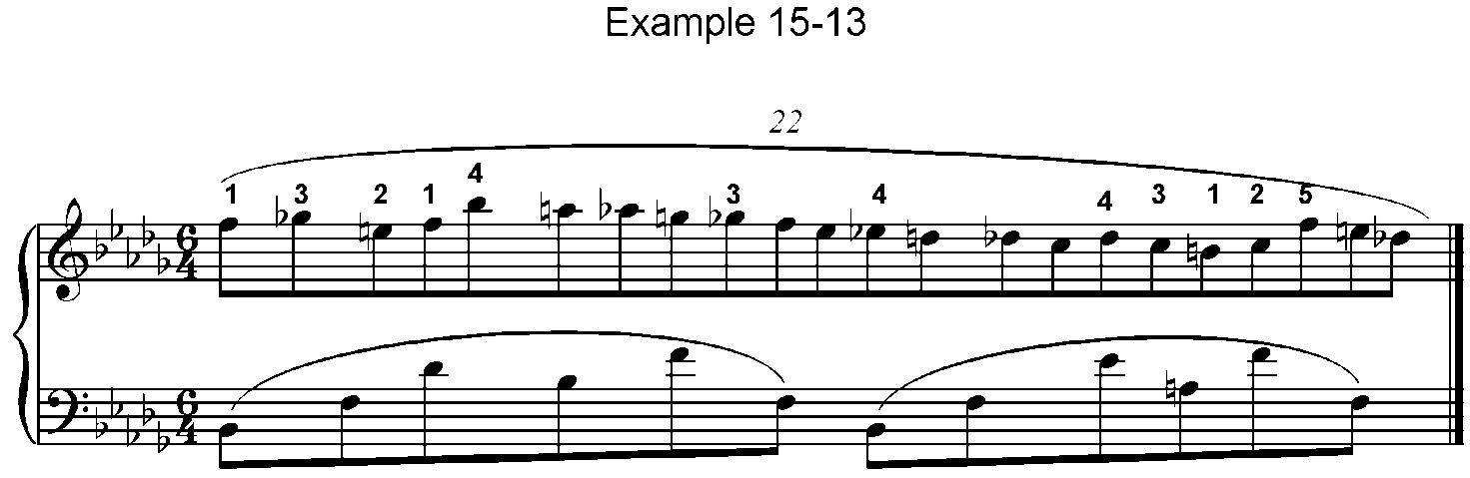;B;2^J_G;2"F*_I;2"G_G^2<K

Signs from Table 2.

=>/k= G clef in the left hand part

=>#k= F clef in the right hand part

* * *

15-14. When clef signs are included for blind teachers of sighted students, modified clef signs are used to indicate that one hand part is printed in the staff allotted to the other. The direction in which intervals and in-accords are read or used is unaffected by these special clef signs.

Example 15-14.

.C

.>'>/L.:#%0;O#%0V<K

_>'>#L_ZI"E>/K"%"G!.E"%GE"

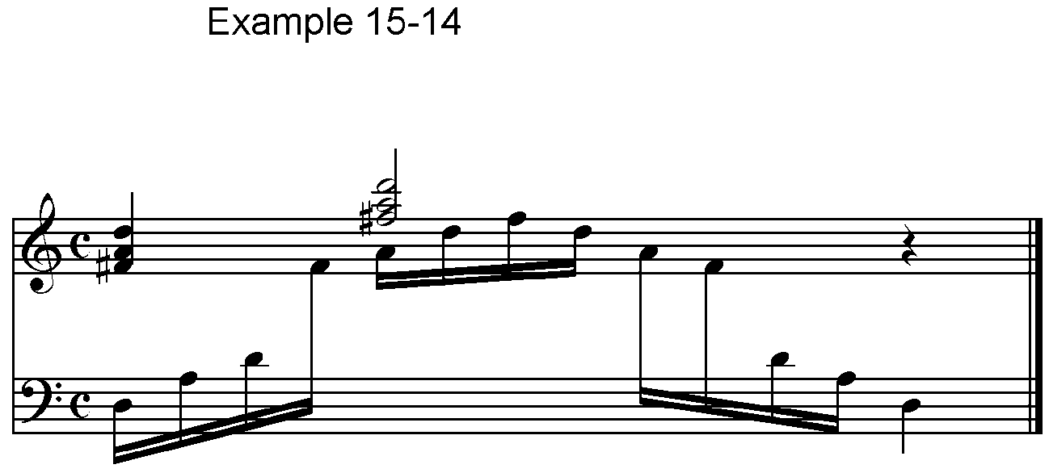"!G>#L"E_I:<K

#### 2. Piano Pedalling

Signs from Table 15 A.

=<c= Ped. or other indication for pedal down

=*c= Star or other indication for pedal up

=*<c= Star and Ped. under one note

="<c= Half-pedal

="*c= Pedal up as soon as chord is struck

* * *

15-15. Pedal indications such as the print star and "ped." are placed where they occur in print. They are usually transcribed into the left hand part unless the notes of the right hand part provide the clarity needed to place them accurately. It is advisable to treat the pedal depression and release as a pair, if possible, placing them both in the same hand part.

15-16. Directions such as "con ped." should be transcribed according to the exact wording, and when "ped." is not followed by a star, it is better to write that abbreviation with the word sign.

15-17. When the indications for pedal down, half-pedalling or the combination of a star and pedal are placed directly under a note or rest in print, they are transcribed before the note or rest indicated.

15-18. The sign for pedal up follows the note, interval or rest. In Example 15-18 the pedal is held through a long rest; in Example 15-19 the pedal is released before the rest.

Example 15-18.

#C4

_>'<C>P>C.8^?_\#0*CXH<+0

<C>F_]<+<0-,8<^E<-XV<L*C<K

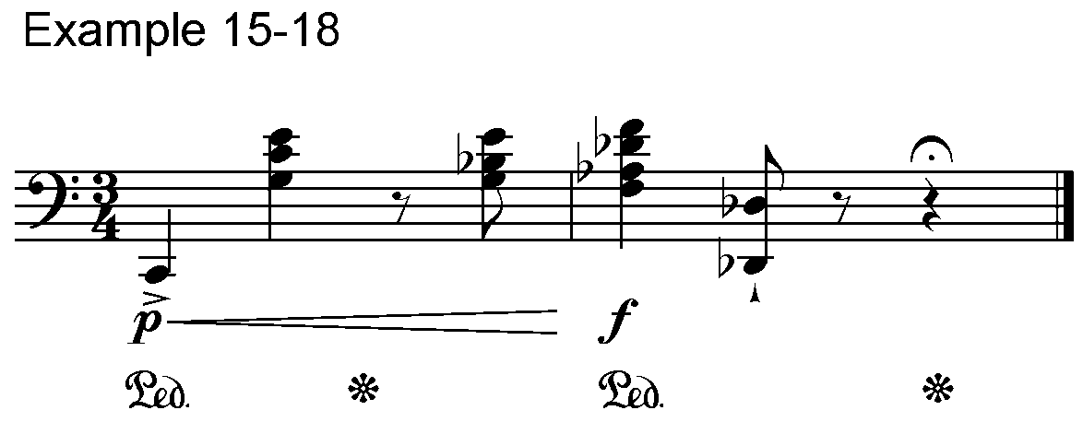

15-19. When the star appears under one note or chord and "ped." is under the next, the sign for pedal up is not included.

Example 15-19.

#C4

>#L'<C>P>C.8^?_\#0<C\<+0

<C>F_]<+<0-,8<^E<-*CXV<L<K

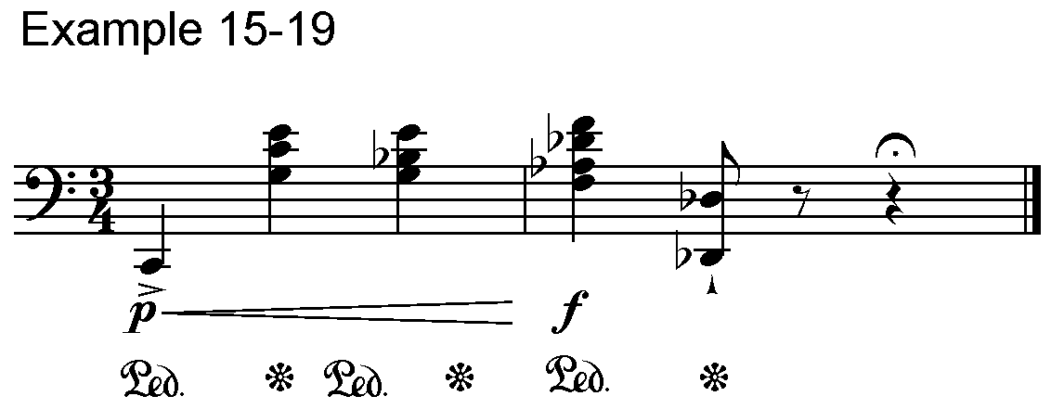

15-20. When both the star and the "ped." are printed under the same note, the sign =*<C= is used.

Example 15-20.

#E<#C4

_>'<C^I-_!##00!II#0*<C"

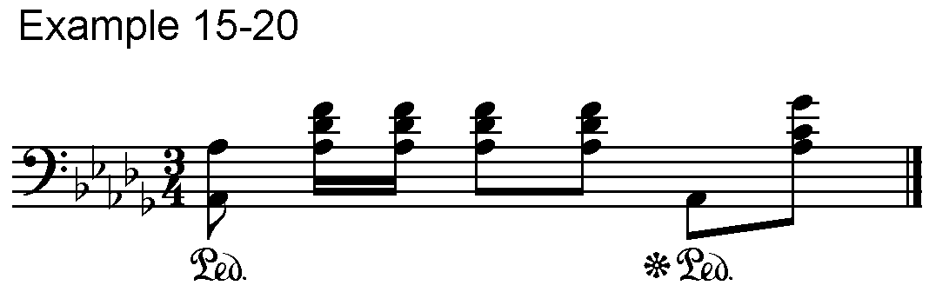 ^I_I+3<K

15-21. Half-pedalling is indicated in print in a variety of ways. It usually involves a horizontal line that is bent in some way or arranged with an inverted **V** where the half-pedalling should occur. In Example 15-21, placing the sign for half-pedalling in the in-accord clarifies its position in print.

Example 15-21.

#D4

>#L'<C@(-.C<>U^T+0 7<L<>

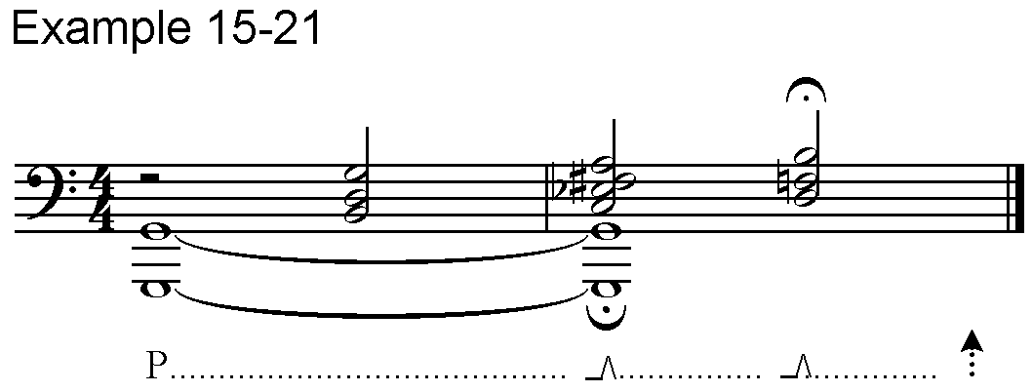"<C_N<+%#0"<CO*+0<L*C<K

15-22. The sign for pedal up immediately is used when there is a visual clue that the pedal should not remain through the entire note. Example 15-22 is in 3/4 time. In the first measure the star is placed directly under the E-sharp in the left hand to indicate immediate release of the pedal. In the second measure, the star is placed slightly after the first beat, so the normal pedal release is used in braille.

Example 15-22.

%%#C4

A .>'>MF.?'1%++B.C2YZKAYJ%+D+

_> <C;B^G_==K"G%F"*C*FA_G^2

B .>'>D.F++E>D.E1D%+>D.F+E+<>

"]]]<K

_>'<C_JA^))B*C_GC^GJC@J<K

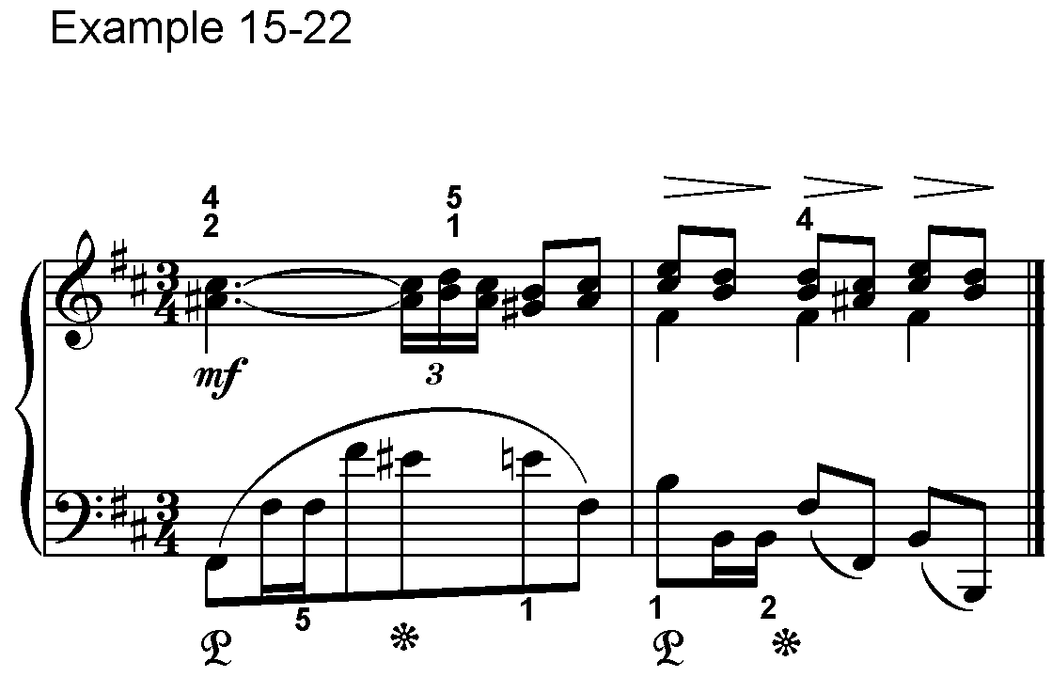

15-23. Repeats may be used with pedalling as long as the meaning is very clear.

Example 15-23.

#D4

<C_YFH"D&D_HF<C7*C<K

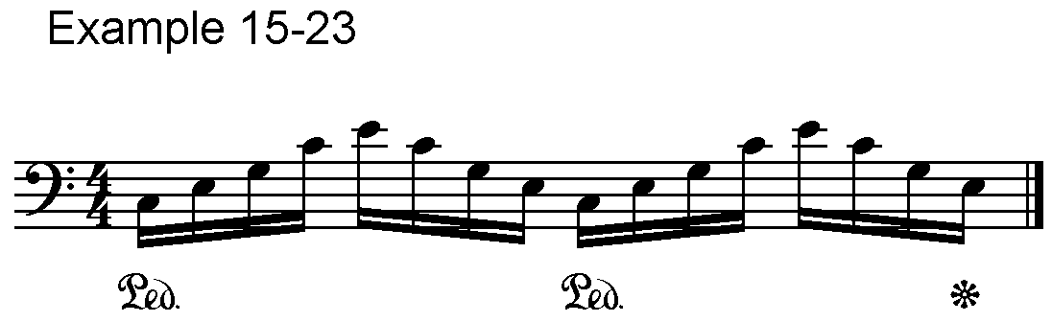

15-24. In Example 15-24, a repeat sign would indicate incorrectly that the pedal is lifted and depressed before the fourth beat. No repeat should be used in this type of situation.

Example 15-24.

#D4

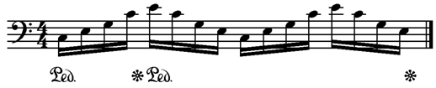<C_YFH"D<C&D_HFYFH"D&D_HF*C<K

15-25. If the pedal is only used during part of the repeated passage and the repetition is exact, the repeat sign includes the pedalling.

Example 15-25.

#D4

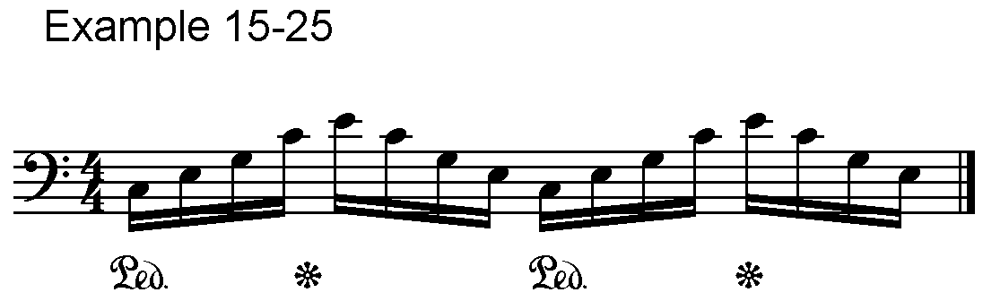<C_YFH"D*C&D_HF7<K

### B. Organ

15-26. The signs for right and left hand parts as well as the information in Paragraphs 15-1 through 15-14 also apply to the right and left hand parts of organ music.

#### 1. Organ Pedals

Signs from Table 15 B.

=^>= Organ pedal part

=^>_>= Start of passage when pedal and left hand parts are written on same print staff

=@>= Return to left hand only; pedal drops out

=a= Left toe (wedge ^ beneath a note)

=b= Left heel (u or o beneath a note)

=l= Right toe (wedge ^ above a note)

=1= Right heel (u or o above a note)

=c= Between foot signs, change of pedalling on one note

=k= Change without indication of toe or heel

=@k= Foot crosses in front (dash _ above toe or heel sign)

=,k= Foot crosses behind (dash _ beneath toe or heel sign)

* * *

15-27. When a pedal part for organ is printed on a separate staff, it is transcribed as a separate braille part beginning with the prefix shown above. When the pedal part is written in the same print staff as the left hand part, the prefixes for organ pedal and left hand are combined as shown in Example 15-27. This combined prefix is used only where such a passage starts. Succeeding measures or sections carry the normal prefix for a left hand part.

Example 15-27.

#D4

^>_>^OS<>_=+90 ^OO<>_Q'@C+0@C"

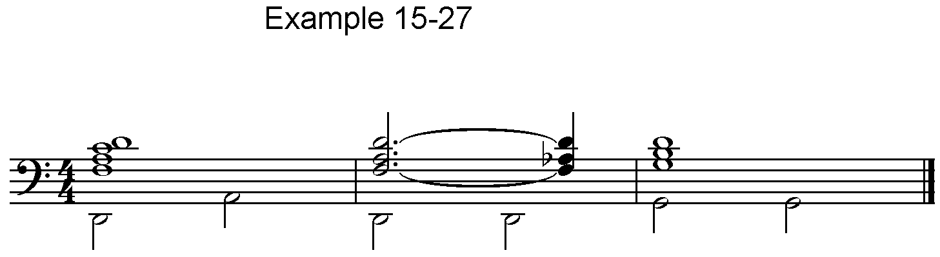 ]<+0 ^RR<>_(+9<K

15-28. When the pedal drops out, the prefix =@>= appears only once to confirm that fact. If it is clear from the music itself that the pedals are no longer in use, that prefix is not necessary. If the pedal returns, the combined prefix is used again. If there was no pedal part in the third measure of Example 15-27, the braille would appear as follows.

Example 15-28.

#D4

^>_>^OS<>_=+90 ^OO<>_Q'@C+0@C"

]<+0 @>_(+9<K

15-29. When the pointed print symbols for toe and the rounded heel signs are placed under the staff, they indicate the use of the left foot. When these identical symbols are placed above the staff, they indicate the use of the right foot. In braille, these signs follow the notes or intervals and are treated like fingering signs.

15-30. Horizontal lines above or below foot symbols generally indicate crossing of the feet, but they may have other meanings in some organ publications. The signs for foot crossing are placed before the note.

Example 15-30.

.C

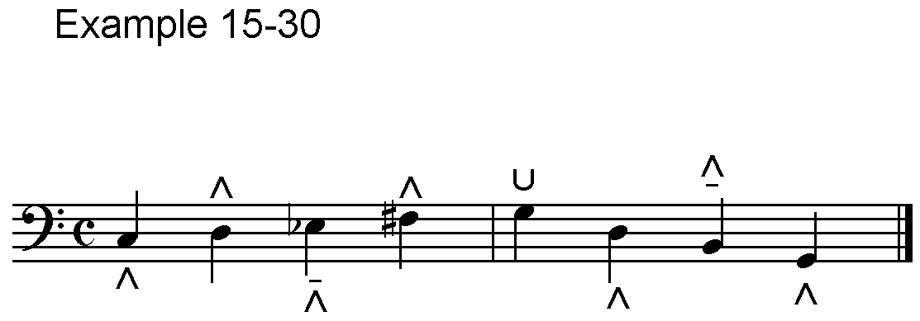^>_?A:L@K<$A%]L \1:A,KWL\A<K

15-31. Some print publications have symbols for using the inside or outside of the toe and/or the heel. This does not happen often enough to warrant specific international agreement for the diversity of print symbols individual authors may use, but Denmark*1 has devised braille signs for these unusual pedal signs that may be used.

[*1 O. Kjær Nielson. **Den Brailleske Nodeskrift, Dansk Revision**. København: Statens Bibliotek og Trykkeri for Blinde, [The Danish National Library for the Blind], (Københaven, 1978), print edition, p.161; braille edition, Vol. 1, p.143.]

#### 2. Registration

15-32. Care should be taken to include all indications for registration, use and change of manuals, information about stops, etc.

15-33. The tabulation of the details of organ registration at the beginning of a piece or movement should duplicate the print as far as possible.

15-34. Print signs for "foot," "plus" and "minus" are brailled according to the national code of the country. The American code is used in this edition.

Example 15-34.

,GT4 #H FT4 SW4 COUPLED

,SW4 ,STOPPED DIAP41 CLARABELLA

AND GAMBA 7OR SALICIONAL7

#H FT4

,PED4 ,BOURDON #AF FT4 AND

,BASS FLUTE #H FT4

,GT4 TO ,PED4

Gt. 8 ft. sw. coupled

Sw. Stopped diap., clarabella and gamba (or salicional) 8 ft.

Ped. Bourdon 16 ft. and Bass flute 8 ft.

Gt. to Ped.

15-35. Major changes of registration that occur during a piece can be set out as above, but most changes are placed as word text in the braille music.

Example 15-35.

%%%#D4

.>'6.]C$X"J.FH<>"TU 6.]C$"

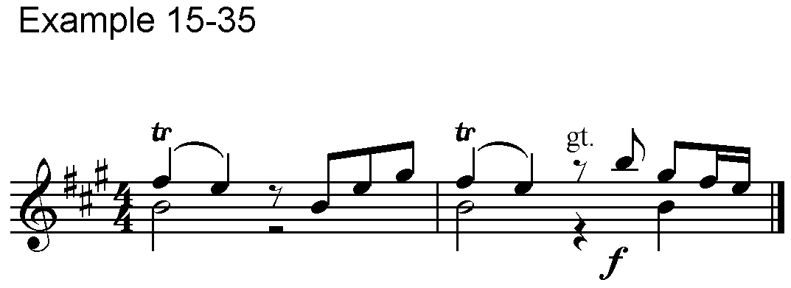 X>GT'.JH=&<>"TV>F"W<K

15-36. Changes that occur should be put in the parts with careful attention to placing them in either or both hand parts as well as the pedal. As in Example 15-36, an abbreviation is often placed between staves and printed only once. When registration applies to more than 1 staff, it should be written out in all relevant parts in the braille. The abbreviations or words used in print should be used in braille.

Example 15-36.

#D<#C4

.>'V>G.$*:<>V"S@C<K

_>'V>G"?*W<K

^>'>P@ED'>G^SV<K

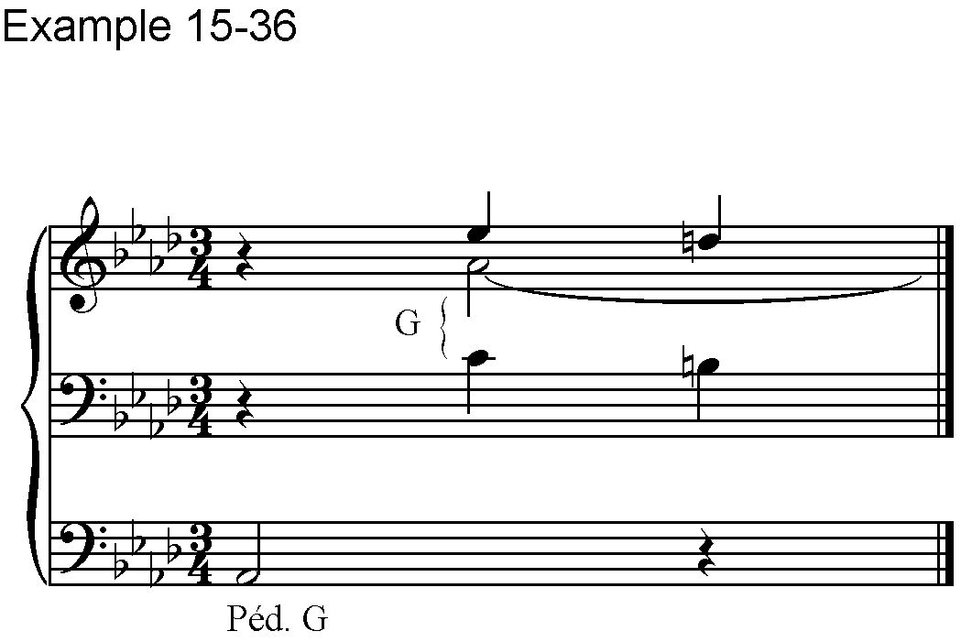

15-37. When more than one type of registration is included in print, it is also included in braille. For Example 15-37, a print diagram provides registration information for "Electronic Or Pipe Organ" and also for "Drawbar Organs". The words and/or series of numbers are transcribed in standard literary code.

Example 15-37.

,ELECTRONIC ,OR ,PIPE ,ORGAN3

,UPPER3 ,FLUTES #H FT4 #B FT4

PLUS ,XYLOPHONE

,LOWER3 ,FLUTES #H FT4 #D FT4

,MELODIA #H FT4

,PEDAL3 #AF FT4 #H FT4

,DRAWBAR ,ORGANS3

,U3 #JJ #HJDH #JJJ PLUS ,PERC4

7,XYLOPHONE7

,L3 7#JJ7 #HDBB #JJJ

,PEDAL3 #D 7#D7 ,VIBRATO3 ,SMALL

,AUTOMATIC ,RHYTHM3 ,JAZZ

|  |  |  |  |
| --- | --- | --- | --- |
| Electronic Or Pipe Organ: | Upper: Flutes 8’, 2’  + Xylophone | Lower: Flutes 8’, 4’  Melodia 8’ | Pedal: 16’, 8’ |
| Drawbar Organs: | 00 8048 000  + Perc. (Xylophone) | (00) 8422 000  **L** | Pedal: 4 (4)  Vibrato: Small |
|  | Automatic Rhythm: Jazz |  |  |

15-38. There are many possible variations for the presentation of registration. Electronic keyboards sometimes have stops that show pictures of instrument types. In the print registration below, the instruments are pictured; in braille they are named.

Example 15-38.

#F ,MELLOW ,BRASS

,UPPER3 ,TROMBONE

,LOWER3 ,CELLO

|  |  |  |
| --- | --- | --- |
| **6** | **MELLOW**  **BRASS** | MC900150963[1]Upper: |
| Lower: |

## XVI. Vocal Music

(Table 16)

Signs from Table 16.

=c= Syllabic slur

=ca cb= Syllabic slur for first & second language

=cl c1= Syllabic slur for third & fourth language

=_c= Syllabic slur variation for single verses in one language

=;b ^2= Beginning and end of phrase

=b= Two syllables sung on one note

=l= Three syllables sung on one note

=>1= Half breath

=,/= Full breath

=8 0= Merged text sung on one note

=9= Repeat text once i.e., 9,amen9

=99= Repeat text twice

=#c9= or =9#c= Repeat text three (or other number) times

* * *

16-1. A vocal solo part is transcribed like an instrumental part except for the transcription of slurs and accommodations for the vocal text.

16-2. Lines or sections of word text are alternated with lines or sections of the corresponding music for that text. Text parts are identified with the prefix =;2=, the first initial of the voice, or by placement on the braille page.

16-3. Music parts are identified with the prefix =,'=, the initial of the voice part, or by placement on the braille page. If intervals appear in the music, a note should be included to indicate the direction for reading the intervals.

16-4. In some countries text is written before music; in other countries music precedes text. Examples in this chapter reflect some of the different possibilities for presenting vocal music in braille.

16-5. It is helpful to add directions such as "rit.," "accel.," and "a tempo," to the braille vocal part if they appear only in the accompaniment of the print copy.

16-6. Music and its text are not vertically aligned as in print. Therefore, the correlation of syllables and notes must be made very clear using the signs illustrated in Examples 16-7 to 16-10.

16-7. The slur =C= between notes indicates that one syllable of text is sung on those two notes. The sign is doubled if one syllable continues for more than four notes. The signs =;B= and =^2= are reserved for phrases; they are not used for the correlation of syllables with notes.

Example 16-7.

%%#C4

,'^W_G=C%&CG%H I!C%([V

;2,TU SOLUS ALTISSIMUS

,'X_ECC"E'Y)CI%HCG %$%ECD<K

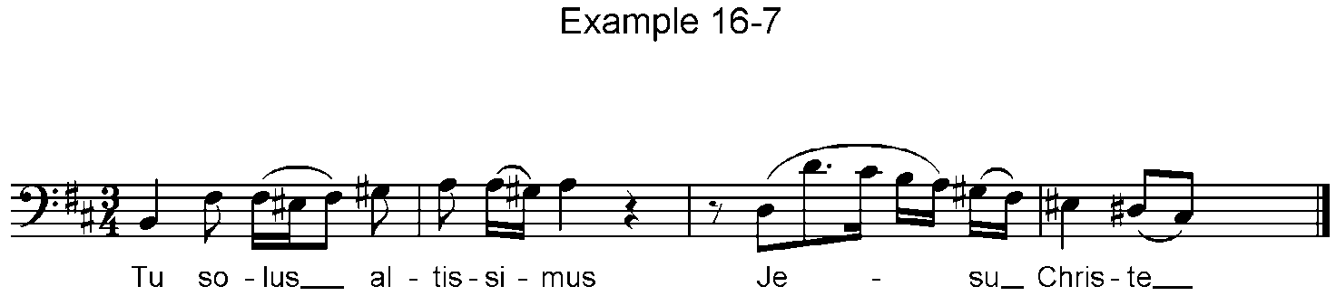 ;2,JESU ,CHRISTE

16-8. When two or three syllables or vowels are merged on one note, the sign =B= or =L= is placed after the note affected. In the word text, the syllables or vowels to be merged are enclosed between the signs =8= and =0=.

Example 16-8.

<#F8

,FINCH! L'A8RIA ! AN0COR BRUNA1

"]GFHL.D I.E"

8E IL0 MONDO TACE4

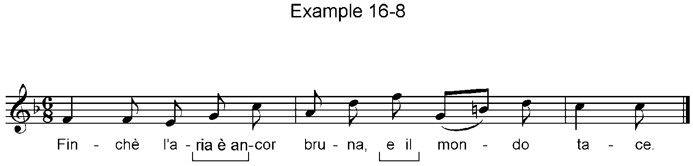 .GB"HC*JE ?D<K

16-9. When songs are printed in two or more languages, the number of syllables in a measure may vary between the different texts. Slur signs followed by "finger" signs are used to indicate to which language they apply. In the third measure of Example 16-9, the first slur applies to both languages; the second slur applies only to the second language.

Example 16-9.

<<#B4

,'"WBGG .?"GX .:)'CNZ'BCBP ?V<K

;28,VOI0 CHE SAPETE1 CHE CO8SA

!0 AMOR1

;2,YOU WHO HAVE KNOWLEDGE1

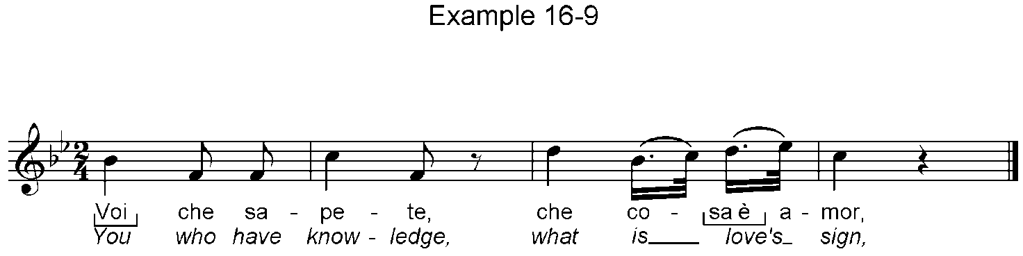 WHAT IS LOVE'S SIGN1

16-10. When there is a difference in syllables in a melodic repetition of one verse or between two verses of the same language, the slur =_C= indicates that the slur applies to one set of words only.

Example 16-10.

%#D4

;2COME YE TO ,BETHLEHEM2

;2CITIZENS OF ,HEAVEN ABOVE6

,'"]_C\[W Q_C$'E Z<K

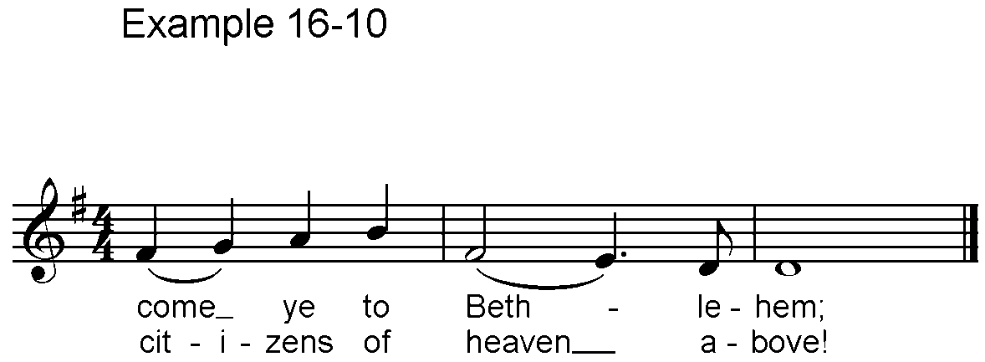

16-11. Breath signs are placed where they occur, and an octave sign is not required for the next note. Printed breath symbols vary in shape, and the symbol used by one composer for a half breath may be used for a full breath by another composer or music publisher. When it is not clear whether a half or full breath is intended, a transcriber's note should be included describing the shape of the print symbols with their braille representations. Example 16-11, in print only, shows the common symbols used in print for either a half or full breath.

Example 16-11.

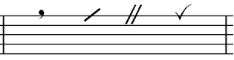

16-12. Except for printed repeats in the music, the only braille repeats advised are the measure repeat for short measures and the braille segno (for very long and obvious repeats such as the final repetition of an aria after the middle section).

16-13. Words or phrases of the text are repeated by using the sign, =9=, placed before and after with no intervening space. If the repetition is to occur twice (to be sung three times), the sign is doubled **either** before or **after** (not both). If more than twice, a number is combined with that sign. The number shows the **repetitions**. Example 16-13 in braille only, shows both ways of marking "Amen" when it is to be sung six times.

Example 16-13.

#E9,AMEN9 (or) 9,AMEN9#E

16-14. Temporary divisi parts or alternative notes are written as intervals or as in-accords. If written in small print, the small-type sign, =,5= (Table 1 A), must be used.

16-15. A separate indication of vocal range should be brailled as printed.

Example 16-15.

>/L":.[<K

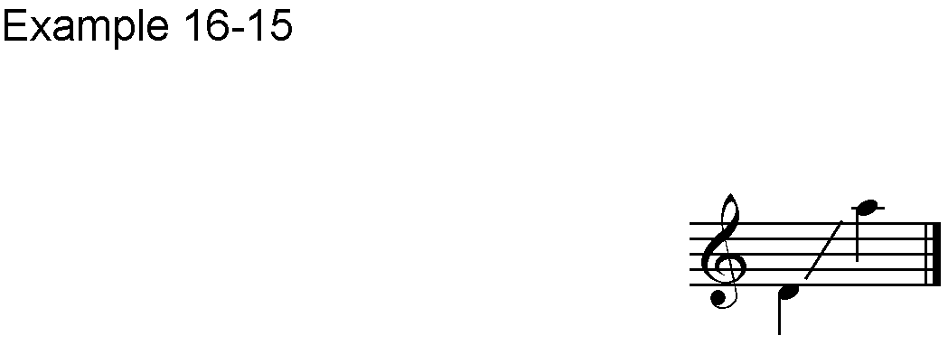

16-16. Hyphens printed between syllables for vertical alignment with notes are not included in braille.

16-17. When tenor parts are printed in the G clef an octave above actual pitch, they are generally transcribed in braille at the actual pitch to be sung.

16-18. A vocal ensemble or choral score is a logical extension of the format in use for solo music with lines or sections of music for each voice part. When the text is the same for all parts, it is given only once; when text varies, it appears separately for each voice.

16-19. Keyboard accompaniments do not appear as a part in a choral score. They are transcribed separately and usually include an outline of the important themes, voice entrances, or other features of the ensemble. Instrumental accompaniments have their own score, including piano if used, also with an outline of the vocal music

## XVII. String Instruments

(Table 17)

### A. General Signs

17-1. The music for string instruments is brailled using all of the previous signs that apply.

17-2. Because of the lack of standardization in print symbols for strings, positions, barrés, harmonics and other features, it is essential that the transcriber have a thorough knowledge of string music, preferably as a performer.

17-3. Some countries use clef signs as a prefix for all instrumental music. When clef signs are used, they determine the direction for intervals and in-accords. The C clef reads downward for viola and upward for violoncello and bass. In the absence of clef signs a note should be included. The form used in Example 17-3 may be helpful.

Example 17-3.

"?/ 33 "?<>":

17-4. The G clef with a little "8" below, sometimes used for plucked instruments, indicates that the notes sound one octave lower than printed, but the music is transcribed at the printed pitch.

Signs from Table 17 A.

=%a= 1st string =%k= 5th string

=%b= 2nd string =%2= 6th string

=%l= 3rd string =%'= 7th string

=%1= 4th string

* * *

17-5. In print, strings are indicated with roman numerals, arabic numbers or letters. A note should be included stating the method used in print. When word-letter combinations such as "sul G" appear, they should be transcribed as they are in print.

17-6. An octave mark is not required for the next note after a string sign.

17-7. Lines of continuation are shown by the principle of doubling; only the second character of the sign is written twice.

Example 17-7.

.C

#A %1"?:$] \%LL[W? :?W[

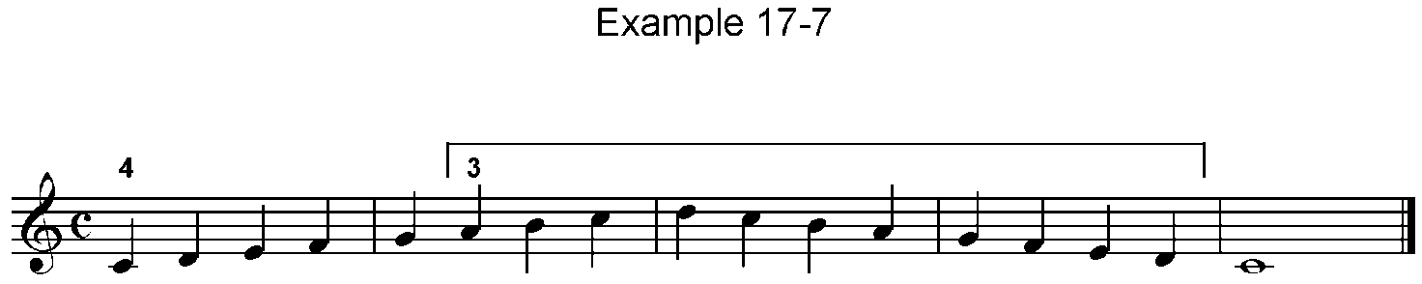 "\]$%L: Y<K

Signs from Table 17 B.

=>>= 1stposition/fret =,>3= 7th position/fret

=>/= 2ndposition/fret =>-= 8th position/fret

=>+= 3rd position/fret =>-/= 9th position/fret

=>#= 4thposition/fret =>-+= 10th position/fret

=>9= 5thposition/fret =>>/= Half position

=>0= 6thposition/fret

=@a= Glissando or shift to a new position

=@a'= Beginning of shift line

=,@a= End of shift line

* * *

17-8. Position/fret signs usually follow string signs and precede bowing or plectrum signs. The word "position" is used for instruments that have a smooth fingerboard, and the word "fret" is used for instruments that have frets on the fingerboard.

17-9. In print, position or fret signs usually are roman numerals or arabic numbers. A note should be included to describe the type of print marking used.

17-10. The next note after the position or fret sign must have an octave mark.

17-11. A line of continuation following a position sign is shown with two dot 3s, =''=. The sign for the end of this line, =>'=, follows the last note affected and is not used if another position sign follows immediately.

Example 17-11.

%%#D4

>9'';ZFGF Z.IGFZ"I>>"GF"

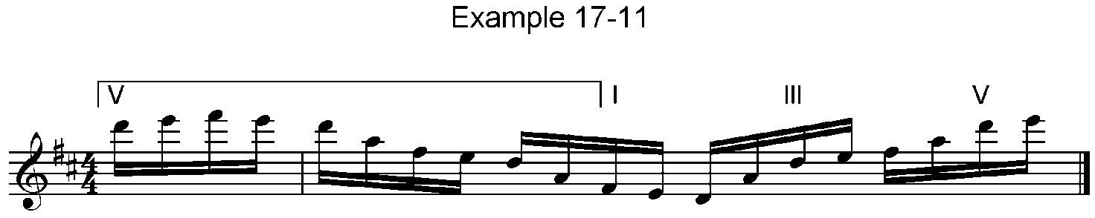ZI>+.EF=I>9;EF<K

17-12. For the fingering of bowed and plucked instruments, see Chapter VIII, Fingering. Part B contains signs and examples.

17-13. Shifting lines are commonly found in guitar music and occasionally in bowed string music. They look like glissandos in print and in braille, but unless the word or abbreviation for glissando is present, the slanting lines indicate shifting to another fret or position. The sign is placed between the notes affected. If the word "glissando" or an abbreviation appears in print, it should be included in braille.

17-14. When intervening notes appear, it may be necessary to indicate the beginning and the end of the shift using the signs above. Always use the standard sign when possible. Example (a) illustrates the standard shift, and Example (b) illustrates the need for and the use of the beginning and ending signs.

Example 17-14.

(a)

#C4

.[1@A\'1G<>V":[<K

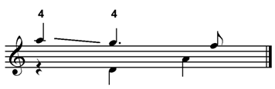

(b).

#D%#I8

.JHF;D1@A'.HF,@A;E1@A'.HF L

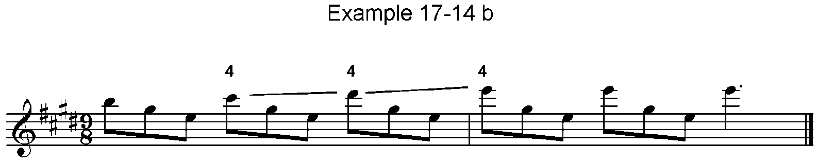,@A;F1.HF;F.HF;$'<K

17-15. The sign for glissando is placed after the first of the two notes affected. If a slur is also printed, the slur sign precedes the glissando sign. If the word or abbreviation for glissando appears in print, it should also appear in braille.

Signs from Table 17 D.

=k= Natural harmonic or open string

=*l= Artificial harmonic

* * *

17-16. Natural and artificial harmonics are identified by print shape. The sign for artificial harmonic is used for diamond-shaped notes; the sign for natural harmonic is used when a round note that is not an open string has a zero above it.

17-17. The sign for natural harmonic follows the note; the artificial-harmonic sign precedes the note and is separated from it only by an octave mark and/or an accidental. Words or abbreviations such as "art. arm." are always included as word text.

17-18. When fingering is given for a natural harmonic, the fingering precedes the harmonic sign.

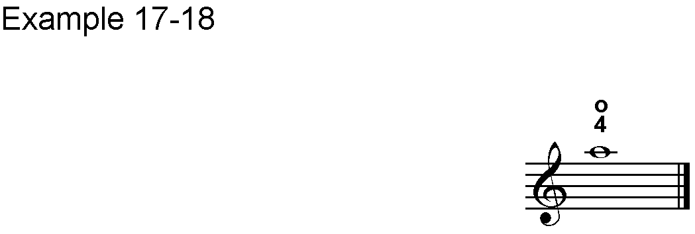Example 17-18.

.!1K<K

17-19. The signs for artificial and natural harmonics may be doubled for a series of more than three notes or intervals. The artificial harmonic sign is doubled as =*L*L=.

17-20. The following three examples illustrate harmonics and other features of string music. In Example 17-20, for guitar, the abbreviation "harm" is shown with a bracket to indicate which notes are harmonics. In braille, the line of continuation is used. Another bracket, with a roman numeral, shows that the hand should remain in third position, so a second line of continuation is used. Circled Arabic numbers indicate string signs.

Example 17-20.

#C4

%A>HARM''>+--.W1%B]L"\K

:K%2_$B>->'%A.\1<K

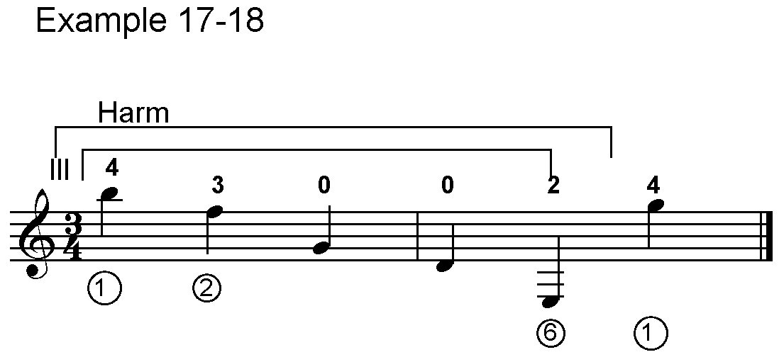

17-21. In Example 17-21, diamond-shaped notes are shown in addition to the print abbreviation, so the sign for artificial harmonic is used along with the abbreviation and its line of continuation. In this guitar example, the print has circled letters that contain names of strings, e.g., G, B, and E. The transcriber must understand all string instruments to know that G is 3rd string in guitar music, 4th string in violin music, 3rd string in viola music, etc. The bar line sign =L= is useful in complex string music.

Example 17-21.

%#B4

")K>HARM''%L*L*L.HF%BJ"

.(;F.J%L.D L 2;F>RALL'%B.F%LD"

%A*L.[A<L>'<K

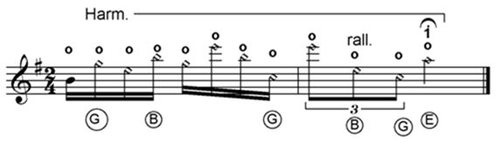

17-22. In Example 17-22, the abbreviation "arm" and the sign for twelfth fret are both included, as in print, to indicate the harmonic. Fingering, string, and fret signs are all indicated with Arabic numerals, so a knowledge of string instruments is again essential in order to determine the meaning of each number.

Example 17-22.

#E4

%11;B"IAJL?1JLIAJA%KHB"

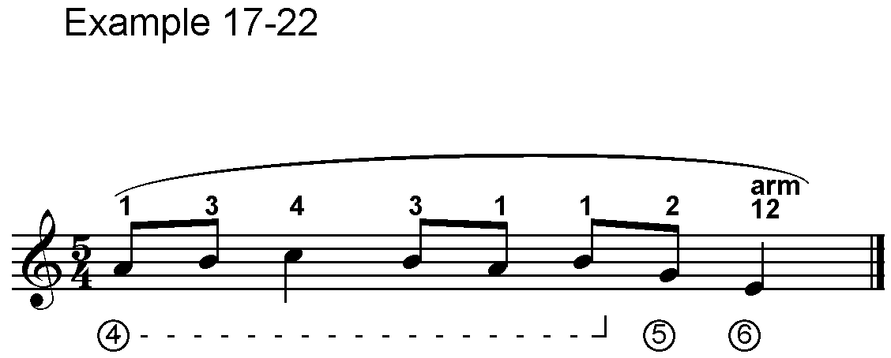%2>ARM'>-9"$^2<K

17-23. When resultants are printed for natural or artificial harmonics, they are written as small notes and placed in an in-accord. If two artificial harmonics are written as a chord, it is best to separate them with in-accords because the diamond-shaped notes do not produce the sound represented by the printed notes. The resultants may be written as chords, however.

Example 17-23.

>/L'*L"!#<>*L%"Y+<>,5;&%+<K

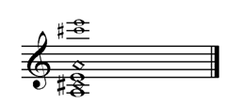

### B. Bowed Instruments

More signs from Table 17 D.

=<b= Down bow

=<'= Up bow

* * *

17-24. Bowing or plectrum signs usually follow string or positions signs. They may be doubled. If the phrasing slur, =;B=, is used, it generally precedes the bowing or plectrum sign.

Example 17-24.

%%#B4

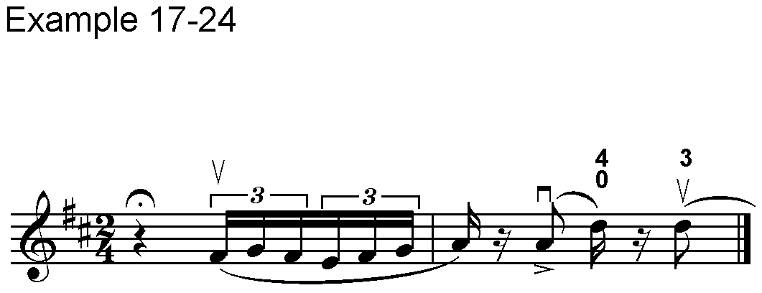V<L;B2<'"=HG2&GH !^2M<B.8IC"

.Z1KM<'ELC<K

17-25. On a bowed string instrument it is possible to play a three- or four-note chord, holding the top or bottom two notes longer than the others. When a single chord has notes of different values, in-accords are used as necessary.

Example 17-25.

>/L;Q.+"1":9"V.KV<L<K

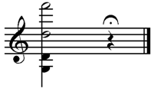

17-26. When print indicates that the left hand should execute pizzicatos (usually with a plus sign), the standard left hand sign precedes all notes so marked. This sign may be doubled. Example 17-26 is music for the violin.

Example 17-26.

%#F8

>/L_>.(_>.G_>.F8E_>.D_>"J"

_>"!8H_>"G_>"F_>"E8D

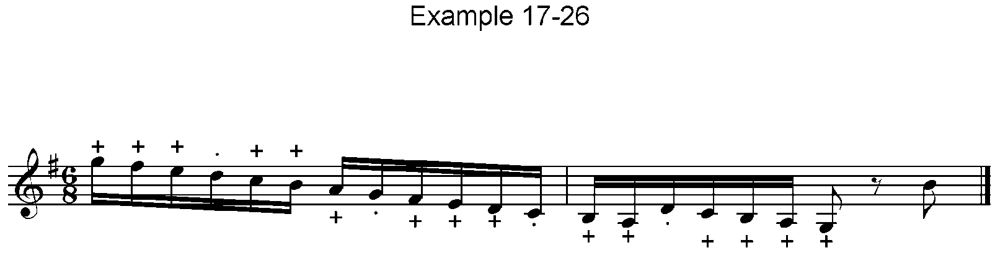_>_)_>_!8"Z_>_>"Y)!_>_HX"J<K

17-27. For scores with string instruments, see Examples 20-9 to 20-11.

### C. Plucked Instruments

Signs from Table 17 C.

=_= Grand or full barré

=^= Half or partial barré

=@= Vertical bracket barré

* * *

17-28. Barrés are indicated two different ways in print notation: (1) above the staff with capital letters alone or in combination with numbers or fractions that indicate whether the barré is full or partial; (2) on the staff with vertical brackets placed before notes or chords. For (1), a note should be included to describe the print notation. For (2) the bracket barré sign in braille indicates that a bracket appears in print.

17-29. Full barrés are usually indicated above the staff with "C" or "B". Indications for partial barrés include the C or B with a slash through them, 1/2C, 1/2B, PB, MC, MB, etc.

17-30. Barré signs immediately precede fret signs. Fret signs must be followed by an octave mark.

17-31. Example 17-31 shows a full barré followed by the roman numeral for 5th position/fret and a line of continuation that ends when the next barré and the roman numeral for third position/fret occur. Therefore, the end of the continuation line is not marked.

Example 17-31.

<#C8

_>9''.)BCD1JCI_>+.HCG<>

"HIJ<K

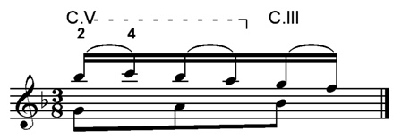

17-32. Example 17-32 shows a partial barré with an ending to its line of continuation.

Example 17-32.

<#C4

>D^>/''%.]+0"D.G+07>'<K

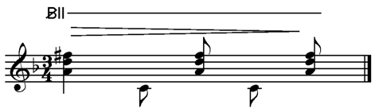

17-33. In Example 17-33, a bracket barré is printed vertically through the entire staff, showing that the barré includes the initial notes of both in-accord parts. Therefore, it appears at the beginning of both in-accord parts in braille.

Example 17-33.

<#D4

@>+X.Z&LG1IL%DE1XE<>

@>_\VV%K"]B<K

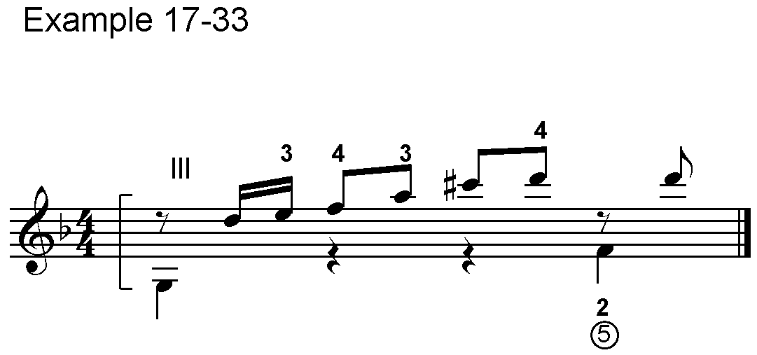

17-34. When the symbol for a barré is not followed by a fret symbol, it should be followed by the first character of a fret sign (dots 3-4-5) in braille. In Example 17-34 there is no symbol for fret, so the single fret character is used in both of the in-accords affected by the bracket barré.

Example 17-34.

%#B4

.$'@>.G<>"\@>"[<>"N<K

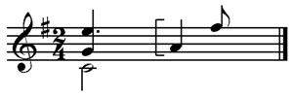

Signs from Table 17 D.

=<b= Down stroke

=<'= Up stroke

* * *

Signs from Table 11.

=>k= Arpeggio up

=>kk= Arpeggio down

* * *

17-35. In some guitar music the print symbol for "down stroke" is an arrow pointing up. The print symbol for "upstroke" is an arrow pointing down. (Moving the hand down across the strings causes them to be plucked from lowest to highest.) In other publications an arrow pointing up is the print indication of an upstroke, and an arrow pointing down indicates a down stroke. Therefore, a note should describe the print marking.

17-36. For Rasgueado (a special technique for the rapid strumming of chords both up and down), the arpeggio signs, rather than the stroke signs should be used. For an upward arrow, use the sign =>K=, and for the downward arrow use the sign =>KK=. If arrows go in both directions use both signs, following the print. Include the word rasgueado (with its different spellings) or any abbreviation, as printed.

Example 17-36.

#C4

>K.$+0-+V>RASQ'"

>K_5'"YFH.DF<K

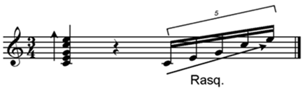

17-37. When Golpe (knock) is indicated, use the word or abbreviation according to print. When it is executed on a rest, the word or initial is placed before the rest. Otherwise, braille follows print placement, before or after a note, rasgueado or other feature.

Example 17-37.

#C8

>KK.F+0-+>G'X>G'X

>RASQ'>K_5'"NPR.NP>G'X>G'X<K

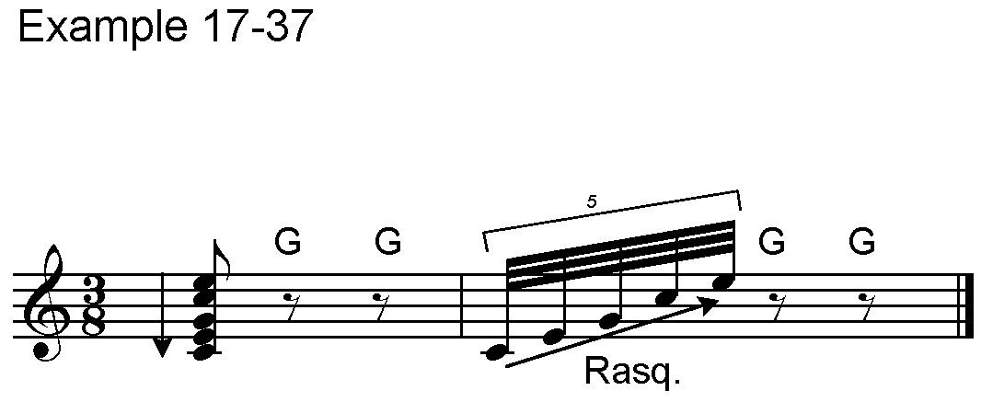

17-38. A slur that does not end on a note or the "slur into nowhere" =;C= requires careful recognition by transcribers. Example 17-38 contains music for guitar in bass clef with the intervals reading up. The knowledgeable transcriber realizes that the first slur does not end on a note and that its interval is not to be tied to the half note. The special slur sign is placed after both notes of the chord. If a slur is an indication of ornamentation for guitar, this slur sign can be used.

Example 17-38.

<<#C4

>#L^\;C9;C_O<>_T' ^\;C9;C"

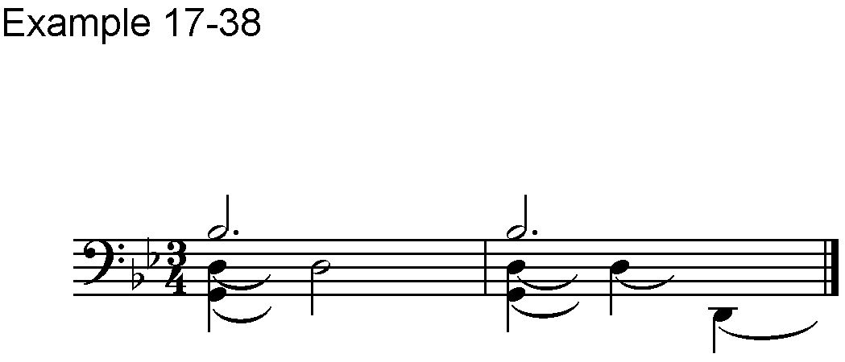 _:;C^:C<>_T'<K

17-39. Right-hand fingering for guitar is shown in Part B2 of Chapter VIII, Fingering; Signs from Table 8 B and in Paragraphs 8-10 & 8-11.

## XVIII. Wind and Percussion Instruments

(Table 18)

### A. Wind Instruments

18-1. Wind instruments make use of all the standard signs including others that have special meaning for winds.

Signs from Table 18 A.

=k= Letter **O** over or under the note

=<b= Plus sign over or under the note

* * *

Signs from Table 16 C.

=>1= Half breath

=,/= Full breath

* * *

18-2. The letter **O** signifies an open sound and often indicates for the player to remove a mute or adjust for a non-muted sound. This sign generally follows the note.

18-3. The plus sign usually indicates the place where a mute is to be added or a muted sound used. This sign may be found either preceding or following the note in transcriptions from different countries.

18-4. Breath symbols consist of commas, double slanted lines, and various other kinds of print marks. In some publications a comma indicates a full breath and in other publications it indicates a half breath. The same is true for the other symbols. The transcriber should determine the intended meaning, if possible, and include a transcriber's note describing the shape of the print symbol(s) with their braille representations.

18-5. Breath signs are placed where they occur, and an octave sign is not required for the next note.

Example 18-5. (Solo Tuba)

<#D4

>#L^&C(7&C!7GE_E^G \,/[,/"

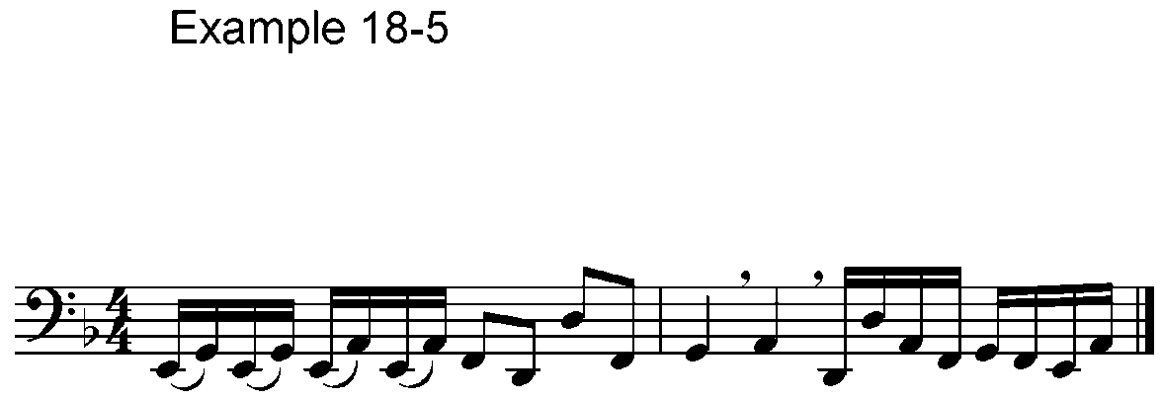^Z_E^IG(GFI<K

18-6. Parts for transposing instruments are brailled using the pitches that appear on the print page. When this happens in an ensemble or with keyboard accompaniment, each part may have a different key signature. The key signatures should appear at the beginning of each parallel or section.

Example 18-6.

,ANDANTINO4 #B4

"> M ''''''' >P"$CHCI<K

.>'<< >P"E++CD7 DCJ+7<K

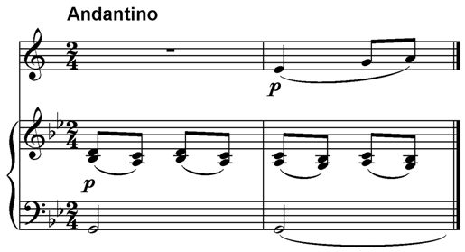_>'<< ^R '''''' R@C<K

18-7. When two-note chords appear in music for winds, interval signs or in-accords may be used, according to national preference.

18-8. Directions such as "à 2" or "solo" should be included as in print.

18-9. Accompaniments are brailled separately, and they usually include an outline of the solo part as shown below or a duplication of the solo part as in Example 18-6. Both examples are the same in print.

Example 18-9.

,ANDANTINO4 #B4

"> M ''''''' "$CHCI<K

.>'<< >P"E++CD7 DCJ+7<K

_>'<< ^R '''''' R@C<K

18-10. For unusual modern notation, see Section XIII, Modern Notation, as necessary. Example 18-10 is from a modern piece, but the tremolo repetition in thirty-second notes is standard notation. It indicates flutter tonguing to the performer. Use standard notation wherever possible.

Example 18-10.

(no time signature)

>PPP"\^1CF^1>P'8<;="

>PPP;B<"W^11C<[>D'<"\C"

<F^1^2>4<K

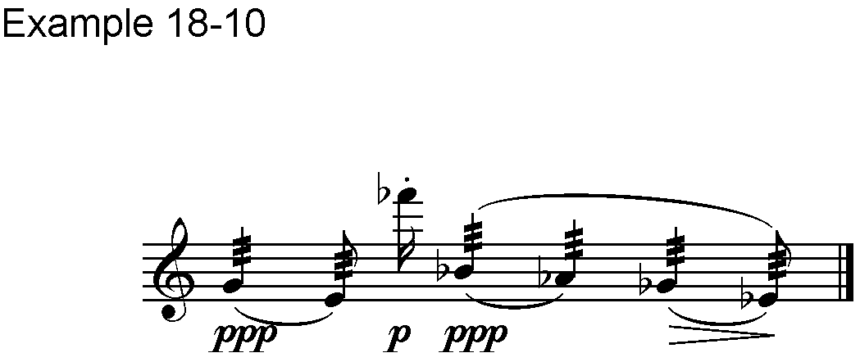

### B. Percussion

18-11. For melodic percussion instruments such as bells, xylophone, and harp, standard braille music notation is used.

18-12. For non-melodic percussion instruments, music is usually printed in one of two ways described below. A note should be included giving details of the print presentation including the number of lines used for the percussion "staff".

(1) A 5-line staff is printed with notes to represent the instruments to be played by one player. Each different note represents a different instrument; the notes are arranged melodically or in chords depending upon whether the player will be "hitting" one or more devices at the same time.

(2) Notes for each instrument are not written on a 5-line staff. Time signatures and note values are provided, but the notes are written along a single horizontal line, or, in some cases, two or three horizontal lines.

18-13. The 5-line staff for non-melodic percussion instruments has a time signature, note values, dynamics, and other details of performance. It does not usually have a normal clef sign. For braille transcription, notes are transcribed as if they are in the F clef. All other performance details are transcribed in the standard way. In-accords or intervals are used and intervals are doubled normally. Example 18-13 is from a solo for two tom-toms.

Example 18-13.

#D4

.8_D77HHHDD D.8HDD.8?9\

.8?'99.8D.C?V .8D.8?"

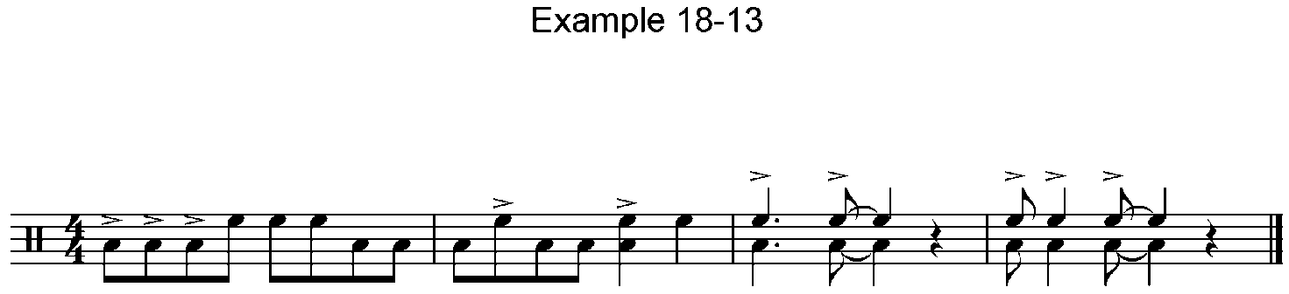.8D.C?9V<K

Signs from Table 18 B.

=l= Right hand

=a= Left hand

* * *

18-14. In print, letters such as R and L are commonly used to indicate the use of the right or left hand. In braille, the percussion hand signs follow the notes and are treated like finger signs. Example 18-14 is from an exercise book for snare drum.

Example 18-14.

#B4

<7.8_&LFA.8FL.8FA&LFL.8FAFL

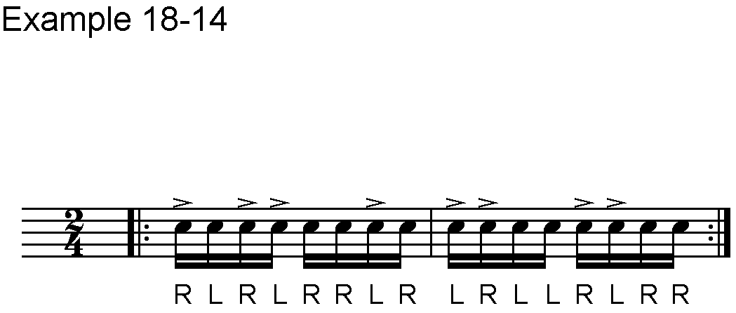.8&A.8FLFAFA.8&L.8FAFLFL<2

18-15. Indications for changing instruments, sticks, brushes, etc. are included as printed when words are used. If drawings or symbols are provided instead of words, there are two possibilities. Special signs may be devised or short abbreviations used, such as "hs" for hard stick. A transcriber's note should explain the signs or abbreviations at the beginning of the piece.

18-16. Example 18-16 is a fragment of music for two cymbals played in a variety of ways. The fact that the notes are X-shaped is noted in the list of instruments and does not have to be repeated in the music. All of the other symbols are pictorial in print. In this example, the "slur into nowhere”, =;C=, means that the tone from the cymbal is allowed to continue to ring.

Example 18-16.

^J ,LOW SUSPENDED ,CYMBAL

7,X-SHAPE NOTES7

_G ,HIGH SUSPENDED ,CYMBAL

7,X-SHAPE NOTES7

>RS' REVERSE END OF RATTAN

STICKS

>BR' BRUSHES

>DC' ON DOME OF CYMBAL

>CC' ON CENTER OF CYMBAL

>EC' ON EDGE OF CYMBAL

#C4

>EC>P^J;CXV>RS'V #B4 V"

>DC>PP'2_Q>CC^)>DC_Q>CC^)@C"

>SIM'2^T)_Q^T_Q@C

#C8 2_Q=Q.8^)@CJ;C>BR'X<K

Low suspended Cymbal High suspended Cymbal

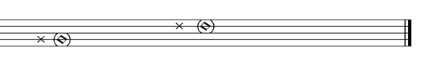

|  |  |
| --- | --- |
| reverse end of rattan sticks | on dome of cymbal |
| brushes | on centre of cymbal |
|  | on edge of cymbal |

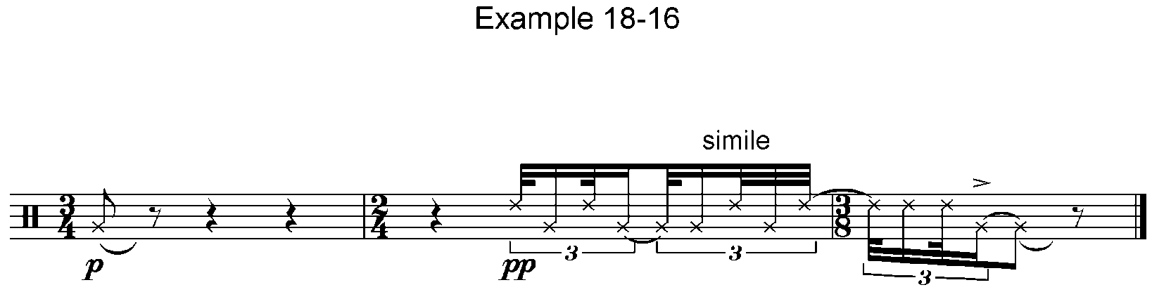       *simile *

18-17. Percussionists speak of "flams," "rolls" and use other terminology that differs from keyboard music, but the notation on the print page is followed as if it is keyboard music. Example 18-17, a drum solo, has a flam (short appoggiatura) and rolls (repetition as 16th and 32nd notes). This type of percussion music can be found either on a staff or on a single print line.

Example 18-17.

#B4

_F^LC .8FX.8$^1C .8F2&&&7

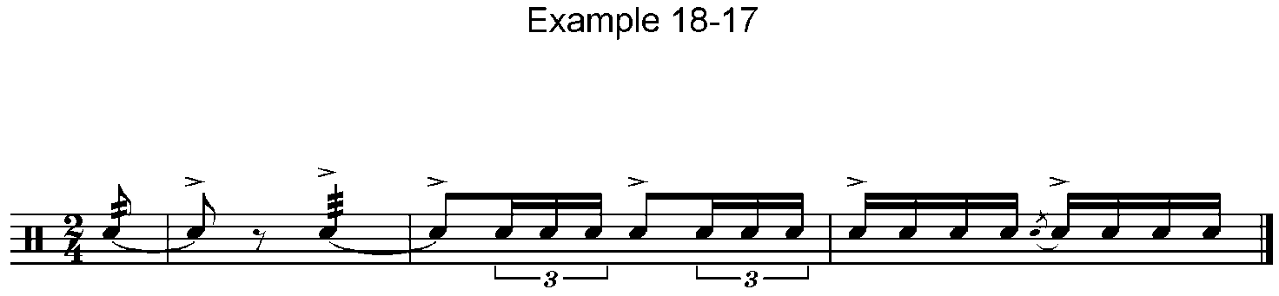.8&&&&5FC.8&FFF<K

18-18. When there is a print explanation showing which notes are assigned to which instruments, this must be included and may be transcribed as shown in Example 18-18. When several parts appear on one staff, they are played by one performer and are transcribed with chords or in-accords. When they appear on individual staves, as below, they are transcribed separately.

Example 18-18.

?7#ABJ-AFJ #D4

,TIMBALE ,'.8_HFF.8HFF.8HF 7<2

,CLAVES ,'_$X$X$ V$$V<2

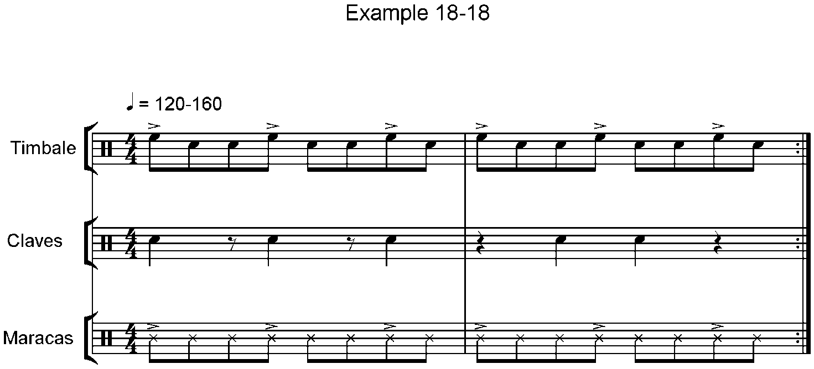,MARACAS ,'.8_EEE.8EEE.8EE 7<2

18-19. When the notes appear on a single line, a single note name is provided for the notes with their time values. The note C is commonly used, the note D is sometimes used, and, as below, other notes may be selected.

18-20. In Example 18-20, printed on a single line, the direction of stems indicates different instruments. The notes for small drum all have stems that go down; the notes for triangle all have stems that go up. The instruments are identified at the beginning and stems become the identifiers for the rest of the piece in print. In braille, a note is assigned for the drum and a different note is assigned for the triangle.

Example 18-20.

=_]= SMALL DRUM

="W= TRIANGLE

#C4

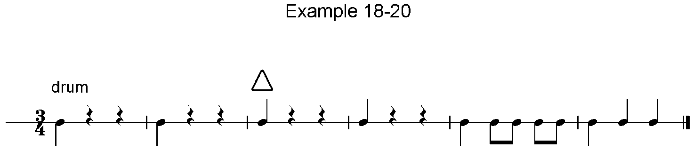 _]VV 7 "WVV 7 _]GG7 ]"WW<K

## XIX. Accordion

(Table 19)

Signs from Table 19 A.

=,>= Prefix for accordion music

**Rows of buttons**

=@= First row – dash below the note (contra-bass notes)

=^= Second row – no indication (bass notes)

=_= Third row – 1 or M (major chords)

="= Fourth row – 2 or m (minor chords)

=.= Fifth row – 3, S or 7 (seventh chords)

=;= Sixth row – 4 or d (diminished chords)

=,= Seventh row – (varying indications)

=,,= Eighth row – (varying indications)

=@@= Row zero – (varying indications)

* * *

19-1. The accordion signs apply only when the prefix =,>= is used for the left hand part of the music *1.

[*1 Signs for the Russian accordion, bayan, are different. These are explained in: Shamina, U.I.; Klevezal, G.P.; and Smirnov, G.A. **Notnaya Sistema** **Brailia**. (Moscow: Prosveshcheniye, 1978), Vol. IV, pp. 165-203.]

19-2. In print, the bass notes (first 2 rows of buttons) are usually written in the lower part of the staff with stems going up. Notes representing chords (remaining rows) occur in the upper part of the staff with stems going down. Octave marks are unnecessary, so these signs are used to number the rows of buttons. A row sign remains in effect until a new row sign appears.

19-3. In some countries the signs for rows of buttons precede the notes immediately and are not to be separated from them by any other signs except accidentals. In these countries a row sign is placed before a sharp, flat or natural.

Example 19-3.

.C

,>^?_?@$_? ^\.\^W.\<K

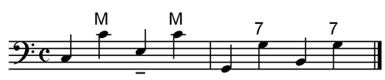

Signs from Table 19 A.

=<b= Draw (V pointing left)

=<'= Push (V pointing right)

=>1= Cesur (neither draw nor push)

=>bs'= Bass solo (B.S.)

=>r'= Register

=>wr'= Without Register (use printed initials)

* * *

19-4. Abbreviations are placed in the accordion part unspaced. The print initials should be used, and the abbreviations are followed by dot 3. For example:

S.R. (for "senza registro") =>SR'=

19-5. Fingering is included in the following bass solo.

Example 19-5.

#D4

,>'>BS'^DLX@JBXI1X^HBX G1X"

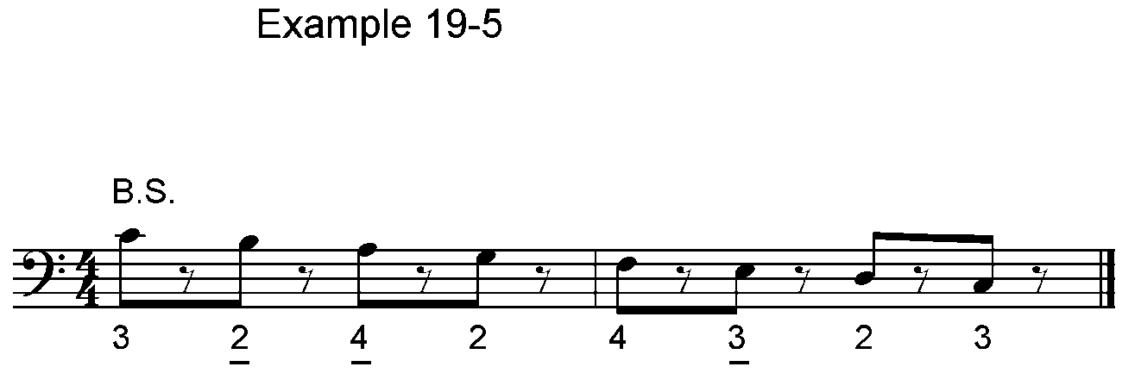@FLX^EBXDLX<K

19-6. The registration information from the circular symbols (see Table 19 B) must be followed by dot 3 and placed in the accordion part without spaces. A space is necessary before the registration only when it follows a time signature.

Example 19-6.

#1 1-4

.>_C >#H'V>P"$+0C.8\<+<0C%]+0

V\<+<0C.8<W<+<0C[+0

V%[%+%0C.8%?*+0C%W%+%0

V%?+0C.8$*+0C%:+%0<K

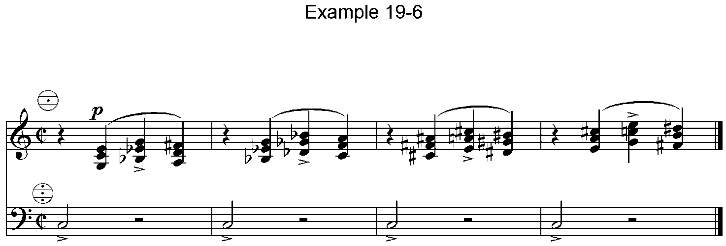,>_C >#D#H#AF'.8^NU 7#C<K

19-7. If registration symbols other than those in Table 19 B appear, a note of explanation should be added. If the print registration is numbered, the print order must be followed in braille. When the registration circle has three cross-lines (as in Example 19-6), a dot in the top section represents "2 ft." =>#B'=

19-8. If there is fingering for both piano accordion and button accordion, the fingering for piano accordion must be written first in the braille. A transcriber's note should record that fact.

19-9. When notes for chords stand over basses of identical time value, being played simultaneously with them, these chord notes can be written as intervals preceded by the row signs. In this case each row sign applies to one interval only.

Example 19-9.

#C8

,>^?_-X :"-X $_0X ]_-X \_-X

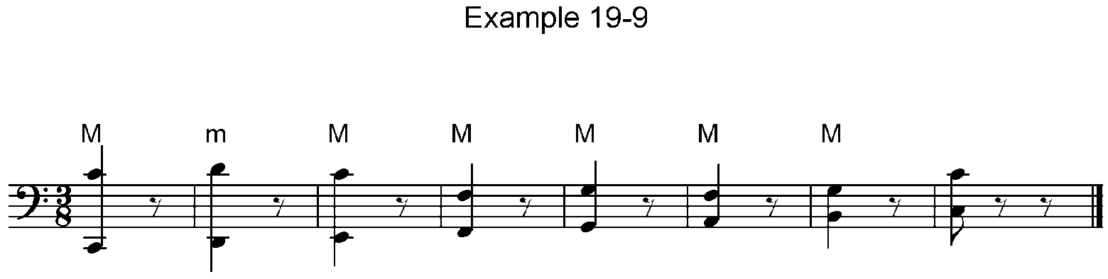[_0X W_0X D_-XX<K

19-10. Intervals may be doubled, but the doubling must be broken before a change of row.

Example 19-10.

%#F8

,>^\'_--.CHHH_- ['"--.CIII"-

W'_--.CJJJ ?'.CDDD :'.CEXX

W'.CJJJ_- ['"-:'.- \'_-.CH_-"

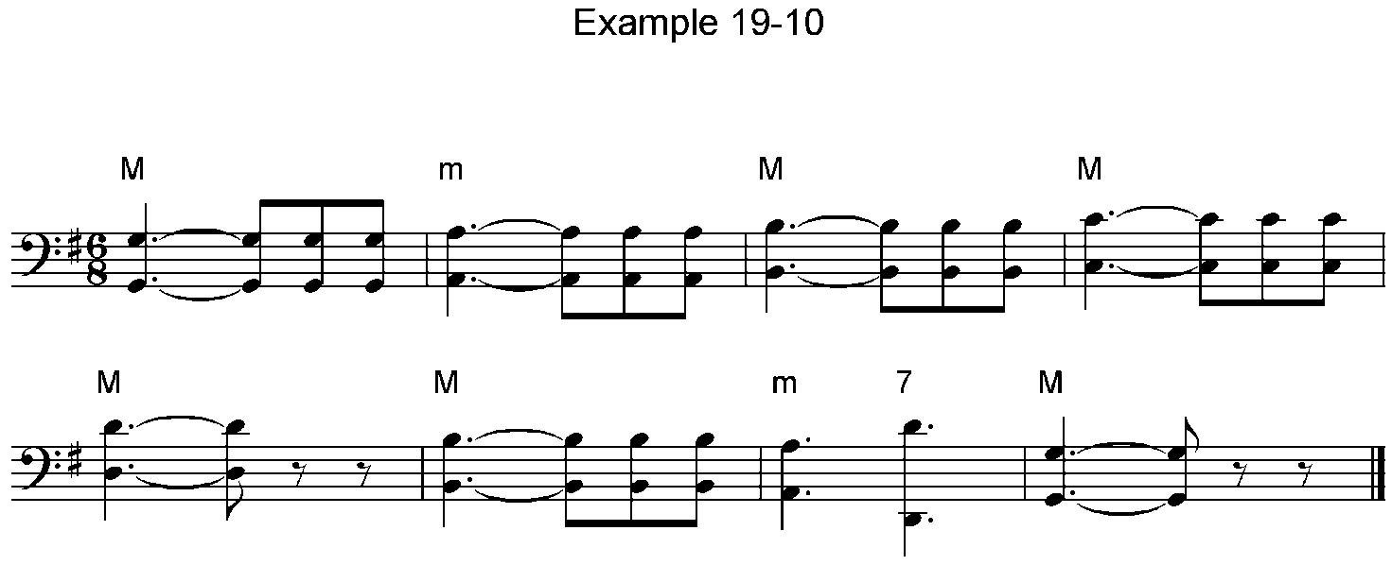XX<K

19-11. When there is a change from normal chord accordion to melody bass, the sign for left hand, =_>=, is inserted, the letters "BAR," or other print indications are included, and octave signs are used. When the prefix =,>= reappears, it indicates the return to chord accordion with row signs.

Example 19-11.

,>'%% ^[C.-.8@F"+<L,/^IC.-C

OC@C<>_:"\C ^E_-X_>'>BAR';B^\

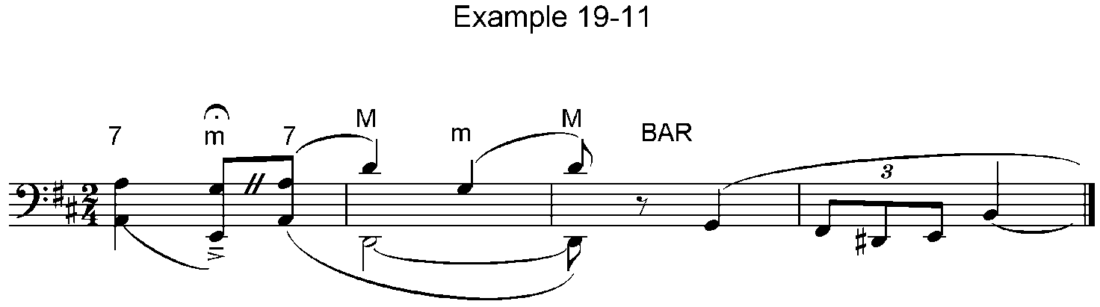 2G%EFW@C<K

19-12. The right hand part is written as in other keyboard music. The signs for draw and push are placed in this part and do not require an octave mark for the next note.

Example 19-12.

#D4

.>'>MF'<B"DAFBGLH1IKH1GLFB

<'EAGBHLI1JKI1HLGB<K

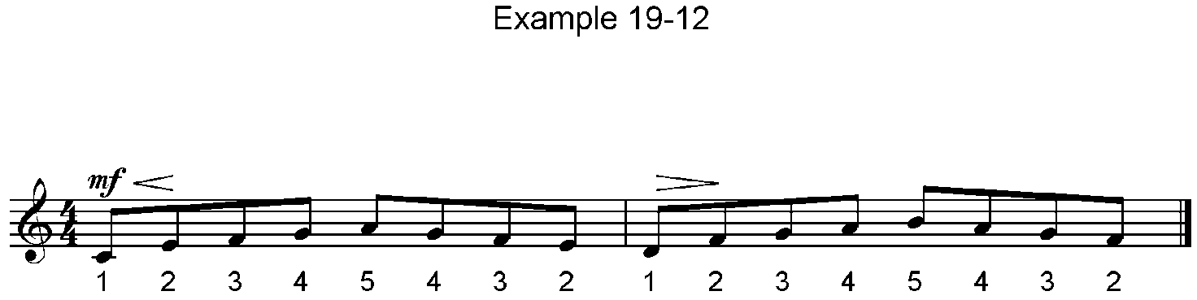

## XX. Instrumental Scores

20-1. A listing of instruments as shown in print is provided in braille along with the abbreviations that will be used in the braille score. These abbreviations are generally written in the language of the country of transcription, consist of 2 or 3 letters, and are followed by a dot 3.

20-2. Usually, all parts are shown on the first page; on succeeding pages, if a part is silent, it is not shown.

20-3. If clef signs are included, they need only appear on the first page or when a part appears for the first time.

20-4. Unless all instruments play in the same key, key signatures follow the part name on every page of the score.

20-5. Information about rehearsal letters, measure numbers, and/or page numbers appears on a free line above each parallel or section.

20-6. When chords or in-accords appear, all parts should read in the same direction. The direction should be made clear at the beginning of the score, for example:

Y/ 33 Y<>Z

20-7. Divisi parts may be written as chords or in-accords, but the following system helps identify the parts and also indicate the directions of intervals. The example is for trumpet in two parts (lower-cell numbers "2 1") to be read from the bottom up.

>TPT21'

20-8. Parallel motion may be used for parts immediately adjacent in the score. For very important, obvious lines doubled at some distance from another part on the page, it can be treated as follows:

>VL1'< "->FL1'

20-9. Example 20-9 (a) contains the list of instruments for Beethoven, Symphony No. 3 with English abbreviations for the parts. This is followed by (b) which contains the first six measures of the first movement. In this score all intervals read up. The identification before the score indicates that this section contains measures 1-6 from the first system on page 1 of the print score. [Double bars have not been added to the examples in this chapter.]

Example 20-9.

(a)

,,SYMPHONIE ,NO4 #C

,L4 VON ,BEETHOVEN

,OP4 #EE

#B ,FL@OTEN '''''''''''' >FL21'

#B ,HOBOEN ''''''''''''' >OB21'

#B ,KLARINETTEN IN ,B >CL21'

#B ,FAGOTTE '''''''''''' >BS21'

#C ,H@ORNER IN ,ES

>HN21' ''''''''''''''' >HN3'

#B ,TROMPETEN IN ,ES ''' >TR21'

,PAUKEN IN ,ES-,B '''''' >TIM'

#A4 ,VIOLINEN '''''''''' >VL1'

#B4 ,VIOLINEN '''''''''' >VL2'

,BRATSCHEN ''''''''''''' >VLA'

,VIOLONCELLI ''''''''''' >VC'

,KONTRAB@ASSE '''''''''' >CB'

(b)

,' ?/ 33 ?<>:

,ALLEGRO CON BRIO4 #C4

#1-6 "3#1'A

>FL21'>/L'<<< >F'8.W#VV 7 MM

<7MM

>OB21'>/L'<<< >F'8.$+VV 7 MM

<7MM

>CL21'>/L'< >F'8"[0VV 7 MM

<7MM

>BS21'>#L'<<< >F'8_$-VV 7 MM

<7MM

>HN21'>/L >F'8"$0VV 7 MM

<7MM

>HN3'>/L >F'8.?VV 7 MM <7MM

>TR21'>/L >F'8"?VV 7 MM

<7MM

>TIM'>#L >F'8_$VV 7 MM <7MM

>VL1'>/L'<<< >F'8_\0+-VV 7 MM

<7MM

>VL2'>/L'<<< >F'8_\0.0VV 7

>P"R'^B 7 <7"R'^B 7

>VLA'>+L'<<< >F'8_\0VV 7

>P_T'^B 7 <7_T'^B 7

>VC'>#L'<<< >F'8_$VV 7

>P_PC\C PC^W <7_$C\CW PC:C

>CB'>#L'<<< >F'8_$VV 7 MM

<7MM

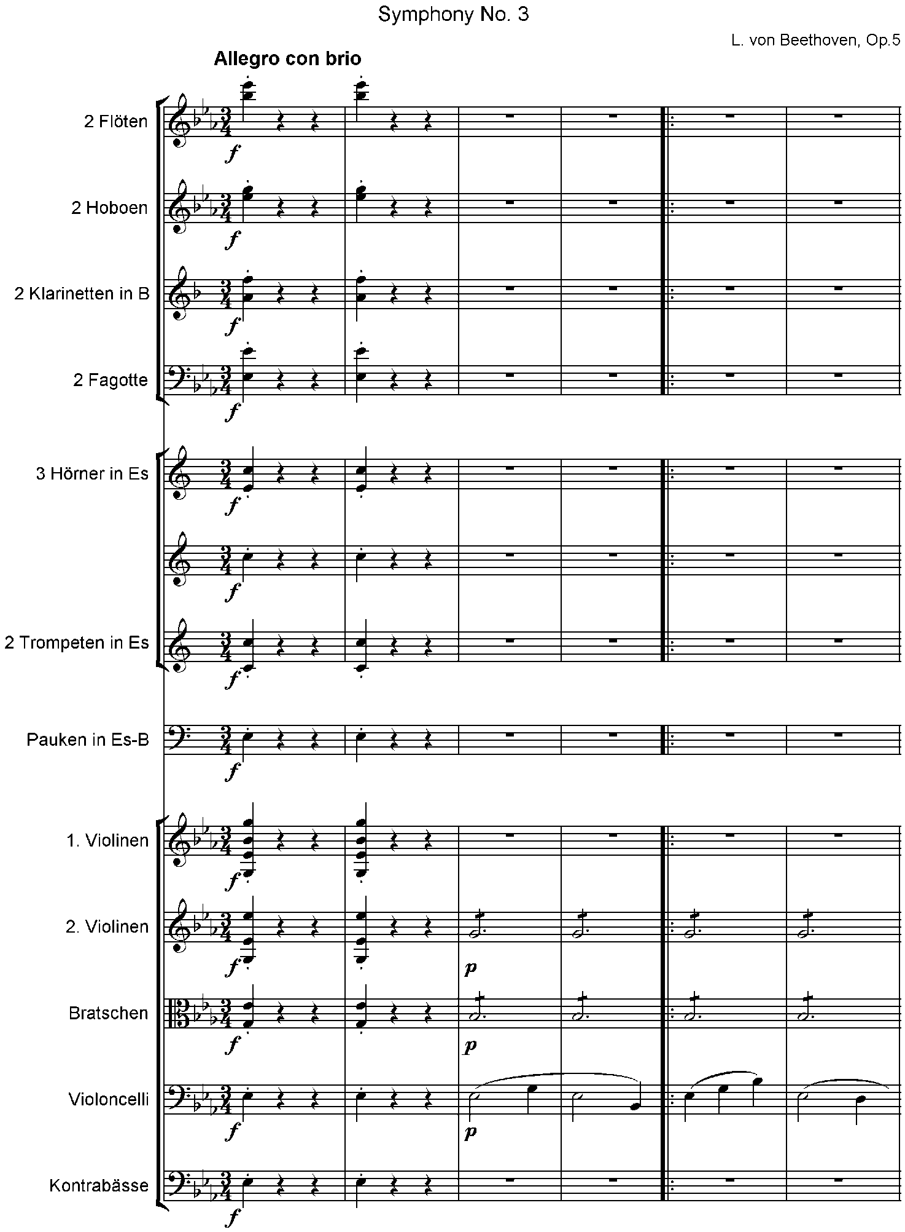

20-10. The next example contains the next four measures of the same symphony. The instruments that are silent do not appear in either the print or the braille score. In order to show an additional format possibility, this segment is written bar-over-bar.

Example 20-10.

7#G7

>VL1'<<< X>P>CRESC'.\\H@C H\\H@C

>VL2'<<< >CRESC'"R'^B R'^B

>VLA'<<< >CRESC'_T'^B T'^B

>VC'<<< >CRESC'%_N'@C N'

7#I7

>VL1'<<< .R' '''''' >SF>D.S'@C

>VL2'<<< ;B"H_J77^2 >SF>D;B"G '''

>VLA'<<< _WVV ''''' >SF>D"S'@C

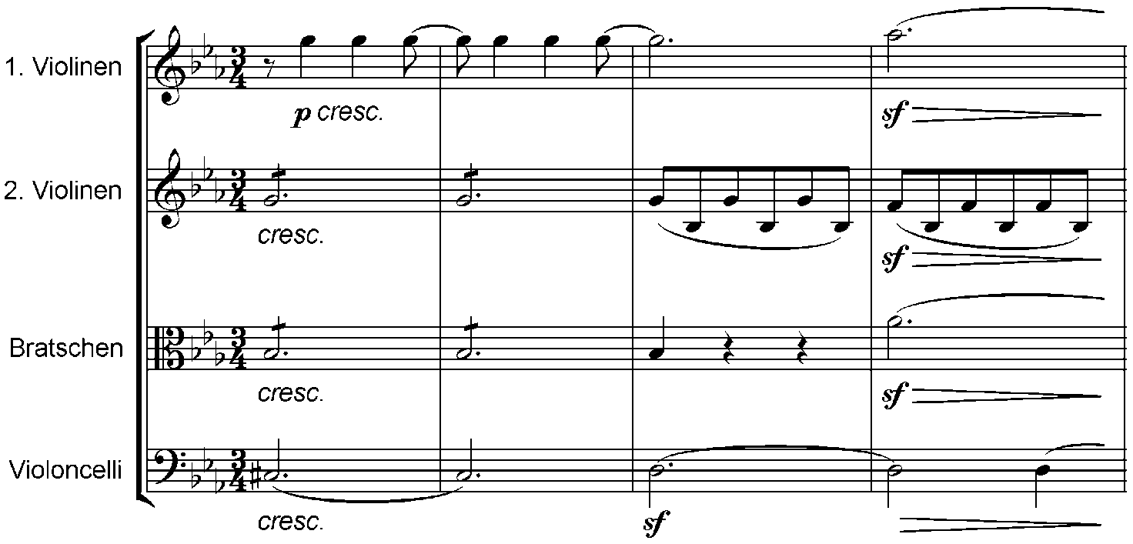>VC'<<< >SF_O'@C >D_O:C

20-11. Example 20-11 shows the beginning of Symphony No. 6 by Chaikowsky. The introductory information shows that intervals read down in this score. This excerpt contains measures 1-4. The print page and system numbers are both in the upper-cell position, and the meaning is clear. The print shows the full score, but the braille shows only the instruments that are active. When the other instruments enter for the first time, their clef signs appear. After that the clef signs are not repeated.

Example 20-11.

,SYMPHONIE ,NO4 #F

7,PATHETIQUE7

Y/ 33 Y<>)

,ADAGIO4 ,'?7#ED,' %%.C

#1-4 "3#C'A

>BS12'>#L'%% UV>SOLO>PP>C^FCG

>D^\C>C^Q>P>C^GCH >D^[C>C^R"

>MP>C^HCI >D^WC>C'%^S'

>VLA1'>+L'%% MMM UV>MF>C'<'_FCG

>VLA2'>+L'%% MMM >MP>C'<'_&

>CB12'>#L'%% >DIV'>PP'<'_)@C<>

>PP'<'_&@C _T@C>CRESC_T@C<>

_P>CRESC'%_O@C <B_)<>_O*O@C

<'_(<>_O%?*?

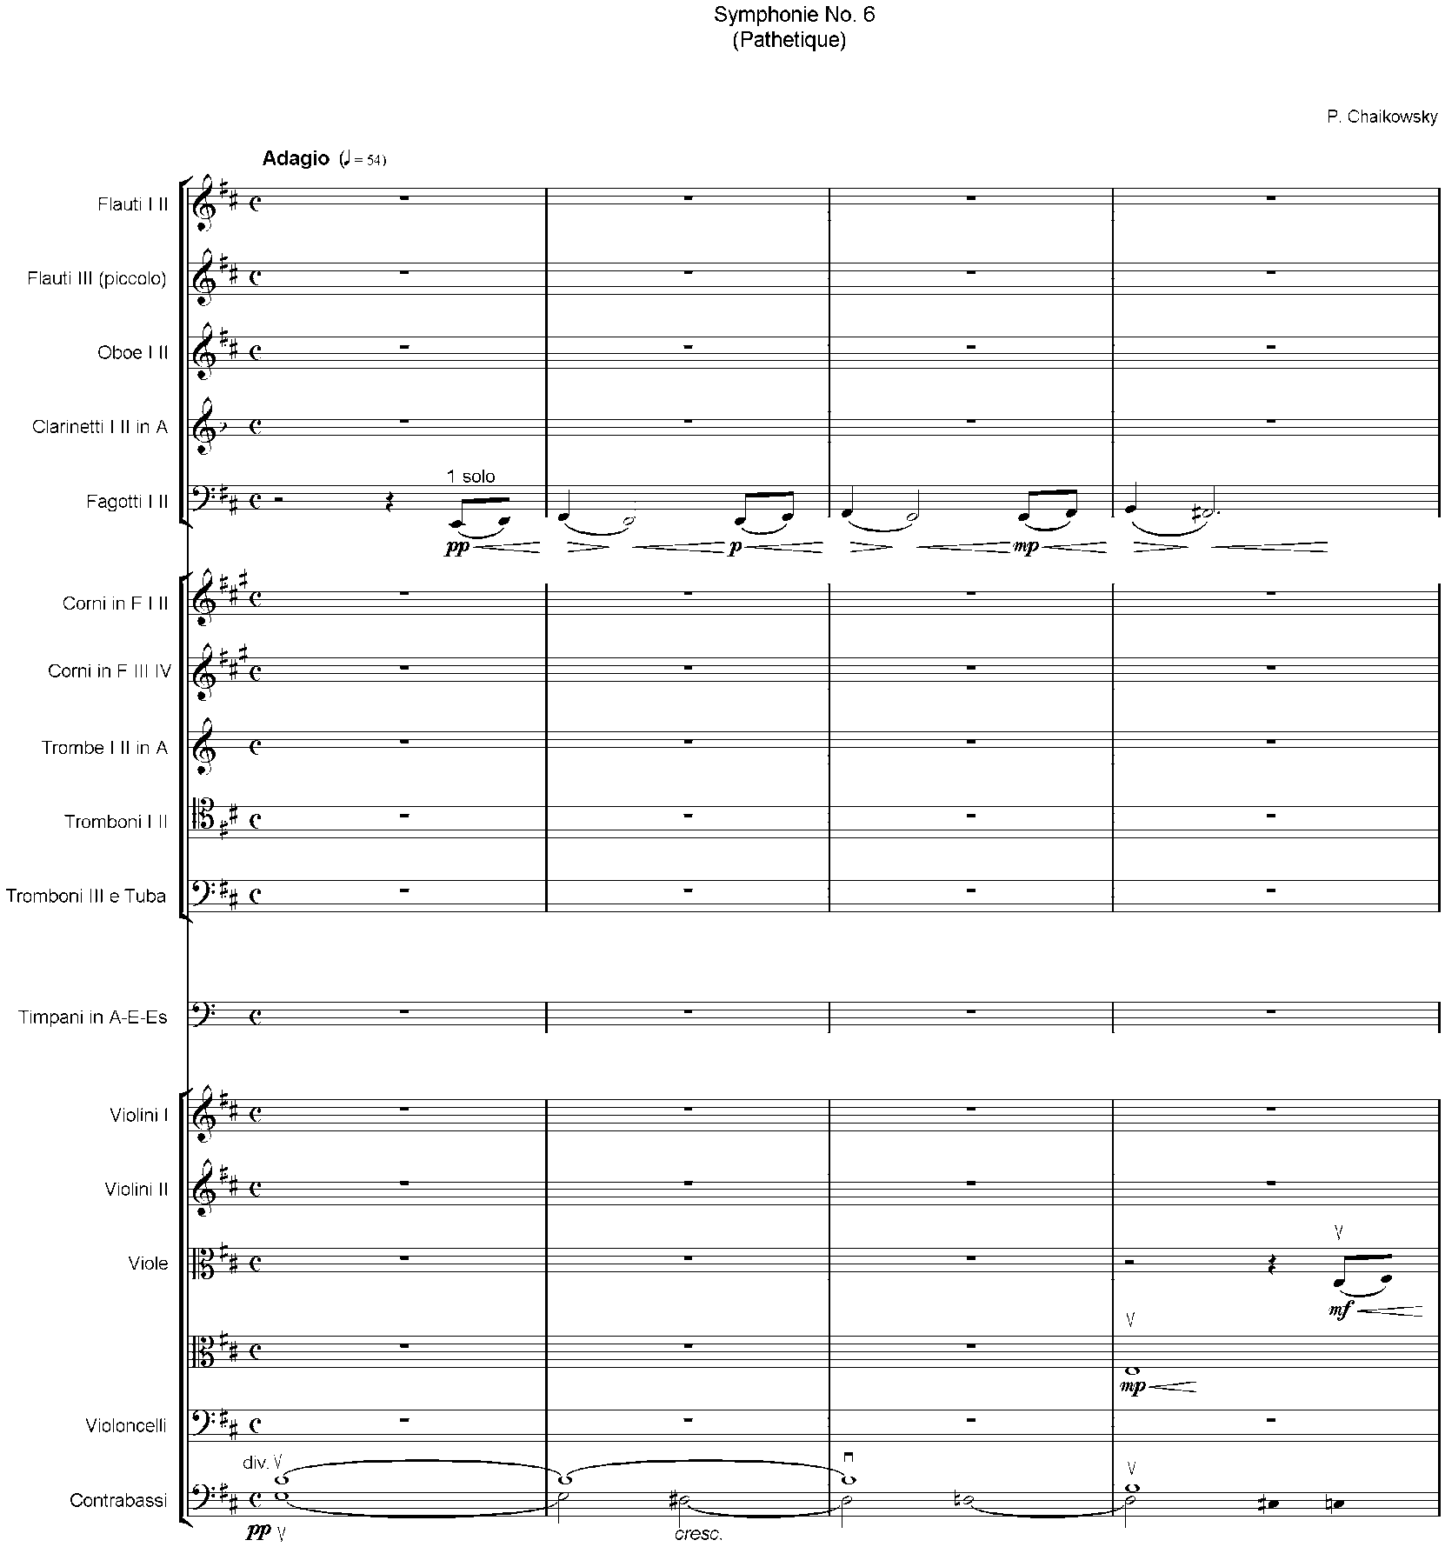

## Authorities for this Work

Music Authorities

**The New Grove Dictionary of Music and Musicians**. Edited by Stanley Sadie, London: Macmillan Press Limited, 1980.

Apel, Willi. **Harvard Dictionary of Music**. Second Edition, Cambridge, Massachusetts: The Belknap Press of Harvard University Press, 1972.

Minutes of Meetings and Working Groups

**Braille Music Conference, 1992, Saanen Switzerland**. Zürich: Braille Press Zürich, 1992.

“Working Group Meeting on Braille Notation for the Accordion”. Fredericia, Denmark, 1990.

“Workshop on Organ Music and Music Theory”. Eastbourne, United Kingdom, 1989.

“Workshop Studying Specific Sign Notation for the Guitar”. Madrid, 1988.

**BRAMCE, Braille Music Conference, 1987**. Marburg/Lahn: Deutsche Blindenstudienanstalt e. V., Marburg/Lahn, 1991.

“International Conference on Unification of Braille Music Notation and Publication of Music Literature for the Blind, 1982, Moscow”. Conference papers prepared by Gleb A. Smirnov, Moscow, 1982.

Sources of Print Illustrations

Association Valentin Haüy. **Notation Musicale Braille**. Conformé aux Décisions du Congrès International convoqué par American Braille Press, Inc. à Paris, en Avril, 1929. Paris: American Braille Press, Inc.

DeGarmo, Mary Turner. **Introduction to Braille Music Transcription**. Washington: Library of Congress, 1970.

Kerkhof, F. and Slegers, A. **Het Braille Muziekschrift**. Nijmegen: Instituut “Henricus” voor Visueel Gehandicapten, 1979.

Nielsen, O. Kjær. **Den Brailleske Nodeskrift. Dansk Revision, 1976**. København: Statens bibliotek og trykkeri for blinde, 1978.

Smirnov, Gleb A. **Zappsy Not Po Sisteme Brailia**. Moscow: Prosveshcheniye, 1988.

Spanner, H.V., comp. **Revised International Manual of Braille Music Notation, 1956**. Louisville, Kentucky: American Printing House for the Blind, 1961.

## National Signs of 16 Countries

In the international braille music code, the signs for plus, minus, oblique stroke, uppercase letters, lowercase letters, italicized letters, and a special letter sign, if used, come from the country preparing the transcription. These national signs are included here for 16 countries. In addition, countries that have accented letters have included the braille signs that may be encountered when reading vocal text or other literary material in those languages. Rules for transcription are not included; the signs are shown only as an aid for reading. It was not possible to include the Cyrillic or Japanese characters although some of the Russian symbols are included. The following countries are represented in alphabetical order:

Australia

Brazil

Czech Republic

Denmark

Finland

France and Switzerland (French)

Germany and Switzerland (German)

Italy and Switzerland (Italian)

The Netherlands

North America (Canada & U.S.A.)

Poland

Russia

Spain

United Kingdom

### National Signs of Australia

=;6= + plus

=;-= - minus

=/= / oblique stroke

=99= * asterisk

=#H@9= 8’ "foot" for organ music

=,D= D uppercase letter

=.D= *d* italic

=;D= d with letter sign

=@= Dot 4 is used for an unspecified foreign accent

### National Signs of Brazil

=5= + plus

=9= - minus

=/= / oblique stroke

=..d= D upper case

=_d= *d* italic

=,d= d with letter sign

Accented Letters

=(= **á** acute

=== **é** acute

=/= **í** acute

=+= **ó** acute

=)= **ú** acute

=*= **â** circumflex

=<= **ê** circumflex

=?= **ô** circumflex

=$= **à** grave

=>= **ã** tilde

=[= **õ** tilde

=\= **ü** diaeresis, umlaut

### National Signs of the Czech Republic

=4= + plus

=-= - minus

=]= / oblique stroke

=9= * asterisk

=.d= or =,d= D uppercase letter

=@d= d with letter sign

Accented Letters

=*= **á** acute

=%= **č** hacek, caron, wedge

=?= **d’** alif, hamza, apostrophe

=>= **é** acute

=<= **ě** hacek, caron, wedge

=/= **í** acute

=$= **ň** hacek, caron, wedge

=[= **ó** acute

=w= **ř** hacek, caron, wedge

=:= **š** hacek, caron, wedge

=\= **t’** alif, hamza, apostrophe

=+= **ú** acute

=)= **ů** overring, krouzek, circle above

=&= **ý** acute

=!= **ž** hacek, caron, wedge

### National Signs of Denmark

=6= + plus

=-= - minus

=/= / oblique stroke

=>59= * asterisk

=#h'= 8' "foot" for organ music

=.d= D uppercase letter

=,d= d lowercase letter

=;d;= *d* italic

=>d= d with letter sign

Accented Letters

Most accented letters are written normally and preceded by dot 5. For example ="a= **á à** acute or grave

The exceptions are:

=>= **ä æ** diaersis, umlaut or ae diphthong

=[= **ö ø** diaeresis, umlaut or oe diphthong

=*= **å** overring, circle above

In chord symbols the U.S. literary signs will be used.

### National Signs of Finland

=6= + plus

=-= - minus

=/= / oblique stroke

=,d= D uppercase letter

=.d= *d* italic

=;d= d with letter sign

Accented Letters

=>= **ä** umlaut, diaeresis

=*= **å** overring, circle above

=[= **ö** umlaut, diaeresis

=^= Dots 4-5 are used for an unspecified foreign accent

### National Signs of France and Switzerland (French)

=6= + plus

=-= - minus

=/= / oblique stroke

=#h'= 8’ "foot" for organ music

=.d= D uppercase letter

=_d= *d* italic

Accented Letters

=(= **à** grave

=*= **â** circumflex

=== **é** acute

=!= **è** grave

=<= **ê** circumflex

=$= **ë** diaeresis, umlaut

=%= **î** circumflex

=]= **ï** diaeresis, umlaut

=/= **ì** grave

=+= **ò** grave

=?= **ô** circumflex

=)= **ù** grave

=:= **û** circumflex

=\= **ü** diaeresis, umlaut

=&= **ç** cedilla

=[= **œ** oe diphthong

### National Signs of Germany and Switzerland (German)

=@6= + plus

=@-= - minus

="1= / oblique stroke

='= Full stop for sentence, abbreviation dot, or apostrophe in music context

=#h'= 8’ "foot" for organ music

=.d= D uppercase letter

=_d= *d* italic

=,d= d with letter sign

Accented Letters

=>= **ä** umlaut, diaeresis

=[= **ö** umlaut, diaeresis

=\= **ü** umlaut, diaeresis

=@= Dot 4 is used for an unspecified foreign accent

The signs for "plus" and "minus" may be preceded by dot 4 or 5 in some situations. The apostrophe in literary braille is dot 6, but dot 3 is used in music as above. Several capital letters in a row are marked with dots 4-5, i.e., BWV ^bwv

### National Signs of Italy and Switzerland (Italian)

=6= + plus

=-= - minus

=/= / oblique stroke

=#h'= 8’ "foot" for organ music

=.d= D uppercase letter

=_d= *d* italic

Accented Letters

=(= **à** grave

=!= **è** grave

=== **é** acute

=/= **ì** grave

=+= **ò** grave

=)= **ù** grave

### National Signs of The Netherlands

=6= + plus

=-= - minus

=/= / oblique stroke

=9= * asterisk

=#h'= 8' "foot" for organ music

=.d= D uppercase letter

=_d= *d* italic

Accented Letters

=>= **ä** diaeresis, umlaut

=(= **à** grave

=*= **â** circumflex

=$= **ë** diaeresis, umlaut

=!= **è** grave

=== **é** acute

=[= **ö** diaeresis, umlaut

=+= **ò** grave

=?= **ô** circumflex

=]= **ï** diaeresis, umlaut

=%= **î** circumflex

=\= **ü** diaeresis, umlaut

=)= **ù** grave

=:= **û** circumflex

=&= **ç** cedilla

### National Signs of North America (Canada and USA)

=+= + plus

=-= - minus

=/= / oblique stroke

=99= * asterisk

=#h FT4= 8' "foot" for organ music

=,d= D uppercase letter

=.d= *d* italic

=;d= d with letter sign

=@= Dot 4 is used for an unspecified foreign accent

### National Signs of Poland

=6= + plus

=-= - minus

=\= / oblique stroke

=9= * asterisk

=#h/= 8' "foot" for organ music

=^d= D uppercase letter

=,d= d lowercase letter

=_d= *d* italic

Accented Letters

=*= **ą** ogonek, Polish hook

=%= **ć** acute

=:= **ę** ogonek, Polish hook

=<= **ł** letter l with short cross-line

=?= **ń** acute

=+= **ó** acute

=[= **ś** acute

=&= **ż** z overdot

=!= **ź** acute

### National Signs of Russia

=6= + plus

=-= - minus

=.t= T uppercase letter

=^' ,b= ( ) round brackets

=_2 ;l= [ ] square brackets

### National Signs of Spain

=6= + plus

=-= - minus

Accented Letters

=(= **á** acute

=!= **é** acute

=/= **í** acute

=+= **ó** acute

=)= **ú** acute

=\= **ü** diaeresis, umlaut

=]= **ñ** tilde

### National Signs of the United Kingdom

=;6= + plus

=;-= - minus

=;7= equals

=/= / oblique stroke

=#h@9= 8' "foot" for organ music

=,d= D uppercase letter

=.d= *d* italic

=;d= d with letter sign

=@= Dot 4 is used for an unspecified foreign accent

## Index of Signs in Standard Braille Order

Numbers in parentheses are Table numbers. The table reference is followed by a Paragraph reference and, in italics, a Topic in the Index where additional references are located.

In the following diagram the sixty-three braille characters are arranged in seven rows, each sign having a reference number. The Index is divided into paragraphs, each headed by its own number.

Signs with two or more characters will be found. in the paragraph headed by the number of the initial character (e.g.=ca= is under 3; =*k= is under 31).

**Diagram of the 63 Braille Characters**

Signs 1-10: A B C D E F G H I J

Signs 11-20: K L M N O P Q R S T

Signs 21-30: U V X Y Z & = ( ! )

Signs 31-40: * < % ? : $ ] \ [ W

Signs 41-50: 1 2 3 4 5 6 7 8 9 0

Signs 51-56: / + # > ' -

Signs 57-63: @ ^ _ " . ; ,

Index of Signs in Standard Braille Order

Numbers in parentheses are references to the Tables of Signs

Hyphenated numbers are chapter-paragraph references

Bold indicates topics from the main Index

**1.** =a=

=a= First Finger (8A 8B) 8-1 see **fingering**

Left Toe (15B) 15-29 see **organ pedals**

Ring finger **anular** (guitar) (8B) 8-10 see **fingering**, "**pima**”

Left hand (percussion) (18B) 18-14 see **percussion**

**2.** =b=

=b= Second Finger (8A 8B) 8-1 see **fingering**

Left Heel (15B) 15-29 see **organ pedals**

Two syllables sung on one note (16B) 16-8 see **vocal text**

**3.** =c=

=c= Slur between two notes or chords (6A) 6-2 see **slurs**

Syllabic slur (16B) 16-7 see **vocal music**, **slurs**

Between fingerings, change of fingers on one note (8A 8B) 8-2 see **fingering**

Between foot signs, change of pedalling on one note (15B) 15-29 see **organ pedals**

=ca= Syllabic slur for the first language (16B) 16-9 see **vocal text**

=cb= Syllabic slur for the second language (16B) 16-9 see **vocal text**

=cl= Syllabic slur for the third language (16B) 16-9 see **vocal text**

=cc= Phrasing slur (6A 16B) 6-3(a) see **slurs**

=c1= Syllabic slur for the fourth language (16B) 16-9 see **vocal text**

**4.** =d=

=d= C eighth and 128th (1A) 1-1 see **note values**

**5.** =e=

=e= D eighth and 128th (1A) 1-1 see **note values**

**6.** =f=

=f= E eighth and 128th (1A) 1-1 see **note values**

**7.** =g=

=g= F eighth and 128th (1A) 1-1 see **note values**

**8.** =h=

=h= G eighth and 128th (1A) 1-1 see **note values**

**9.** =i=

=i= A eighth and 128th (1A) 1-1 see **note values**

Index finger indice (guitar)(8B) 8-10 see **fingering, "pima”**

**10.** =j=

=j= B eighth and 128th (1A) 1-1 see **note values**

**11.** =k=

=k= Fifth finger (8A) 8-1 see **fingering**

Open string (8B 17D) see **string instruments**

Natural harmonic (17D) 17-16 see **harmonics**

Dotted bar line (9A) 9-2 see **bar lines, dotted**

Letter **O** over or under note (winds) (18A) 18-2 see **wind instruments**

Change of organ pedalling without indication of toe or heel (158)

15-29 see **organ pedals**

**12.** =l=

=l= Third finger (8A 8B) 8-1 see **fingering**

Right toe (15B) 15-29 see **organ pedals**

Three syllables sung on one note (16B) 16-8 see **vocal text**

Bar line (9A) 9-1 see **bar lines**

Right hand (percussion) (18B) 18-14 see **percussion**

**13.** =m=

=m= Measure rest (1A) 1-7 see rests

Whole and 16th rest (1A) 1-1 see rests

Middle finger **mayor** (guitar) (8B) 8-10 see **fingering, “pima”**

=m^cm= Brevis rest (1A) see **rests**

=m^c^cm= Longa rest (1A) see **rests**

**14.** =n=

=n= C half and 32nd (1A) 1-1 see **note values**

**15.** =o=

=o= D half and 32nd (1A) 1-1 see **note values**

**16.** =p=

=p= E half and 32nd (1A) 1-1 see **note values**

Thumb **pulgar** (guitar) (8B) 8-10 see **fingering, "pima”**

**17.** =q=

=q= F half and 32nd (1A) 1-1 see note values

**18.** =r=

=r= G half and 32nd (1A) 1-1 see **note values**

**19.** =s=

=s= A half and 32nd (1A) 1-1 see **note values**

**20.** =t=

=t= B half and 32nd (1A) 1-1 see **note values**

**21.** =u=

=u= Half and 32nd rest (1A) 1-1 see **rests**

**22.** =v=

=v= Quarter and 64th rest (1A) 1-1 see **rests**

**23.** =x=

=x= Eighth and 128th rest (1A) 1-1 see **rests**

Little finger **chiquito** (guitar) (8B) 8-10 see **fingering, ”pima"**

**24.** =y=

=y= C whole and 16th (1A) 1-1 see **note values**

=y^cy= C Brevis (1A) see **note values**

=y^c^cy= C Longa (1A) see **note values**

**25.** =z=

=z= D whole and 16th (1A) 1-1 see **note values**

**26.** =&=

=&= E whole and 16th (1A) 1-1 see **note values**

**27.** ===

=== F whole and 16th (1A) 1-1 see **note values**

**28.** =(=

=(= G whole and 16th (1A) 1-1 see **note values**

**29.** =!=

=!= A whole and 16th (1A) 1-1 see **note values**

**30.** =)=

=)= B whole and 16th (1A) 1-1 see **note values**

**31.** =*=

=*= Natural (3A) 3-1 see **accidentals**

End of original segno passage (9C) 9-47 see **braille segno**

=*c= Star or other indication for pedal up (15A) 15-18 see **pedalling, piano**

=*k= Thumb (strings) (8B) 8-8 see **fingering**

=*l= Artificial harmonic (17D) 17-16 see **harmonics**

=*<c= Star and ped. under one note (15A) 15-20 see **pedalling, piano**

=*7= Beginning of repeat in cadenza or unmeasured music (9C) 9-32 see **cadenzas**

=*'= Swell, diverging and converging lines on one note (10) 10-13 see **nuances**

**32.** =<=

=<= Flat (3A) 3-1 see **accidentals**

=<b= Down bow (17D) 17-24 see **string instruments, bowed**

Plectrum downstroke (17D) 17-35 see **string instruments, plucked**

"Draw" (accordion) (19A) 19-12 see **accordion**

Plus sign over or under note (winds) (18A) 18-3 see **wind instruments**

=<c= Ped. or other indication for pedal down (15A) 15-17 see **pedalling, piano**

=<k= Double bar at end of composition (9A) see **double bar lines**

=<k'= Double bar at end of bar or section (9A) see **double bar lines**

=<l= Fermata, pause (10) 10-13 see **nuances**

=<<= Double flat (3A) 3-1 see **accidentals**

=<1= Separation of rhythmic groups (1A) 4-8 see **rhythmic groups**

Distinction of values (1A) 4-8 see **note values**

=<2= Print double bar with dots preceding; end of repeat (9B) 9-5 see print repeats

=<7= Print double bar followed by dots; beginning of repeat (9B) 9-6 see **print repeats**

=</= Low tremolo (19B) 19-6 see **accordion music, registration**

=<>= Full measure in-accord (5B) 5-11 see **in-accords**

=<'= Up bow (17D) 17-24 see **string instruments, bowed**

Plectrum upstroke (17D) 17-35 see **string instruments, plucked**

"Push" (accordion) (19A) 19-12 see **accordion**

**33.** =%=

=%= Sharp (3A) 3-1 see **accidentals**

=%a= First string (17 A) 17-8 see **string instruments**

=%b= Second string (17 A) 17-8 see **string instruments**

=%k= Fifth string (17A) 17-8 see **string instruments**

=%l= Third string (17A) 17-8 see **string instruments**

=%%= Double sharp (3A) 3-1 see **accidentals**

=%1= Fourth string (17A) 17-8 see **string instruments**

=%2= Sixth string (17 A) 17-8 see **string instruments**

=%/= High tremolo (19B) 19-6 see **accordion music, registration**

=%'= Seventh string (17A) 17-8 see **string instruments**

**34.** =?=

=?= C quarter and 64th (1A) 1-1 see **note values**

**35.** =:=

=:= D quarter and 64th (1A) 1-1 see **note values**

**36.** =$=

=$= E quarter and 64th (1A) 1-1 see **note values**

**37.** =]=

=]= F quarter and 64th (1A) 1-1 see **note values**

**38.** =\=

=\= G quarter and 64th(1A) 1-1 see **note values**

**39.** =[=

=[= A quarter and 64th (1A) 1-1 see **note values**

**40.** =w=

=w= B quarter and 64th (1A) 1-1 see **note values**

**41.** =1=

=1= Fourth finger (8A 8B) 8-1 see **fingering**

Right heel (15B) 15-29 see **organ pedals**

**42.** =2=

=2= Triplet (4) 4-10 see **rhythmic groups**

**43.** =3=

=3= Seventh interval (5A) 5-1 see **intervals**

=3>= Prefix for a chord symbol part (12A) 12-2 see **chord symbols**

**44.** =4=

=4= Turn between notes (11) 11-9 see **ornaments**

Small circle in chord symbols (12A) 12-14 see **chord symbols**

=4l= Inverted turn between notes (11) 11-11 see **ornaments**

=4'= Small circle bisected by line in chord symbol part (12A) 12-14 see **chord symbols**

**45.** =5=

=5= Short appoggiatura (11) 11-8 see **ornaments**

Variant of measure (sign precedes and follows) (9D) 9-55 see **variant passages**

=5a= Black note head with no stem (13A) 13-3 see **notes, with unusual shapes**

=5b= X-shaped note head (13A) 13-2 see **notes, with unusual shapes**

=5k= Vertical stems that indicate approximate pitch (13A) 13-8 see **notes, with unusual shapes**

=5l= Diamond- or triangle-shaped note head (13A) 13-2 see **notes, with unusual shapes**

=5#b= Variant of two (or other number) measures (9 D) 9-55 see **variant passages**

=5'= End of slanting line to designate approximate pitch (13A) 13-9 see **approximate pitch**

**46.** =6=

=6= Trill (11) 11-2 see **ornaments**

**47.** =7=

=7= Measure or part-measure repeat (9C) 9-15 see **braille repeats**

Equals sign in metronome marking (14) 14-17 see **equals sign**

=7'= Part-measure repeats of different value (9C) 9-19 see **braille repeats**

=7#d= Repeat 4 (or other number) times (9C) 9-36 see **braille repeats**

**48.** =8=

=8= Staccato (10) 10-13 see **nuances**

Merged text sung on one note (16D) 16-8 see **vocal text**

**49.** =9=

=9= Fifth interval (5A) 5-1 see **intervals**

Repeat text once (16D) 16-13 see **vocal text**

=99= Repeat vocal text twice (16D) 16-13 see **vocal text**

**50.** =0=

=0= Sixth interval (5A) 5-1 see **intervals**

Small triangle in chord symbol part (12A) 12-14 see **chord symbols**

=0'= Small triangle bisected by line in chord symbol part (12A) 12-14 see **chord symbols**

**51.** =/=

=/= Second interval (5A) 5-1 see **intervals**

**52.** =+=

=+= Third interval (5A) 5-1 see **intervals**

Print segno (9B) 9-9 see **print segno**

=+a= Braille segno (9C) 9-47 see **braille segno**

=+l= Coda sign (9B 9C) 9-9 see **segno sign**

**53.** =#=

=#= Fourth interval (5A) 5-1 see **intervals**

=#a= A line of continuation in figured bass (12B) 12-23 see **figured bass**

=#aa= Two lines of continuation in figured bass (12B) 12-23 see **figured bass**

=#a5#c= Numbered variant, followed by number of measures (90) 9-56 see **variant passages**

=#b5= Second (or other number) variant of measures (9D) 9-56 see **variant passages**

=#d= Repeat four measures (9C) 9-39 see **braille repeats**

=#d#d= Repeat four measures (9C) 9-39 see **braille repeats**

=#1= First ending (9B) 9-6 see **print repeats**

Repeat measure 1 (or other number) (9C) 9-42 see **braille repeats**

=#1-8= Repeat group of measures (9C) 9-42 see **braille repeats**

=#2= Second ending (9B) 9-6 see **print repeats**

Repeat measure 2 (or other number) (9C) 9-42 see **braille repeats**

Figured bass numeral (12B) 12-16 see **figured bass**

=#35= Figured bass numerals (12B) 12-16 see **figured bass**

=#/= Oblique stroke in figured bass (12B) 12-27 see **figured bass**

=#'= Blank space in a string of figures (12B) 12-21 see **figured bass**

=#2= Before a figure, any number that is crossed in print (figured bass) (12B) 12-20 see **figured bass**

**54.** =>=

=>= Word sign; literary material (10) 10-2 see **nuances**

End of barré sign when it is not followed by a fret sign (17C) 17-34 see **barrés**

=>bs'= Bass solo (B.S.) (19A) 19-4 see **accordion**

=>c= Diverging lines (crescendo) (10) 10-5 see **nuances**

=>d= Converging lines (decrescendo) (10) 10-5 see **nuances**

=>k= Arpeggio up (11) 11-20 see **ornaments**

=>kk= Arpeggio down (11) 17-36 see **ornaments**

=>r'= Register (19A) 19-4 see **accordion**

=>wr'= Without register; use print initials (19A) 19-4 see **accordion**

=>1= Comma, half breath (10 16C) 16-11 see **breath signs**

Neither draw nor push, cesur (19A) 19-12 see **accordion**

=>3= End of diverging lines (10) 10-5 see **nuances**

=>4= End of converging lines (10) 10-5 see **nuances**

=>59= Music asterisk (14) 14-16

=>9= Fifth position or fret (17B) 17-8 see **string instruments**

=>0= Sixth position or fret (17B) 17-8 see **string instruments**

=>/= Second position or fret (17B) 17-8 see **string instruments**

=>/k= G clef in left hand part (2) 2-5 see **clef signs**

=>/l= G clef treble (2) 2-1 see **clef signs**

=>/l#h= G clef with small 8 above (2) 2-7 see clef signs

=>/l#8= G clef with small 8 below (2) 2-7 see **clef signs**

=>/@l= G clef on first line; French violin clef (2) 2-6 see **clef signs**

=>+= Third position or fret (17B) 17-8 see **string instruments**

=>+l= C clef; alto clef for viola or high clef for bass (2) 2-1 see **clef signs**

=>+@l= C clef on first line; soprano or descant clef (2) 2-6 see **clef signs**

=>+^l= C clef on second line; mezzo-soprano clef (2) 2-6 see **clef signs**

=>+_l= C clef on third line; alto clef for viola or high clef for bass (2) 2-6 see **clef signs**

=>+"l= C clef on fourth line; tenor clef (2) 2-6 see **clef signs**

=>+.l= C clef on fifth line; baritone clef (2) 2-6 see **clef signs**

=>#= Fourth position or fret (17B) 17-8 see **string instruments**

=>#af'= 16 ft. (19B) 19-6 see **accordion music, registration**

=>#d'= 4 ft. (19B) 19-6 see **accordion music, registration**

=>#d#af'= 4 ft. 16 ft. (19B) 19-6 see **accordion music, registration**

=>#d#h'= 4 ft. 8 ft. (19B) 19-6 see **accordion music, registration**

=>#d#h#af'= 4 ft. 8 ft. 16 ft (19B) 19-6 see **accordion music, registration**

=>#h/'= Tremolo (19B) 19-6 see **accordion music, registration**

=>#h+'= Double tremolo (19B) 19-6 see **accordion music, registration**

=>#h#af'= 8 ft. 16 ft. (19B) 19-6 see **accordion music, registration**

=>#h'= 8 ft. (19B) 19-6 see **accordion music, registration**

=>#k= F clef in right hand part (2) 2-5 see **clef signs**

=>#l= F clef bass (2) 2-1 see **clef signs**

=>#_l= F clef on third line; tenor clef (2) 2-6 see **clef signs**

=>#.l= F clef on fifth line; sub bass clef (2) 2-6 see **clef signs**

=>>= First position or fret (17B) 17-8 see **string instruments**

=>>/= Half position (17B) 17-8 see **string instruments**

=>'= End of first line of continuation (10) 10-16 see **nuances**

=>-= End of second line of continuation (10) 10-16 see **nuances**

Eighth position or fret (17B) 17-8 see **string instruments**

=>-/= Ninth position or fret (17B) 17-8 see **string instruments**

=>-+= Tenth position or fret (17B) 17-8 see **string instruments**

=>-#= Eleventh position or fret (17B) 17-8 see **string instruments**

=>-9= Twelfth position or fret (17B) 17-8 see **string instruments**

**55.** ='=

='= After note or rest; dotted note or rest 1-2 see **note values**

Omission of second fingering when two sets are given (8A) 8-5 see **fingering**

=''= After note or rest; double dotted note or rest 1-2 see **note values**

Beginning of first line of continuation (10) 10-16 see **nuances**

**56.** =-=

=-= Octave interval (5A) 5-1 see **intervals**

Parallel motion (9C) 9-50 see **parallel motion**

Sequence abbreviation (9C) 9-52 see **sequence abbreviation**

Separation of signs (figured bass) (12B) 12-25 see **figured bass**

=--= Beginning of second line of continuation (10) 10-16 see **nuances**

**57.** =@=

=@= First octave (1B) 1-8 see **octave marks**

First row of buttons (19A) 19-2 see **accordion, rows**

Vertical bracket barré (17C) 17-33 see **barrés**

=@a= Glissando (6A 17B) 17-15 see **string instruments**

Shift to new position (17B) 17-13 see **shift lines**

=@a'= Beginning of shift (17B) 17-14 see **shift lines**

=@c= Single-note tie (6B) 6-13 see **ties**

=@k= Foot crosses in front (organ) (15B) 15-30 see **organ pedals**

=@l= Straight line between staves for voice leading (6A) 6-9 see **slurs, straight line**

=@<= ¼ step alteration of a flat (3A) 13-16 see **accidentals**

=@%= ¼ step alteration of a sharp (3A) 13-16 see **accidentals**

=@2= Half phrase (6A) see **slurs**

=@8= Reversed accent (horizontal "V” pointing to the left) (10) see **nuances**

=@8888= Bebung (11) 11-21 see **ornaments**

=@>= Return to left hand part only (15B) 15-28 see **organ music, pedal parts**

=@@= Below first octave (1B) 1-8 see **octave marks**

Row zero (19A) 19-2 see **accordion, rows**

**58.** =^=

=^= Second octave (1B) 1-8 see **octave marks**

Second row of buttons (19A) 19-2 see **accordion, rows**

Partial barré (17C) 17-32 see **barrés**

=^a= Repetition in quarters (7A) 7-2 see **repetition-type tremolo**

=^b= Repetition in eighths (7A) 7-2 see **repetition-type tremolo**

=^c= Accumulating arpeggio (6B) 6-20 see **ties**

=^k= Repetition in 64ths (7A) 7-2 see **repetition-type tremolo**

=^l= Repetition in 16ths (7A) 7-2 see **repetition-type tremolo**

=^*b= Tone cluster with natural sign (13B) 13-10 see **tone clusters**

=^<b= Tone cluster with flat sign (13B) 13-10 see **tone clusters**

=^<l= Fermata in shape of umbrella or tent (10) 13-17 see **nuances**

=^<1= Larger values; eighths and larger (1A) 1-4 see **note values**

=^<1,<1= Accelerando within "fan-shaped" rhythmic group (13C) 13-13 see **rhythmic groups**

=^%b= Tone cluster with sharp sign (13B) 13-10 see **tone clusters**

=^1= Repetition in 32nds (7A) 7-2 see **repetition-type tremolo**

=^2= End of phrasing slur (6A 16B) 6-3 (b) see **slurs**

=^5b= Tone cluster with no accidentals specified (13B) 13-10 see **tone clusters**

=^>= Prefix for organ pedal part (15B) 15-27 see **organ music, pedal parts**

=^>_>= Prefix for pedal and left hand parts on one staff (15B) 15-27 see **organ music, pedal parts**

=^'= Repetition in 128ths (7A) 7-2 see **repetition-type tremolos**

**59.** =_=

=_= Third octave (1B) 1-8 see **octave marks**

Third row of buttons (19A) 19-2 see **accordion, rows**

Full barré (17C) 17-31 see **barrés**

=_a= Quarter stem (5D) 5-31 see **stems**

=_b= Eighth stem (5D) 5-31 see **stems**

=_c= Slur from one in-accord part to another (6A) 6-6 see **slurs**

Syllabic slur for variant verses within one language (16B) 16-10 see **slur, in vocal music**

Barred C, "cut" time (3B) 3-7 see **time signatures**

=_b= Half stem (5D) 5-31 see **stems**

=_l= 16th stem (5D) 5-31 see **stems**

=_<= ¾ step alteration of a flat (3A) 13-16 see **accidentals**

=_<l= Fermata on bar line (10) 10-13 see **nuances**

=_%= ¾ step alteration of a sharp (3A) 13-16 see **accidentals**

=_1= 32nd stem (5D) 5-31 see **stems**

=_2' _3'= Rhythmic grouping (4) 4-10 see **rhythmic groups**

=_8= Agogic accent (10) 10-13 see **nuances**

=_>= Prefix for left hand part (15A) see **keyboard music**

Left hand pizzicato (17D) 17-26 see **string instruments**

=_>>= Left hand part with intervals reading down (15A) 15-11 see **keyboard music**

=_'= Whole stem (5D) 5-31 see **stems**

=_@c= Single-note tie between in-accord parts (6C) 6-22 see **ties**

=_.c= Chord tie between in-accord parts (6C) 6-23 see **ties**

**60.** ="=

="= Fourth octave (1B) 1-8 see **octave marks**

Fourth row of buttons (19A) 19-2 see **accordion, rows**

Hyphen at end of unfinished measure (14) 14-8 see **dot 5**

Prefix for added signs in braille (14) 5-15 see **dot 5**

="c= Slur from one staff to another (6A) 6-7 see **slurs**

="l= Prefix for editorial markings (6A 14) 14-15 see **editorial markings**

="*c= Pedal up as soon as chord is struck (15A) 15-22 see **piano music, pedalling**

="<c= Half pedal (15A) 15-21 see **piano music, pedalling**

="<l= Fermata between notes (10) 10-13 see **nuances**

="1= Part-measure in-accord (SB) 5-17 see **in-accords**

="3= Prefix for pagination or print page turn (14) 14-9 see **page turn**

="5= Appoggiatura (11) 11-7 see **ornaments**

="6= Short trill (11) 11-13 see **ornaments**

="6l= Mordent (11) 11-15 see **ornaments**

="8= Mezzo-staccato (dot and line) (10) 10-13 see **nuances**

="+a= Repeat back to segno A (or B, etc.) (9C) 9-47 see **braille segno**

=">= Solo part to be accompanied (15A) 15-5 see **keyboard accompaniments**

=">k= Upward arpeggio through two or more staves (11) 11-20 see **ornaments**

=">kk= Downward arpeggio through two or more staves (11) 11-20 see **ornaments**

="' ,1= Vertical brackets surrounding notes or features (12C) 12-40 see **brackets**

="@c= Single-note tie between staves (6C) 6-23 see **ties**

=".c= Chord tie between staves (6C) 6-23 see **ties**

**61.** =.=

=.= Fifth octave (1B) 1-8 see **octave marks**

Fifth row of buttons (19A) 19-2 see **accordion, rows**

=.a= Alternation in 64ths (7B) 7-6 see **alternation-type tremolo**

=.b= Alternation in 8ths (7B) 7-6 see **alternation-type tremolo**

=.c= Chord tie (6B) 6-17 see **ties**

C "common" time (3B) 3-7 see **time signatures**

=.k= Measure-division for in-accord (5B) 5-17 see **in-accords**

=.l= Alternation in 16ths (7B) 7-6 see **alternation-type tremolo**

=.1= Alternation in 32nds (7B) 7-6 see **alternation-type tremolo**

=.7= Repeat beginning in fifth (or other number) octave (9C) 9-27 see **braille repeats**

=.8= Accent (horizontal "V” pointing to the right) (10) 10-13 see **nuances**

=.#g= Italicized 7; specialized seventh chord (12B) 12-4 see **chord symbols**

=.>= Prefix for right hand part (15A) see **keyboard music**

=.>>= Right hand part; intervals read up (15A) 15-11 see **keyboard music**

=.'= Alternation in 128ths (7B) 7-6 see **alternation-type tremolo**

=.@l= End of straight voice-leading line (6A) 6-9 see **slurs, straight line**

=._c= Slur from another in-accord part (6C) 6-21 see **slurs**

=._@c= Single-note tie from another in-accord part (6C) 6-21 see **ties**

=._.c= Chord tie from another in-accord part (6C) 6-21 see **ties**

=."c= Slur from another staff (6C) 6-21 see **slurs**

=."@c= Single-note tie from another staff (6C) 6-21 see **ties**

=.".c= Chord tie from another staff (6C) 6-21 see **ties**

=.;c= Slur that does not come from a note (6A) 6-11 see **slurs**

**62.** =;=

=;= Sixth octave (1B) 1-8 see **octave marks**

Sixth row of buttons (19A) 19-2 see **accordion, rows**

Double moving-note (5C) 5-22 see **moving note signs**

=;b= Beginning of phrasing slur (6A) 6-3(b) see **slurs**

=;b^2= Beginning and end of phrasing slur on one note (6A) 6-5 see **slurs**

=;c= Slur that does not end on a note (6A) 6-11 see **slurs**

Slur for short appoggiatura, "grace-note slur" in some countries (6A) 6-12 see **slurs**

=;k= End of rhythmic group (13C) 13-13 see **rhythmic groups**

=;<l= Fermata with square shape (10) 13-17 see **nuances**

=;<1= Prefix for 256th notes (1A) 1-3 see **note values**

=;1 "2= Square bracket above the staff (12C) 12-42 see **brackets**

=;1 "'= Square bracket above the staff with unclear ending (12C) 12-44 see **brackets**

=;11 ""2= Dotted square bracket above the staff(12C) 12-43 see **brackets**

=;2= Prefix for literary material such as vocal text, instructions, or other literary information (14 16A) 14-6 see **literary material**

Coincidence of notes (14) 14-7 see **coincidence of notes**

=;5= Notes printed in large type (1A) see **notes**

=;6= Extended short trill (11) 11-14 see **ornaments**

=;8= Martellato (thick "V”) (10) 10-13 see **nuances**

=;>= Prefix for figured bass part (12B) see **figured bass**

=;' ,2= Square bracket below the staff (12C) 12-42 see **brackets**

=;' ,1= Square bracket below the staff with unclear ending (12C) 12-44 see **brackets**

=;'' ,,2= Dotted square bracket below the staff (12C) 12-43 see **brackets**

**63.** =,=

=,= Seventh octave (1B) 1-8 see **octave marks**

Seventh row of buttons (19A) 19-2 see **accordion, rows**

Moving-note (single) (5C) 5-22 see **moving note signs**

Omission of first fingering when two sets are given (8A) 8-5 see **fingering**

=,c= Beginning and end of short slurs on one note (6A) 6-5 see **slurs**

=,k= Foot crosses behind (organ) (15B) 15-30 see **organ pedals**

=,<1= Smaller values; 16ths and smaller (1A) 1-4 see **note values**

=,<1^<1= Ritardando within "fan-shaped" rhythmic group (13C) 13-13 see **rhythmic groups**

=,<1,<1= Steady rhythm within "fan-shaped" rhythmic group (13C) 13-14 see **rhythmic groups**

=,< ,%= Accidental above or below the note (3A) 3-2 see **accidentals**

=,<4 ,%4= Inflected lower auxiliary of a turn (11) 11-12 see **ornaments**

=,4= Turn above or below a note (11) 11-10 see **ornaments**

=,4l= Inverted turn above or below a note (11) 11-10 see **ornaments**

=,5= Notes printed in small type (1A) 16-14 see **notes**

=,8= Staccatissimo (10) 10-13 see **nuances**

=,/= Full break or breath (10 16C) 16-11 see **breath signs**

=,>= Prefix for accordion music (19 A) 19-1 see **accordion**

=,>3= Seventh position or fret (17B) 17-8 see **string instruments**

=,'= Music prefix (14) 14-5 see **music prefix**

=,' ,'= Music parentheses (round brackets) (12C 14) 14-5 see **brackets**

=,@a= End of shift (17B) 17-14 see **shift lines**

=,,= Notes above seventh octave (1B) 1-8 see **octave marks**

Eighth row of buttons (19A) 19-2 see **accordion, rows**

## Tables of Signs

Table 1. Basic Signs

A. Notes & Rests

B. Octave Marks

Table 2. Clefs

Table 3. Accidentals, Key & Time Signatures

A. Accidentals

B. Key & Time Signatures

Table 4. Rhythmic Groups

Table 5. Chords

A. Intervals

B. In-accords

C. Moving Notes

D. Stem Signs

Table 6. Slurs & Ties

A. Slurs

B. Ties

C. More Slurs and Ties for Use in Section-by-section Formats

Table 7. Tremolos

A. Repetition

B. Alternation

Table 8. Fingering

A. Keyboard Instruments

B. String Instruments

1. Left Hand

2. Right Hand

Table 9. Bar Lines and Repeats

A. Bar Lines

B. Print Repeats

C. Braille Repeats

D. Variants

Table 10. Nuances

Table 11. Ornaments

Table 12. Theory

A. Chord Symbols

B. Figured Bass & Harmonic Analysis

C. Brackets

Table 13. Modern Notation

A. Notes with Unusual Shapes

B. Tone Clusters

C. "Fan-shaped" Rhythmic Groups

Table 14. General Organization

Table 15. Keyboard Music

A. Piano

B. Organ

Table 16. Vocal Music

A. Prefixes for Parts

B. Slurs

C. Breath Signs

D. Text Signs

Table 17. String Instruments

A. String Signs

B. Positions or Frets

C. Barrés

D. Other Signs

Table 18. Winds and Percussion

A. Wind Instruments

B. Percussion

Table 19. Accordion

A. General Signs

B. Registration Signs

### Table 1. Basic Signs

#### A. Notes and Rests

Throughout this work:

whole note or rest = semibreve

half note or rest = minim

quarter note or rest = crotchet

8th note or rest = quaver

16th note or rest = semi-quaver (etc.)

**C D E F G A B Rest**

=Y z & = ( ! ) m= Wholes or 16ths

=N o p q r s t u= Halves or 32nds

=? : $ ] \ [ w v= Quarters or 64ths

=D e f g h I j x= 8ths or 128ths

=;<1= Prefix for 256th notes, i.e., =;<1yz&== (etc.)

=<1= Distinction of values

=^<1= Larger values; 8ths and larger

=,<1= Smaller values; 16ths and smaller

=Y^cy= Brevis, i.e., =z^cz= (etc.)

=m^cm= Brevis rest

=y^c^cy= Longa, i.e. =y^c^cy z^c^cz= (etc.)

=m^c^cm= Longa rest

=;5= Notes printed in large type

=,5= Notes printed in small type

(For modern notation, see Table 13A)

#### B. Octave Marks

=@y= First octave C

=^y= Second octave C

=_y= Third octave C

="y= Fourth octave C

=.y= Fifth octave C

=;y= Sixth octave C

=,y= Seventh octave C

=@@!= A below first octave

=,,y= C above seventh octave

### Table 2. Clefs

=>/l= G clef; treble

=>/k= G clef in the left hand part

=>#l= F clef; bass

=>#k= F clef in the right hand part

=>+l= C clef; alto clef for viola or high clef for bass

=>/l#h= G clef with small 8 above

=>/l#8= G clef with small 8 below

To show the unusual placement of a clef an octave mark is placed before the final character of the clef sign. Examples:

=>/@l= G clef on first line; French violin clef

=>#_l= F clef on third line; tenor clef

=>#.l= F clef on fifth line; sub bass clef

=>+@l= C clef on first line; soprano or descant clef

=>+^l= C clef on second line; mezzo-soprano clef

=>+_l= C clef on third line; alto clef for viola or high clef for bass

=>+"l= C clef on fourth line; tenor clef

=>+.l= C clef on fifth line; baritone clef

### Table 3. Accidentals, Key & Time Signatures

#### A. Accidentals

=%= Sharp

=%%= Double sharp

=<= Flat

=<<= Double flat

=*= Natural

=,% ,<= Accidental above or below the note

=@% @<= ¼ step alteration of pitch

=_% _<= ¾ step alteration of pitch

#### B. Key & Time Signatures

=.c= C or “common” time

=_c= Barred C or “cut” time

=#d4 #ab8= Time signatures with two numbers

=#d= 4 (or other number) Time signature with single number

=d,'?= Time signature: 4 over quarter note

=c,'d= Time signature: 3 over 8th note

=%% <<< #d%= Key signatures

Examples:

(Note the space between is mandatory in some countries)

=%% #f8= Two sharps, six-eight time

=<<<#c8= Three flats, three-eight time

=#d<#ab8= Four flats, twelve-eight time

=#e%.c= Five sharps, common time

### Table 4. Rhythmic Groups

=_2'= Group of two

=2= Triplet

=_3'= Group of three; triplet

=_6'= Group of six

=_10'= Group of ten, etc.

(For “fan-shaped” rhythmic groups, see Table 13, Modern Notation.)

### Table 5. Chords

#### A. Intervals

=/= Second =0= Sixth

=+= Third =3= Seventh

=#= Fourth =-= Octave

=9= Fifth

="?"-= Ex. of Unison

=_?"+= Ex. of Tenth (interval larger than octave)

(For tone clusters, see Table 13 B)

#### B. In-accords

=<>= Full-measure in-accord

="1= Part-measure in-accord

=.k= Measure division for part-measure in-accord

#### C. Moving Notes

=,= Moving-note sign for one interval

=;= Moving-note sign for two or more intervals

#### D. Stem Signs

=_'= Whole “stem” =_b= 8th stem

=_k= Half stem =_l= 16th stem

=_a= Quarter stem =_1= 32nd stem

### Table 6. Slurs & Ties

#### A. Slurs

=C= Slur between two notes or chords

=Cc c= Phrasing slur over more than four notes or chords

=;b ^2= Phrasing slur over more than four notes or chords

=;b^2= Beginning and end of phrasing slur on one note

=,c= Beginning and end of short slur on one note

=_c= Slur from one in-accord part to another

="c= Slur from one staff to another

=@l= Straight line between staves for voice leading

=[.@l](mailto:.@l)= End of straight line

="lc= Slur added by an editor in print

=;c= Slur that does not end on a note

=;c= Slur for short appoggiatura; “grace note” slur in some countries

=.;c= Slur that does not come from a note

=@2= Half phrase

=@a= Glissando

#### B. Ties

=@c= Single-note tie

=.c= Chord tie (two or more voices are tied)

=^c= Accumulating arpeggio

#### C. More Slurs and Ties for Use in Section-by-Section Formats

=._c= Slur from another in-accord part

=."c= Slur from another staff

=_@c= Single-note tie between in-accord parts

="@c= Single-note tie between staves

=_.c= Chord tie between in-accord parts

=".c= Chord note tie between staves

To clarify that the sign is “from”

=._@c= Single-note tie from another in-accord

=."@c= Single-note tie from another staff

=._.c= Chord tie from another in-accord

=.".c= Chord note tie from another staff

### Table 7. Tremolos

#### A. Repetition

=^a= In quarters

=^b= In 8ths

=^l= In 16ths

=^1= In 32nds

=^k= In 64ths

=^'= In 128ths

#### B. Alternation

=.b= In 8ths

=.l= In 16ths

=.1= In 32nds

=.a= In 64ths

=.'= In 128ths

### Table 8. Fingering

#### A. Keyboard Instruments

=A= 1 First finger =1= 4 Fourth finger

=B= 2 Second finger =K= 5 Fifth finger

=L= 3 Third finger

=C= Between fingering, change of fingers on same note

=,= Omission of first fingering when 2 sets are given

='= Omission of second fingering when 2 sets are given

#### B. String Instruments

##### 1. Left Hand

=*k= Thumb =L= 3 Third finger

=A= 1 First finger =1= 4 Fourth finger

=B= 2 Second finger =K= 0 Open string

=C= Between fingering, change of fingers on same note

##### 2. Right Hand

=P= Thumb **pulgar**

=I= Index finger **indice**

=M= Middle finger **major**

=A= Ring finger **anular**

=C= Other single letters; braille as printed

=X= Little finger **chiquito** if ch is printed

### Table 9. Bar Lines & Repeats

#### A. Bar Lines

(space) Bar line

=L= Braille bar line for special uses

=K= Dotted bar line

=<k= Double bar at end of composition

=<k'= Double bar at end of bar or section

#### B. Print Repeats

=<7= Double bar followed by dots; beginning of repeat

=<2= Double bar with dots preceding; end of repeat

=#1 #2= First, second ending (volta)

=+= Print segno sign

=+l= Print coda sign

#### C. Braille Repeats

=7= Full- or part-measure repeat

='= Separation of repeats with different values, i.e., =7'7=

=.7= Repeat beginning in fifth (or other number) octave

=7#d= Repeat four (or other number) times

=*7= Beginning of repeat in cadenza or unmeasured music

=#h#f= Count back and repeat measures

=#d#d= Repeat the last four (or other number) measures

=#d= Repeat the last four (or other number) measures

=#9-16= Repeat specific measures

=#b9-16= Repeat specific measures from a numbered section (i.e. repeat measures 9-16 from Section 2)

=+a= Braille segno A (or B, etc.)

="+a= Repeat back to segno A (or B, etc.)

=*= End of segno music to be repeated

=+l= Coda sign

=-= Parallel motion

=-= Sequence: Continue pattern

#### D. Variants

=5= Variant of measure (sign precedes and follows)

=5#b= Variant of two (or other number) measures

=#b5= Second (or other number) variant of measure

=#a5#c= Numbered variant, followed by number of measures (i.e., Variant 1, for 3 measures)

### Table 10. Nuances

=8= Staccato (dot)

=,8= Staccatissimo (pear-shaped dot)

="8= Mezzo-staccato (dot & line)

=_8= Agogic accent (short line)

=.8= Accent (horizontal “V” pointing to the right)

=@8= Reversed accent (horizontal “V” pointing to the left)

=;8= Martellato (thick “V”)

=>1= Comma, half breath

=,/= Full break or breath

=<l= Fermata

=_<l= Fermata on bar line

="<l= Fermata between notes

=;<l= Fermata with square shape

=^<l= Fermata with tent shape

=>c= Diverging lines (crescendo) =>3= End of diverging lines

=>d= Converging lines (decrescendo) =>4= End of converging lines

=*'= Swell, diverging and converging lines on one note

=''= Beginning of first line of continuation

=>'= End of first line of continuation

=--= Beginning of second line of continuation

=>-= End of second line of continuation

=>= Word sign; literary material

### Table 11. Ornaments

=6= Trill [It. trillo; F. cadence, tremblement; G. Triller; Sp. trino]

="5=  Appoggiatura [It.] [F. port de voix; G. Vorschlag; Sp. apoyadura]

=5=  Short appoggiatura [formerly: grace note]

=4=  Turn [It. fioritura; F. double, cadence, double cadence; G. Doppelschlag; Sp. grupito] between notes

=,4=  Turn above or below a note

=4l=  Inverted turn between notes

=,4l=  Inverted turn above or below a note

=,=  Before an accidental, inflected lower note of ornament. Ex. = ,%4 ,*4=

="6=  Short trill [short shake, pralltriller, inverted, i.e., upper, mordent]

=;6=  Extended short trill, shake or pralltriller

="6l=  Mordent [It. mordente; F. mordant (pincé, pincement); Sp. mordiente]

=;6l=  Extended mordent

=>k= Arpeggio up

=">k=  Upward arpeggio through two or more staves

=>kk= Arpeggio down

=">kk=  Downward arpeggio through two or more staves

=@8888=  Bebung

### Table 12. Theory

#### A. Chord Symbols

=3>= Prefix for a chord symbol part

=4= Small circle

=4'= Small circle bisected by a line

=0= Small triangle

=0'= Small triangle bisected by a line

=.#g= Italicized 7 for a specialized seventh chord

Use national signs of country for plus, minus and oblique stroke

#### B. Figured Bass and Harmonic Analysis

=;>= Prefix for a figured bass part

=#6 #35= Numbers

=#%k #<k= Isolated accidentals

=#'= Omitted figure in a string of figures

=#a= A line of continuation

=#aa= Two lines of continuation

=#;6= Figure (any number) that is crossed in print

=#/= Oblique stroke

=-= Separation of signs

=.#7= Italicised 7 for a specialised seventh chord

Use national signs of country for upper- and lower-case letters as well as upper- and lower-case Roman numerals.

#### C. Brackets

=,' ,'= Music parentheses (round brackets)

="' ,1= Vertical brackets surrounding notes or features

=;1 "2= Square bracket above the staff

=;1 "'= Square bracket above staff with unclear ending

=;11 ""2= Dotted square bracket above the staff

=;' ,2= Square bracket below the staff

=;' ,1= Square bracket below staff with unclear ending

=;'' ,,2= Dotted square bracket below the staff

### Table 13. Modern Notation

(To be used only in modern music)

#### A. Notes with Unusual Shape

=5a= Black note head with no stem

=5b= X-shaped note head

=5k= Vertical stems that designate quasi-notes

=5l= Diamond- or triangle-shaped note head

=5'= End of a slanting line to designate approximate pitch (quasi-note)

When no specific note value appears, the value of an 8th note is used, i.e., 5a.d

#### B. Tone Clusters

(Placed between a note and its interval sign)

=^*b= Tone cluster with natural sign

=^<b= Tone cluster with flat sign

=^%b= Tone cluster with sharp sign

=^5b= Tone cluster with no accidentals specified

=>/l.q^5b-= i.e., Play every note in this octave as a chord

#### C. “Fan-shaped” Rhythmic Groups

=^<1,<1= Accelerando within rhythmic group

=,<1^<1= Ritardando within rhythmic group

=,<1,<1= Steady rhythm

=;k= End of rhythmic group as shown in print

### Table 14. General Organization

=,'= Prefix for music; music parentheses

=;2= Prefix for literary material such as vocal text, instructions, or other literary information

=;2= Coincidence of notes in more than one part

="= Hyphen for unfinished measure

="= Prefix for added signs in braille

="3= Prefix for print pagination or print page turn

="l= Prefix for editorial markings

=>59= Music asterisk

=7= Equals sign in a metronome marking

### Table 15. Keyboard Music

#### A. Piano

=.>= Right hand part

=_>= Left hand part

=">= Solo part to be accompanied

=.>>= Right hand part when intervals read up

=_>>= Left hand part when intervals read down

=<c= Ped. or other indication for pedal down

=*c= Star or other indication for pedal up

=*<c= Star or Ped. under one note

="<c= Half-pedal

="*c= Pedal up as soon as chord is struck

#### B. Organ

=^>= Organ pedal part

=^>_>= Start of passage when pedal and left hand parts are written on same print staff

=@>= Return to left hand only; pedal drops out

=a= Left toe (wedge ^ beneath a note)

=b= Left heel (u or o beneath a note)

=l= Right toe (wedge ^ above a note)

=1= Right heel (u or o above a note)

=c= Between foot signs, change of pedalling on one note

=k= Change without indication of toe or heel

=@k= Foot crosses in front (dash _ above toe or heel sign)

=,k= Foot crosses behind (dash _ beneath toe or heel sign)

### Table 16. Vocal Music

#### A. Prefixes for Parts

=;2= Vocal text

=>s'= Soprano

=>a'= Alto

=>t'= Tenor

=>b'= Bass

=>s1'= First Soprano (or other voice part)

=>s2'= Second Soprano (or other voice part)

#### B. Slurs

=c= Syllabic slur

=ca cb= Syllabic slur for first & second language

=cl c1= Syllabic slur for third & fourth language

=_c= Syllabic slur variation for single verses in one language

=;b ^2= Beginning and ending of phrase

=b= Two syllables sung on one note

=l= Three syllables sung on one note

#### C. Breath Signs

=>1= Half breath

=,/= Full breath

#### D. Text Signs

=8 0= Merged text sung on one note

=9= Repeat text once i.e., 9,amen9

=99= Repeat text twice

=#c9= or =9#c= Repeat text three (or other number) times

### Table 17. String Instruments

#### A. String Signs

=%a= 1st string =%k= 5th string

=%b= 2nd string =%2= 6th string

=%l= 3rd string =%'= 7th string

=%1= 4th string

#### B. Positions or Frets

=>>= 1stposition/fret =,>3= 7th position/fret

=>/= 2ndposition/fret =>-= 8th position/fret

=>+= 3rd position/fret =>-/= 9th position/fret

=>#= 4thposition/fret =>-+= 10th position/fret

=>9= 5thposition/fret =>>/= Half position

=>0= 6thposition/fret

=@a= Glissando or shift to a new position

=@a'= Beginning of shift line

=,@a= End of shift line

#### C. Barrés

=_= Grand or full barré

=^= Half or partial barré

=@= Vertical bracket barré

=>= End of barré sign when it is not followed by a fret sign

#### D. Other Signs

=k= Natural harmonic or open string

=*l= Artificial harmonic

=<b= Down bow or down stroke

=<'= Up bow or up stroke

=_>= Left hand pizzicato

### Table 18. Winds & Percussion

#### A. Wind Instruments

=k= Letter **O** over or under the note

=<b= Plus sign over or under the note

#### B. Percussion

=l= Right hand

=a= Left hand

### Table 19. Accordion

#### A. General Signs

=,>= Prefix for accordion music

**Rows of buttons**

=@= First row (dash below the note)

=^= Second row (no indication)

=_= Third row (1 or M)

="= Fourth row (2 or m)

=.= Fifth row (3, 7 or S)

=;= Sixth row (4 or d)

=,= Seventh row (varying indications)

=,,= Eighth row (varying indications)

=@@= Row zero (varying indications)

=<b= Draw (V pointing left)

=<'= Push (V pointing right)

=>1= Cesur (neither draw nor push)

=>bs'= Bass solo (B.S.)

=>r'= Register

=>wr'= Without Register (use printed initials)

#### B. Registration Signs

=>#h'= 8 ft.; circle with a dot between the 2 cross-lines

=>#af'= 16 ft.; circle with a dot below the 2 cross-lines

=>#d'= 4 ft.; circle with a dot above the 2 cross-lines

=>#d#h#af'= 4 ft. 8 ft. 16 ft.; circle with a dot above, one between and one below the 2 cross-lines

=>#h#af'= 8 ft. 16 ft.; circle with a dot between the 2 cross-lines and one below

=>#d#h'= 4 ft. 8 ft.; circle with a dot above the 2 cross-lines and one between

=>#d#af'= 4 ft. 16 ft.; circle with a dot above the 2 cross-lines and one below

=>#h/'= Tremolo; 2 horizontal dots between the 2 cross-lines

=>#h+'= Double tremolo; 3 horizontal dots between the 2 cross-lines

=%/= “High Tremolo”; a dot to the right between the 2 cross-lines or to the right of the centre dot

=</= “Low Tremolo”; a dot to the left between the 2 cross-lines or to the left of the centre dot

=>#h%</#af'= Example of combination of more tremolos

## General Index

Locators with the letters "CN" refer to Compiler’s Notes.

Two-part locators refer to chapter-paragraph numbers.

Locators enclosed in parentheses refer to Tables of Signs.

NUMERALS

1/4 step alteration of pitch, 3-3, 13-16, (3A)

3/4 step alteration of pitch, 3-3, 13-16, (3A)

1st position/fret (strings), (17B)

1st string (strings), (17A)

2nd position/fret (strings), (17B)

2nd string (strings), (17A)

3rd position/fret (strings), (17B)

3rd string (strings), (17A)

4/4 time

time signature for, 1-12

**See also** "common" time signature

4th position/fret (strings), (17B)

4th string (strings), (17A)

5th position/fret (strings), (17B)

5th string (strings), (17A)

6th position/fret (strings), (17B)

6th string (strings), (17A)

7 (italicized numeral)

in chord symbols, 12-14, (12A)

in figured bass, (12B)

7th position/fret (strings), (17B)

7th string (strings), (17A)

8ba, indicating with octave marks, 1-13

8th notes, (1A)

grouping, 4-1

across bar lines, 4-8

and groupings of smaller-value notes, 4-3

syncopated, 4-7

as tremolos, (7)

8th position/fret (strings), (17B)

8th rest, (1A)

and groupings of smaller-value notes, 4-3

8th stem, (5D)

8va, indicating with octave marks, 1-13

9th position/fret (strings), (17B)

10th position/fret (strings), (17B)

11th position/fret (strings), (17B)

12th position/fret (strings), (17B)

16th notes, (1A)

grouping, 4-1, 4-2, 4-5

as tremolos, (7)

16th rest, (1A)

16th stem, (5D)

32nd notes, (1A)

grouping, 4-1, 4-2, 4-5

as tremolos, (7)

32nd rest, (1A)

32nd stem, (5D)

64th notes, (1A)

as tremolos, (7)

64th rest, (1A)

128th notes, (1A)

as tremolos, (7)

128th rest, (1A)

256th notes, prefix for, 1-3, (1A)

**A**

"a la Coda," 9-10

abbreviations, CN-6, 14-19

for accordion music, 19-4

dot 3 following, 10-4, 19-4

indicating harmonics, 17-17, 17-20 to 17-22

in instrumental scores, 20-1

word sign with, 10-2 to 10-3, 10-7

accelerando, within rhythmic group, 13-13, (13C)

accent signs, in foreign words, CN-6

accents

agogic, (10)

normal (horizontal "V" pointing right), (10)

reversed, (10)

accidentals, 3-1 to 3-3, (3A)

above or below a note, (3A) 3-2

before doubled intervals, 5-8

in chord symbols, 12-4

with doubled octaves, 5-9

with figured bass, 12-18 to 12-19, (12B)

in in-accord parts, 5-15

with moving-note signs, 5-27

with notes tied over bar lines, 6-14

with octaves, 5-9

with ornaments, 11-12, (11)

quarter-step alterations, 3-3, 13-16, (3A)

accompaniments

for choral music, 16-19

for keyboard solo parts, 15-5, (15A)

for vocal music, 16-19

for wind instruments, 18-9

accordion music, 19-1 to 19-12, (19)

bass notes, 19-2, (19A)

chords, 19-2, 19-9, (19A)

doubling intervals, 19-10

fingering, 19-5, 19-8

prefix for, 19-1, 19-11, (19A)

registration, 19-6 to 19-7, (19B)

rows of buttons, 19-2 to 19-3, (19A)

accumulating arpeggio, 6-20, (6B)

agogic accent (short line), (10)

alternate passages. **See** variant passages

alternation-type tremolos, 7-6 to 7-7, (7B)

**See also** repetition-type tremolos

alternative fingerings, for keyboard instruments, 8-4 to 8-5

alternative notes, in vocal music, 16-14

alto (vocal part)

direction of intervals, 5-1

prefix for, (16A)

alto clef for viola, (2)

anacrusis, 1-5

anular (ring finger) (plucked strings), (8B)

appoggiaturas, 11-6 to 11-8, (11)

short, 11-6 to 11-8, 11-18, (11)

modern notation for, 13-8

slurs for, 6-12, (6A)

approximate pitch (quasi-note), slanting line designating, 13-9, (13A)

arpeggio down, (11)

for rasgueado, 17-36

arpeggio up, 11-20, (11)

for rasgueado, 17-36

arpeggios, 11-20, (11)

accumulating, 6-20, (6B)

with in-accords, 11-20, (11)

artificial harmonics (strings), 17-16 to 17-17, 17-19 to 17-23, (17D)

doubling of sign, 17-19

placement of sign, 17-17

resultants of, 17-23

asterisk (music), 14-16, (14)

Australia, national signs of, page 194

authorities for this work, page 191

auxiliary notes, letters representing, in harmonic analysis, 12-36

**B**

bar lines, 9-1 to 9-4, (9A)

braille, 9-1, 12-33, 12-38, 17-21, (9A)

dotted, 9-2, 13-9, (9A)

grouping 8th notes across, 4-8

space indicating, 1-12, 9-1, (9A)

ties over, 6-14

bar-over-bar formats

chord symbols in, 12-7, 12-11

figured bass in, 12-22

harmonic analysis in, 12-34 to 12-35

measure numbers in, 14-13

tracker dots in, 6-7, 12-11

baritone clef, (2)

barred C time signature, (3B)

barrés (plucked strings), 17-2, 17-28 to 17-34, (17C)

placement of signs, 17-30 to 17-31

"Bartok" pizzicato, 8-9

basic signs, 1-1 to 1-13, (1)

notes and rests, 1-1 to 1-7, (1A)

octave marks, 1-8 to 1-13, (1B)

**See also** braille signs; notes; octave marks; rests

bass (string bass), direction of intervals, 5-1, 17-3

bass (vocal part)

direction of intervals, 5-1

prefix for, (16A)

bass clef, (2)

high clef for bass, (2)

on the treble staff, 2-5

**See also** F clef

bass notes (accordion), 19-2, (19A)

bass parts, order of parts in in-accords, 5-13

bass solo (B.S.) (accordion), (19A)

bass staff, treble clef on, 2-5

beams

joining smaller-value notes, 4-1

**See also** rhythmic groups

bebung, 11-21, (11)

black note head, with no stem, (13A)

bowed string instruments, 17-24 to 17-27, (17D)

playing chords on, 17-25

**See also** string instruments

bowing signs (bowed strings), 17-24, (17D)

bracket barré (plucked strings), 17-28, 17-33 to 17-34, (17C)

brackets, 12-39 to 12-44, (12C)

above/below the staff, 12-41, (12C)

dotted/dashed, 12-43, (12C)

indicating harmonics (strings), 17-20

indicating position (strings), 17-20

round. **See** parentheses

square, 12-40 to 12-44, (12C)

with unclear ending, 12-44, (12C)

vertical, 12-40, (12C)

Braille Authority of North America, national signs, CN-2

braille bar line, 9-1, 12-33, 12-38, (9A)

in string music, 17-21

braille bebung, 11-21, (11)

braille coda, (9C)

braille edition of this manual, CN-3

braille examples, CN-3

compared with print examples, CN-3, CN-6

braille pagination, 14-10

braille repeats, 9-14 to 9-53, (9C)

full-measure, 9-33 to 9-46, (9C)

part-measure, 9-15 to 9-32, (9C)

in vocal music, 16-12, (16D)

braille score, adding braille signs to, A-6, (14)

braille segno, 9-13, 9-47 to 9-49, (9C)

in vocal music, 16-12, (16D)

braille signs

adding to a braille score, A-6, (14)

in different contexts, A-9

dot 5 preceding, A-6

index of, page 207 to 228

tables of, page 229 to 254

special, 14-2

break, full, (10)

breath signs

in vocal music, 16-11, (10), (16C)

for wind instruments, 18-4 to 18-5, (10), (16C)

brevis, (1A)

brevis rest, 1-7, (1A)

buttons (accordion), 19-2 to 19-3, (19A)

**C**

C ("common" time signature), (3B)

C clef, (2)

direction of intervals, 17-3

cadenzas

large and small value signs in, 1-6

repetition of passages in, 9-32, (9C)

capitalization sign, CN-2, 12-3, 12-31, (12B)

**See also** uppercase letters

cello, direction of intervals, 5-1, 17-3

cesur (neither draw nor push) (accordion), (19A)

change-of-staff tie sign, 6-23 to 6-24, (6C)

chiquito (little finger) (plucked strings), (8B)

choral music, 16-18 to 16-19

keyboard accompaniments, 16-19

**See also** vocal music

chord symbol prefix, 12-12, (12A)

chord symbols, 12-2 to 12-14, (12A)

accidentals in, 12-4

aligning with notes, 12-10 to 12-11

aligning with text, 12-7 to 12-9

in bar-over-bar formats, 12-7, 12-11

examples, 12-6

in harmonic analysis, 12-32

indicating note value with, 12-13

placement of, 12-7 to 12-11

prefix for chord symbol part, 12-12, (12A)

in section-by-section formats, 12-12

chord ties, 6-17 to 6-18, 6-22 to 6-24, (6B), (6C)

from another in-accord, 6-21 to 6-23, (6C)

from another staff, 6-21, 6-24, (6C)

with chords with doubled intervals, 6-17

doubling, 6-18

and full-measure repeats, 9-35

between in-accord parts, 6-22, (6C)

between staves, (6C)

**See also** single-note ties

chords, 5-1 to 5-31, (5)

in accordion music, 19-2, 19-9, (19A)

alignment of, 12-37

on bowed string instruments, 17-25

chord ties, 6-17 to 6-18, 6-22 to 6-24, (6B), (6C)

dotted notes in, 5-6

indicating with intervals, 5-1 to 5-2, 5-6 to 5-7

in instrumental scores, 20-6 to 20-7

in music for winds, 18-7

with notes of equal value, 5-1

octave marks preceding, 5-7

slurs with, 6-3, 6-8, (6A)

tied notes in, 6-15 to 6-19, (6B)

tone clusters as, 13-10

**See also** chord symbols; intervals

circle, in chord symbols, 12-14, (12A)

circular symbols, for accordion registration, 19-6 to 19-7, (19B)

clef signs, 2-1 to 2-7, (2)

for blind teachers, 15-14

in braille music, 2-1, 2-2

changes in, and intervals, 5-10, 15-10

dot 3 following, 2-4

in instrumental scores, 20-3

location on the staff, 2-6

for non-melodic percussion instruments, 18-13

and octave marks, 2-3, 2-6

as prefix for instrumental music, 17-3

in print music, 2-1

with small 8 above/below, 2-7

with small 16 above/below, 2-7

as used in examples, CN-4

**See also** C clef; F clef; G clef

clusters. **See** tone clusters

coda sign

braille, (9C)

print, 9-9 to 9-11, (9B)

coincidence of notes, in more than one part, 14-7, 15-13, (14)

"Cologne Key" of 1888

on chords, 5-1 to 5-2

example of octave marks, 1-11

"coming from" sign, for slurs and ties, 6-21, 6-23, (6C)

comma (half breath), 16-11, 18-4, (10)

"common" time signature, 1-12, (3B)

Compiler's Notes to this manual, CN-1 to CN-8

composers' names, 14-2

"con ped.," in piano music, 15-16

continuations, 10-16 to 10-17, (10)

with harmonics, 17-20 to 17-21

with position/fret signs, 17-11, 17-20

print lines of continuation (figured bass), 12-23, (12B)

with string signs, 17-7

with trills, 11-5

contra-bass notes (accordion), 19-2, (19A)

contractions, in literary portions, A-4, 14-2

converging lines (decrescendo), 10-5 to 10-6, (10)

crescendo (diverging lines), 10-5 to 10-6, (10)

"crossed" (raised) figures, in figured bass, 12-20, (12B)

crotchet, (1A)

"cut" time signature, (3B)

**D**

dashed brackets, 12-43, (12C)

dashed lines, indicating editorial markings, 14-15

decrescendo (converging lines), 10-5 to 10-6, (10)

descant clef, (2)

diamond-shaped note heads, 13-2, 13-6, (13A)

indicating artificial harmonics, 17-16, 17-21, 17-23, (17D)

diminished chords, 12-14

in accordion music, (19A)

diminished seventh chords, 12-14

distinction of values sign, 1-4, 4-8, (1A)

diverging lines (crescendo), 10-5 to 10-6, (10)

divisi parts

in instrumental scores, 20-7

in vocal music, 16-14

dot (spiccato), 10-11, (10)

dot (staccato), (10)

and the braille bebung, 11-21, (11)

dot 1, print lines of continuation (figured bass), 12-23, (12B)

dot 3

alternative fingerings (strings), 8-7

in chord symbols, 12-4

following abbreviations, 10-4, 19-4

following accordion registration symbols, 19-6

following clef signs, 2-4

following dynamics, 10-4

following hand or part signs, 15-3

following measure numbers, 14-12

omitted figures (figured bass), 12-21, (12B)

omitted fingering (keyboards), 8-5, (8A)

separating repeats of different values, 9-19, (9C)

and three-cell grouping signs, 4-11

as tracker dots, 6-7, 12-11

dot 5

preceding accidentals in in-accord parts, 5-15, 5-19

preceding added abbreviations, 15-9

preceding braille signs not in print score, A-6, (14)

preceding rests in in-accord parts, 5-16, 5-19

preceding rests with chord symbols, 12-12

preceding spaces, 14-8, (14)

dot 6

alternative fingerings (strings), 8-7

moving-note sign for one interval, 5-23 to 5-24, (5C)

omitted fingering (keyboards), 8-5, (8A)

preceding accidentals with ornaments, 11-12, (11)

dot and line (mezzo-staccato), (10)

dotted bar lines, 9-2, 13-9, (9A)

dotted brackets, 12-43, (12C)

dotted double bar lines (repeats), 9-5, (9B)

dotted notes, 1-2

in chords, 5-6

ties with, 6-13

dotted rests, 1-2

dotted stems, 5-31

double bar lines, 1-2, 9-3 to 9-4, (9A)

dotted (repeats), 9-5, (9B)

final, (9A)

in braille examples, CN-3

music hyphen following, 9-4

octave mark following, 9-3

double flat sign, (3A)

double octave marks, 1-13

double sharp sign, (3A)

doubled octaves, 5-9

doubled slurs, 6-7

doubling

accordion intervals, 19-10

in braille music, A-8

expression marks, 10-13

of grouping signs, 4-11

interval doubling with ornaments, 11-17 to 11-18

notes with unusual shape, 13-3

and part-measure repeats, 9-28 to 9-29

and segno passages, 9-49

short appoggiaturas, 11-8

staccatos with in-accords, 10-14

with string signs, 17-7

tone-cluster sign, 13-11

down bow (bowed strings), (17D)

down stroke (plucked strings), 17-35, (17D)

draw (V pointing left) (accordion), 19-12, (19A)

"D.S.," 9-10

**See also** segno sign

dynamics

added by an editor in print, 6-10

dot 3 following, 10-4

examples, 10-17

in keyboard music, 10-18

with sustained notes, 10-19

word sign with, 10-3 to 10-4

**E**

editorial markings, 6-10

dashed lines indicating, 14-15

prefix for, 14-15, (14)

editorial slurs, 6-10, 14-15, (6A)

8th notes, (1A)

grouping, 4-1

across bar lines, 4-8

and groupings of smaller-value notes, 4-3

syncopated, 4-7

as tremolos, (7)

8th position/fret (strings), (17B)

8th rest, (1A)

and groupings of smaller-value notes, 4-3

8th stem, (5D)

11th position/fret (strings), (17B)

"ending" sign, for straight line between staves, 6-9, (6A)

equals (=) sign, in metronome markings, 14-17, (14)

examples

braille, CN-3, CN-6

used in this manual, CN-1, CN-4, CN-7

**See also** braille examples; print examples

expression marks

above and below a note, 10-13

combining, 10-15

doubling, 10-13

and full-measure repeats, 9-45

**See also** nuances

extended mordent, 11-15, (11)

extended short trill, 11-14, (11)

**F**

F clef

on the third line, (2)

on the fifth line, (2)

in the right hand part, (2)

**See also** bass clef

"fan-shaped" rhythmic groups, 13-13 to 13-14, (13C)

fermatas, 10-13, (10)

doubling, 10-13

initial signs for, 13-17

unusual, 13-17

fifth (interval), (5A)

fifth finger (keyboard), (8A)

5th position/fret (strings), (17B)

5th string (strings), (17A)

figured bass, 12-15 to 12-27, (12B)

accidentals in, 12-18 to 12-19, (12B)

in bar-over-bar formats, 12-22

change of figures on one note, 12-24

continuation lines, 12-23, (12B)

"crossed" (raised) figures, 12-20, (12B)

with harmonic analysis, 12-38

notes with, 12-26

omitted figures, 12-21, (12B)

with other musical signs, 12-25

prefix for figured bass part, (12B)

in section-by-section formats, 12-22

separation of signs, 12-25, (12B)

**See also** harmonic analysis

figured bass prefix, (12B)

fingering, 8-1 to 8-11, (8)

for accordion music, 19-5, 19-8

for keyboard instruments, 8-1 to 8-5, (8A)

for natural harmonics (strings), 17-18

with ornaments, 11-16

and part-measure repeats, 9-31

"pima" (strings), 8-10 to 8-11, (8B)

for plucked string instruments, 8-10 to 8-11, (8B)

for string instruments, 8-6 to 8-11, (8B)

and variants, 9-57

first ending (volta), (9B)

first finger (keyboard), (8A)

first finger (strings), (8B)

1st position/fret (strings), (17B)

first soprano (vocal part), prefix for, (16A)

1st string (strings), (17A)

flams (percussion instruments), 18-17

flat sign, (3A)

placement of, 3-1

printed backwards, 13-16

tone cluster with, (13B)

flutter tonguing, 18-10

in flute music, 13-6

foot crossing, in organ music, 15-30, (15B)

foot symbols, in organ music, 15-29 to 15-31, 15-34, (15B)

footnotes, 14-16, (14)

foreign languages, vocal music in, 16-9

foreign words, accent signs in, CN-6

4/4 time

time signature for, 1-12

**See also** "common" time signature

fourth (interval), (5A)

fourth finger (keyboard), (8A)

fourth finger (strings), (8B)

4th position/fret (strings), (17B)

4th string (strings), (17A)

French violin clef, (2)

fret signs (strings), 17-8 to 17-11, (17B)

indicating change of position, 17-13 to 17-14, (17B)

octave marks following, 17-10

placement of, 17-8

"from" signs

with slurs, 6-6, 6-7, 6-21, (6C)

with ties, 6-21, 6-23, (6C)

full barré (plucked strings), 17-28 to 17-31, (17C)

full break (or breath), (10)

full breath (or break), 16-11, (10)

full breath (vocal music), 16-11, (16C)

full breath (winds), 18-4, (16C)

full-measure braille repeats, 9-33 to 9-46, (9C)

count back and repeat, 9-38 to 9-41, (9C)

and expression marks, 9-45

and in-accords, 9-37

and numbered measures, 9-42 to 9-43, (9C)

numerals with, 9-36, (9C)

and octave marks, 9-40, 9-43 to 9-44

and slurs, 9-34, 9-41

and ties, 9-35

**See also** part-measure braille repeats

full-measure in-accords, 5-11 to 5-16, 5-21, (5B)

accidentals in, 5-15

octave marks with, 5-12

rests in, 5-16

**See also** part-measure in-accords

**G**

G clef

on the first line, (2)

in the left hand part, (2)

with small 8 above, (2)

with small 8 below, 17-4, (2)

tenor parts in, 16-17

**See also** treble clef

general signs, A-1 to A-9

"generally," as used in this manual, CN-8

glissandos, 13-9, (6A)

with slurs, 17-15, (6A)

on string instruments, 17-13, 17-15, (17B)

Golpe (knock) (plucked strings), 17-37

grace note. **See** short appoggiaturas

grace-note slur, 6-12, (6A)

grand barré (plucked strings), 17-28 to 17-31, (17C)

grouping

doubling of grouping signs, 4-11

rhythmic grouping, 4-9, (4)

slurs representing, 13-6

of smaller-value notes, CN-4, 4-1 to 4-12

**See also** rhythmic groups

guitar. **See** plucked string instruments

**H**

half barré (plucked strings), 17-28 to 17-30, 17-32, (17C)

half breath (comma), 16-11, 18-4, (10)

half breath (vocal music), 16-11, (16C)

half breath (winds), 18-4, (16C)

half-diminished chords, 12-14

half notes, (1A)

half-pedalling (piano), 15-17, 15-21, (15A)

with in-accords, 15-21

half phrase slur, (6A)

half position (strings), (17B)

half rest, (1A)

half stem, (5D)

hand signs

changing direction of intervals, 15-11

with in-accords, 15-12

octave mark following, 15-4

for percussion instruments, 18-14, (18B)

in piano and organ music, 15-1 to 15-14, (15A)

placement of, 15-2

harmonic analysis, 12-28 to 12-38, (12B)

in bar-over-bar formats, 12-34 to 12-35

direction of intervals, 12-28

with figured bass, 12-38

figures in, 12-30

placement of, 12-33

in section-by-section formats, 12-34 to 12-35

**See also** figured bass; theory notation

harmonics (strings), 17-2, 17-16 to 17-23, (17D)

doubling of signs, 17-19

placement of signs, 17-17

resultants of, 17-23

harp, direction of intervals, 5-1

heel/toe signs, in organ music, 15-29, 15-31, (15B)

high clef for bass, (2)

horizontal beams

joining smaller-value notes, 4-1

**See also** rhythmic groups

horizontal lines, for non-melodic percussion instruments, 18-12, 18-19 to 18-20

hyphen

between syllables of vocal text, 16-16

for unfinished measures, 14-8, (14)

**See also** literary hyphen (-) sign; music hyphen

**I**

in-accords, 5-11 to 5-21, (5B)

accidentals in, 5-15

with arpeggios, 11-20, (11)

with barrés (plucked strings), 17-33 to 17-34

chord tie between, 6-22, (6C)

chord tie from another, 6-21 to 6-23, (6C)

with chords having notes of different values (bowed strings), 17-25

doubled intervals in, 5-14

for dynamics with sustained notes, 10-19

with figured bass, 12-26

full-measure, 5-11 to 5-16, 5-21, (5B)

and full-measure repeats, 9-37

with hand signs, 15-12

with harmonics, 17-23

in instrumental scores, 20-6 to 20-7

measures requiring more than two, 5-20

octave marks with, 5-12, 5-18

order of parts in, 5-13

part-measure, 5-17 to 5-21, (5B)

measure division for, 5-17, (5B)

rests in, 5-16

single-note tie between, 6-22, (6C)

single-note tie from another, 6-21 to 6-23, (6C)

slurs between parts, 6-1, 6-6, (6A), (6C)

and the stem sign, 5-30

in vocal music, 16-14

index finger (indice) (plucked strings), (8B)

index of signs in standard braille order, pages 207 to 228

indice (index finger) (plucked strings), (8B)

instrumental scores, 20-1 to 20-11

abbreviations in, 20-1

chords in, 20-6 to 20-7

clef signs in, 20-3

divisi parts in, 20-7

example scores, 20-9 to 20-11

in-accords in, 20-6 to 20-7

key signatures in, 20-4

parallel motion in, 20-8

instrumentation, annotations about, 15-6

international agreements

general philosophy of, A-5

minutes of meetings, page 191

recorded in this manual, A-1

working groups, page 191

internationally approved signs, versus locally-developed signs, A-2

interval doubling, with ornaments, 11-17 to 11-18

intervals, 5-1 to 5-10, (5A)

and changes of clef, 5-10, 15-10

doubled

accidentals before, 5-8

in in-accord parts, 5-14

indicating chords with, 5-1 to 5-2, 5-6 to 5-7

larger than an octave, 5-3, 5-5, (5A)

melodic, 1-10

more than three identical consecutive, 5-8

moving-note signs for, 5-23 to 5-25, (5C)

multiple, 5-5

requiring octave marks, 1-10

with moving-note signs, 5-26

**See also** chords

inverted mordent. **See** short trills

inverted turns, 11-11, (11)

inverted V, indicating piano half-pedalling, 15-21

ISBN numbers, 14-3

italicized 7

in chord symbols, 12-14, (12A)

in figured bass, (12B)

italics sign, CN-2, 12-3

**J**

No index entries.

**K**

key signatures, 3-4 to 3-5, 3-8 to 3-9, 14-18, (3B)

in the braille edition, CN-3

change of, 3-9

combined with time signature, 3-8

in instrumental scores, 20-4

number sign in, 3-4

octave mark following, 3-5

space following, 3-5

of transposing wind instruments, 18-6

keyboard music, 15-1 to 15-38, (15)

accompanying vocal music, 16-19

alternative fingerings, 8-4 to 8-5

dynamics, 10-18

fingering, 8-1 to 8-5, (8A)

hand signs, 15-1 to 15-14, (15A)

measure numbers, 14-13

octave marks in examples, CN-4

organ music, 5-1, 15-26 to 15-38, (15B)

parallel motion, 9-50 to 9-51, (9C)

passages with alternating hands, 15-7 to 15-9

piano music, 5-1, 15-1 to 15-25, (15A)

**See also** organ music; piano music

**L**

large type, notes printed in, (1A)

larger-values sign (8ths and larger), 1-4, 1-6, (1A)

and syncopated 8th notes, 4-7

left hand part

in piano and organ music, (15A)

and piano pedalling indications, 15-15

when intervals read down, 15-11, (15A)

left hand pizzicatos (bowed strings), 17-26, (17D)

left hand sign, (15A)

in accordion music, 19-11

for percussion instruments, 18-14, (18B)

placement of, 15-2

left toe/heel, in organ music, 15-29, (15B)

letter O over or under the staff (winds), 18-2, (18A)

letter sign (lower case), CN-2, 12-3

**See also** lowercase letters

letters, in harmonic analysis, 12-29, 12-31, 12-35 to 12-36, (12B)

literary hyphen (-) sign, 12-3

**See also** minus (-) sign

literary material

contractions and short-form words in, A-4, 14-2

prefix for, 14-6, (14)

word sign for, 10-2 to 10-3, 10-7 to 10-10, 10-12, (10)

**See also** text; vocal text

little finger (chiquito) (plucked strings), (8B)

local formats, CN-5, A-2

locally-developed signs, versus internationally approved signs, A-2

loco, indicating with octave marks, 1-13

longa, (1A)

longa rest, (1A)

louré (short line), 10-11, (10)

lower-cell numbers, in time signatures, 3-6

lowercase letters, CN-2

in chord symbols, 12-3

in harmonic analysis, 12-31, 12-35 to 12-36, (12B)

lowercase roman numerals, in harmonic analysis, 12-31, 12-36, (12B)

**M**

major chords

in accordion music, (19A)

in harmonic analysis, 12-36

major seventh chords, 12-14

manuals (organ). **See** registration

"mark"

as used in this manual, 1-8

**See also** octave marks

martellato (thick "V"), (10)

mayor (middle finger) (plucked strings), (8B)

measure division, for part-measure in-accords, 5-17, (5B)

measure numbers, 14-12 to 14-13

in instrumental scores, 20-5

measures

numbering, 14-12 to 14-13

unfinished, 14-8, 14-12, (14)

**See also** bar lines

melodic intervals, octave marks with, 1-10

melodic percussion instruments, 18-11

metronome markings, 14-17 to 14-18

equals sign in, 14-17, (14)

mezzo-soprano clef, (2)

mezzo-staccato (dot and line), (10)

"middle C," 1-8

middle finger (mayor) (plucked strings), (8B)

minim, (1A)

minor chords

in accordion music, (19A)

in harmonic analysis, 12-36

minus (-) sign, CN-2, A-7, 12-3, (12A)

in organ music, 15-34

modern music notation, 13-1 to 13-19, (13)

"fan-shaped" rhythmic groups, 13-13 to 13-14

notes with unusual shapes, 13-2 to 13-9

tone clusters, 13-10 to 13-12

for wind instruments, 18-10

mood indications, 14-18

mordents, 11-15, (11)

extended, 11-15, (11)

moving-note signs, 5-22 to 5-29, (5C)

accidentals with, 5-27

octave marks with, 5-26

for one interval, 5-23 to 5-24, (5C)

for two or more intervals, 5-25, (5C)

usefulness of, 5-28

multiple intervals (in chords), 5-5

music asterisk, 14-16, (14)

music commas, doubling, 10-13

music examples. **See** braille examples; examples; print examples

music hyphen

following double bar line, 9-4

with literary expressions, 10-9

and print repeats, 9-5

and stem signs, 5-31

music parentheses (round brackets), 12-39, 14-5, (12C), (14)

music prefix, 14-5, (14)

in time signatures, 3-10

for vocal music, 16-3

music theory. **See** theory notation

"must," as used in this manual, CN-8

mutes, with wind instruments, 18-2 to 18-3, (18A)

**N**

nation-specific formats, CN-5

national signs, CN-2, A-7, pages 193 to 206

notes about, 14-2

used in this manual, CN-2

natural harmonics (strings), 17-16 to 17-23, (17D)

doubling of sign, 17-19

fingering, 17-18

placement of sign, 17-17

resultants of, 17-23

natural sign, (3A)

placement of, 3-1

tone cluster with, (13B)

Netherlands, The, national signs of, page 201

New International Manual of Braille Music Notation

about the examples, CN-1, CN-4, CN-7

authorities for, page 191

braille edition, CN-3

Compiler's Notes, CN-1 to CN-8

purpose of, A-1

ninth (interval), 5-3

9th position/fret (strings), (17B)

non-chord notes, letters representing, in harmonic analysis, 12-36

non-melodic percussion instruments, 18-12 to 18-20

non-specific note values, 13-4, (13A)

North American signs, A-7,

**See also** national signs

note heads

black, with no stem, (13A)

diamond-shaped, 13-2, 13-6, 17-16, 17-21, 17-23, (13A), (17D)

triangle-shaped, (13A)

x-shaped, 13-7, (13A)

note names, 1-1, (1A)

note pages, 14-2, 14-4

note values

with chord symbols, 12-13

distinction of values sign, 1-4, 4-8, (1A)

indicating with dot 3 and/or dot 6, 1-1

larger-values sign, 1-4, 1-6, (1A)

non-specific, 13-4, (13A)

smaller-values sign, 1-4 to 1-6, 13-9, (1A)

notes, 1-1 to 1-7, (1A)

appearing in time signatures, 3-10, 13-18

coincidence of, in more than one part, 14-7, 15-13, (14)

dotted, 1-2

printed in large type, (1A)

printed in small type, (1A)

in figured bass, 12-26

slurs between, 6-1, (6A)

with unusual shapes, 13-2 to 13-9, (13A)

**See also** note names; note values

nuances, 10-1 to 10-20, (10)

above and below a note, 10-13

combining, 10-15

and part-measure repeats, 9-30

repeats with, 10-20

with stem signs, 5-31

number combinations, upper- and lower-cell, 14-10 to 14-11

number signs

and figured bass, 12-15, 12-22, 12-27, (12B)

in key signatures, 3-4

preceding numbers, 12-5

in time signatures, 3-6

numbered variants, 9-56, (9D)

numbers

in chord symbols, 12-5

in key signatures, 3-4

measure numbers, 14-12 to 14-13

printed above rhythmic groups, 4-9, 4-12

system numbers, 14-13 to 14-14

in time signatures, 3-6

upper- and lower-cell number combinations, 14-10 to 14-11

numeral sign

preceding numbers, 12-5

**See also** number signs

**O**

"O" (letter), over or under the staff (winds), 18-2, (18A)

oblique stroke, CN-2

in chord symbols, 12-3, (12A)

in figured bass, 12-27, (12B)

octave (interval), (5A)

accidentals with, 5-9

doubled, 5-9

and the prime or unison, 5-4

octave marks, 1-8 to 1-13, (1B)

after double bar, 9-3

after position/fret signs, 17-10

with articulations, 10-12

with chords with multiple intervals, 5-5

and clef signs, 2-3, 2-6

and continuations, 10-16

double, 1-13

following hand signs, 15-4

following key signatures, 3-5

following literary expressions, 10-8

following nuances, 10-3, 10-12

following time signatures, 3-7

and full-measure repeats, 9-40, 9-43 to 9-44

with in-accords, 5-12, 5-18

with intervals larger than an octave, 5-3, 5-5

and key signature/time signature changes, 3-9

in keyboard examples, CN-4

with melodic intervals, 1-10

with moving-note signs, 5-26

and ornaments, 11-1

and parallel motion, 9-50

and part-measure repeats, 9-27

placement of, 1-9

preceding chords, 5-7

with the prime or unison, 5-4

and repeats, 9-8

and segno passages, 9-12, 9-49

with string signs, 17-6

as used in examples, CN-4

and variants, 9-55

128th notes, (1A)

as tremolos, (7)

128th rest, (1A)

open string (strings), (8B), (17D)

organ music, 15-26 to 15-38, (15B)

direction of intervals, 5-1

hand signs, 15-1 to 15-14, (15A)

pedal parts, 15-27 to 15-31, (15B)

registration, 15-32 to 15-38

organ pedals, 15-27 to 15-31, (15B)

foot crossing, 15-30, (15B)

foot symbols, 15-29 to 15-31, 15-34, (15B)

toe/heel signs, 15-29, 15-31, (15B)

ornaments, 11-1 to 11-21, (11)

with accidentals, 11-12, (11)

combinations of, 11-19

with fingering, 11-16

with interval doubling, 11-17 to 11-18

names of, 11-2

placement of, 11-1

**P**

page numbers. **See** pagination

page turn (print), prefix for, 14-9, (14)

pagination (braille), 14-10

pagination (print), 14-9 to 14-10

in instrumental scores, 20-5

prefix for, 14-9, (14)

parallel motion, 9-50 to 9-51, (9C)

in instrumental scores, 20-8

parentheses, CN-2, 12-3

in literary expressions, 10-10

music, 12-39, 14-5, (12C), (14)

part-measure braille repeats, 9-15 to 9-32, (9C)

and cadenzas, 9-32, (9C)

and doubling, 9-28 to 9-29

and fingering, 9-31

and nuances, 9-30

and octave marks, 9-27

and slurs, 9-21 to 9-25

and ties, 9-26

and unmeasured music, 9-32, (9C)

**See also** full-measure braille repeats

part-measure in-accords, 5-17 to 5-21, (5B)

accidentals in, 5-19

measure division for, 5-17, (5B)

octave marks with, 5-18

rests in, 5-19

**See also** full-measure in-accords

partial barré (plucked strings), 17-28 to 17-30, 17-32, (17C)

passing notes, letters representing, in harmonic analysis, 12-36

pear-shaped dot (staccatissimo), (10)

"Ped." (or other indication for pedal down), 15-15 to 15-17, 15-20, (15A)

not followed by a star, 15-16

with star under one note, 15-17, 15-20, (15A)

pedal down, in piano music, 15-15 to 15-17, 15-20, (15A)

pedal up

in piano music, 15-15 to 15-20, 15-22, (15A)

as soon as chord is struck, 15-22, (15A)

pedalling (organ), 15-27 to 15-31, (15B)

**See also** organ pedals

pedalling (piano), 15-15 to 15-25, (15A)

added by an editor in print, 6-10

half-pedalling, 15-17, 15-21, (15A)

placement of pedal indications, 15-15

with repeats, 15-23 to 15-25

percussion instruments, 18-11 to 18-20, (18B)

changing instruments, 18-15

flams, 18-17

hand signs, 18-14, (18B)

melodic, 18-11

non-melodic, 18-12 to 18-20

rolls, 7-3, 18-17

periods (.)

following abbreviations, CN-6

following tempo or mood indications, 14-18

phrasing slurs

and bowing or plectrum sign, 17-24

on one note, beginning and end of, 6-5, (6A)

over more than four notes or chords, 6-3, (6A)

over no more than four notes, 6-2, (6A)

in vocal music, 16-7, (16B)

**See also** slurs

piano music, 15-1 to 15-25, (15A)

coincidence of notes sign, 15-13

direction of intervals, 5-1, 15-11

hand signs, 15-1 to 15-14, (15A)

passages with alternating hands, 15-7 to 15-9

pedalling, 6-10, 15-15 to 15-25, (15A)

"pima" fingering (strings), 8-10 to 8-11, (8B)

pizzicatos

"Bartok," 8-9

left hand (bowed strings), 17-26, (17D)

plectrum signs (plucked strings), 17-24, (17D)

plucked string instruments, 17-28 to 17-39, (17D)

barrés, 17-2, 17-28 to 17-34, (17C)

fingering, 8-10 to 8-11, 17-39, (8B)

G clef for, 17-4

plectrum signs, 17-24, (17D)

**See also** string instruments

plus (+) sign, CN-2, A-7, 12-3, (12A)

indicating left hand pizzicatos (bowed strings), 17-26, (17D)

in organ music, 15-34

in time signatures, 13-19

with wind instruments, 18-3, (18A)

position signs (strings), 17-2, 17-8 to 17-11, (17B)

change of position, 17-13 to 17-14, (17B)

lines of continuation with, 17-11, 17-20

octave marks following, 17-10

placement of, 17-8

pralltriller. **See** short trills

prefixes

for accordion music, 19-1, 19-11, (19A)

for added signs, A-6, (14)

for chord symbol part, 12-12, (12A)

clef signs as, 17-3

for editorial markings, 14-15, (14)

for figured bass part, (12B)

for literary material, 14-6, (14)

music, 14-5, (14)

in time signatures, 3-10

for vocal music, 16-3

for print page turn, 14-9, (14)

for print pagination, 14-9, (14)

for vocal parts, (16A)

for vocal text, 14-6, 16-2, (14), (16A)

prime (interval), 5-4, (5A)

and the stem sign, 5-30

print bar lines, space indicating, 1-12, 9-1, (9A)

print coda, 9-9 to 9-11, (9B)

print examples, compared with braille examples, CN-3, CN-6

print page turn, prefix indicating, 14-9, (14)

print pagination, 14-9 to 14-10

prefix indicating, 14-9, (14)

print repeats, 9-5 to 9-13, (9B)

print segno, 9-9 to 9-13, (9B)

pulgar (thumb) (plucked strings), (8B)

push (V pointing right) (accordion), 19-12, (19A)

**Q**

quarter notes, (1A)

as tremolos, (7A)

quarter rest, (1A)

quarter stem, (5D)

quarter-step alterations of pitch, 3-3, 13-16, (3A)

**See also** accidentals

quasi-notes

slanting line designating, 13-9, (13A)

vertical stems designating, 13-8, (13A)

quaver, (1A)

**R**

rasgueado (plucked strings), 17-36

redoubling, in braille music, A-8

register sign (accordion), (19A)

registration

in accordion music, 19-6 to 19-7, (19B)

in organ music, 15-32 to 15-38

rehearsal letters, in instrumental scores, 20-5

repeats

braille, 9-14 to 9-53, (9C)

dotted double bar, 9-5, (9B)

full-measure, 9-33 to 9-46, (9C)

with nuances, 10-20

and octave marks, 9-8

part-measure, 9-15 to 9-32, (9C)

with piano pedalling, 15-23 to 15-25

print, 9-5 to 9-13, (9B)

ties with, 6-19, 9-26, 9-35

in vocal music, 16-12 to 16-13, (16D)

repetition-type tremolos, 7-2 to 7-5, (7A)

doubling the repetition sign, 7-4

flutter tonguing as, 13-6, 18-10

**See also** alternation-type tremolos

rests, 1-1 to 1-7, (1A)

brevis (square), 1-7

with chord symbols, 12-12

dotted, 1-2

in in-accord parts, 5-16

in rhythmic groups, 4-4

reversed accent (horizontal "V" pointing left), (10)

rhythmic groups, CN-4, 4-1 to 4-12, (4)

doubling of grouping signs, 4-11

end of, (13C)

"fan-shaped," 13-13 to 13-14, (13C)

rests in, 4-4

separation of, 4-8, 4-12, (1A)

steady rhythm, 13-14, (13C)

when not to use, 4-6

right hand part

in piano and organ music, (15A)

and piano pedalling indications, 15-15

when intervals read up, 15-11, (15A)

right hand sign, (15A)

for percussion instruments, 18-14, (18B)

placement of, 15-2

right toe/heel, in organ music, 15-29, (15B)

ring finger (anular) (plucked strings), (8B)

ritardando, within rhythmic group, 13-13, (13C)

rolls (percussion instruments), 7-3, 18-17

roman numerals, in harmonic analysis, 12-29, 12-31, 12-36, (12B)

round brackets. **See** parentheses

row sign (accordion), 19-2 to 19-3, 19-9, (19A)

**S**

second (interval), (5A)

second ending (volta), (9B)

second finger (keyboard), (8A)

second finger (strings), (8B)

2nd position/fret (strings), (17B)

second soprano (vocal part), prefix for, (16A)

2nd string (strings), (17A)

section-by-section formats

chord symbol prefix in, 12-12

figured bass in, 12-22

harmonic analysis in, 12-34 to 12-35

slurs and ties in, 6-21 to 6-24, (6C)

segno sign

braille, 9-13, 9-47 to 9-49, (9C)

print, 9-9 to 9-13, (9B)

semi-quaver, (1A)

semibreve, (1A)

separation of rhythmic groups sign, 4-8, (1A)

when print numbers are missing, 4-12

separation of signs, in figured bass, 12-25, (12B)

sequence abbreviation, 9-52 to 9-53, (9C)

seventh (interval), (5A)

seventh chords, in accordion music, (19A)

7th position/fret (strings), (17B)

7th string (strings), (17A)

sharp sign, (3A)

with one vertical line, 13-16

placement of, 3-1

with three vertical lines, 13-16

tone cluster with, (13B)

shift lines, indicating change of position/fret on string instruments, 17-13 to 17-14, (17B)

short appoggiaturas, 11-6 to 11-8, (11)

doubling, 11-8

and interval doubling, 11-18

modern notation for, 13-8

slurs for, 6-12, (6A)

short-form words, in literary portions, A-4, 14-2

short line (agogic accent), (10)

short line (louré), 10-11, (10)

short line (tenuto), 10-11, (10)

short shake. **See** short trills

short slur

beginning and end of, (6A)

**See also** slurs

short trills, 11-13, (11)

extended, 11-14, (11)

"should," as used in this manual, CN-8

signs, index of, pages 207 to 228

tables of, pages 229 to 254

"signs"

as used in this manual, 1-8

**See also** braille signs

"sim" (abbreviation), 15-9

singing. **See** vocal music; vocal text

single-cell triplet sign, 4-10, (4)

single-note ties, 6-13 to 6-16, 6-22 to 6-24, (6B), (6C)

from another in-accord, 6-21 to 6-23, (6C)

from another staff, 6-21, 6-24, (6C)

with chords, 6-15 to 6-16

with dotted notes, 6-13

and full-measure repeats, 9-35

between in-accord parts, 6-22, (6C)

placement of, 6-13

between staves, (6C)

**See also** chord ties

16th notes, (1A)

grouping, 4-1, 4-2, 4-5

as tremolos, (7)

16th rest, (1A)

16th stem, (5D)

sixth (interval), (5A)

6th position/fret (strings), (17B)

6th string (strings), (17A)

64th notes, (1A)

as tremolos, (7)

64th rest, (1A)

slanting lines

designating quasi-notes, 13-9, (13A)

indicating short appoggiaturas, 13-8

"slur into nowhere," 6-11, 17-38, 18-16, (6A)

**See also** slurs

slurs, 6-1 to 6-12, 6-21, (6A), (6C)

added by an editor in print, 6-10, 14-15, (6A)

from another in-accord part, 6-21 to 6-22, (6C)

from another staff, 6-21, (6C)

with chords, 6-3, 6-8, (6A)

doubled, 6-7

with "from" signs, 6-6, 6-7, 6-21, (6C)

and full-measure repeats, 9-34, 9-41

glissando, 17-15, (6A)

grace-note slur, 6-12, (6A)

half phrase, (6A)

between in-accord parts, 6-1, 6-6, (6A), (6C)

indicating change of fingering, 8-2, (8A)

international variations in usage of, 6-1, 6-8

not coming from a note, (6A)

not ending on a note, 6-11, (6A)

with part-measure repeats, 9-21 to 9-25

phrasing slurs

on one note, beginning and end of, 6-5, (6A)

over more than four notes or chords, 6-3, (6A)

over no more than four notes, 6-2, (6A)

in vocal music, 16-7, (16B)

in print, 6-1, 6-4

reflecting print grouping, 13-6

in section-by-section formats, 6-21, (6C)

for short appoggiaturas, 6-12, (6A)

short slur, beginning and end of, (6A)

"slur into nowhere," 6-11, 17-38, 18-16, (6A)

between staves, 6-7, (6A), (6C)

stem signs with, 5-31

straight line between staves, 6-9, (6A)

"ending" sign for, 6-9, (6A)

between two notes or chords, (6A)

two sets of (in print), 6-4

in vocal music, 16-1, 16-7, (16B)

for foreign languages, 16-9, (16B)

for variant verses, 16-10, (16B)

**See also** ties

small circle, in chord symbols, 12-14, (12A)

small circle bisected by line, in chord symbols, 12-14, (12A)

small triangle, in chord symbols, 12-14, (12A)

small triangle bisected by line, in chord symbols, (12A)

small type

notes printed in, (1A)

in figured bass, 12-26

variants printed in, 9-58

in vocal music, 16-14

smaller-values sign (16ths and smaller), 1-4 to 1-6, 13-9, (1A)

solo part (to be accompanied), in keyboard music, 15-5, (15A)

soprano (vocal part)

direction of intervals, 5-1

prefix for, (16A)

soprano clef, (2)

space

and coda sign, 9-9

following key signature, 3-5

following time signature, 3-7

and full-measure repeats, 9-33

indicating print bar lines, 1-12, 9-1, (9A)

and segno sign, 9-9, 9-48

separating chord symbols, 12-32

separating key signature and time signature, 3-8

special signs, notes about, 14-2

spiccato (dot), 10-11, (10)

square (brevis) rest, 1-7, (1A)

square brackets, 12-40 to 12-44, (12C)

above/below the staff, 12-41, (12C)

dotted/dashed, 12-43, (12C)

with unclear ending, 12-44, (12C)

vertical, 12-40, (12C)

square (brevis) rest, 1-7, (1A)

"square"-shaped fermata, 13-17

staccatissimo (pear-shaped dot), (10)

staccato (dot), (10)

and the braille bebung, 11-21, (11)

doubling with in-accords, 10-14

staff. **See** staves

standard braille order, index of signs in, pages 207 to 228

star (or other indication for pedal up), 15-15 to 15-20, 15-22, (15A)

with "Ped." under one note, 15-17, 15-20, (15A)

placement of, 15-18

staves

chord tie between, (6C)

chord tie from another staff, 6-21, 6-23, (6C)

indicating change of, 6-23 to 6-24

for non-melodic percussion instruments, 18-12 to 18-13

single-note tie between, (6C)

single-note tie from another staff, 6-21, 6-23, (6C)

slur from another staff, 6-21, (6C)

slurs between, 6-7, (6A)

straight line between, 6-9, (6A)

steady rhythm, 13-14, (13C)

stems, 5-30 to 5-31, (5D)

dotted, 5-31

with figured bass, 12-24

with in-accords, 5-30

modified by slurs, ties, and nuances, 5-31

and the music hyphen, 5-31

notes with two stems of different values, 5-30

placement of, 5-31

slashes through, 7-3

vertical, 13-14

designating quasi-notes, 13-8, (13A)

straight line between staves, 6-9, (6A)

"ending" sign for, 6-9, (6A)

straight voice-leading line, 6-9, (6A)

string bass. **See** bass (string bass)

string instruments, 17-1 to 17-39, (17)

barrés, 17-2, 17-28 to 17-34, (17C)

bowed, 17-24 to 17-27, (17D)

example scores, 20-9 to 20-11

fingering, 8-6 to 8-11, (8B)

alternative, 8-6

left hand, 8-6 to 8-9, (8B)

right hand, 8-10 to 8-11, (8B)

glissandos, 17-13, 17-15, (17B)

harmonics, 17-2, 17-16 to 17-23, (17D)

plucked, 17-4, 17-28 to 17-39, (17D)

fingering, 8-10 to 8-11, 17-39, (8B)

position/fret signs, 17-2, 17-8 to 17-11, (17B)

shift lines, 17-13 to 17-14, (17B)

string signs, 17-2, 17-5 to 17-7, 17-20, (17A)

string signs (strings), 17-2, 17-5 to 17-7, 17-20, (17A)

sub bass clef, (2)

suspensions, letters representing, in harmonic analysis, 12-36

swells (diverging and converging lines), (10)

doubling, 10-13

Switzerland, national signs of, pages 199 to 201

syllabic slurs, in vocal music, 16-7, (16B)

syncopated 8th notes, 4-7

system numbers, 14-13 to 14-14

**T**

tables of signs, pages 229 to 254

tactile bar line, 9-1, (9A)

"tapped-key" notes (flute), 13-7

technical studies, sequence abbreviation, 9-52 to 9-53, (9C)

tempo indications, 14-18

temporary divisi parts, in vocal music, 16-14

tenor (vocal part)

direction of intervals, 5-1

in the G clef, 16-17

prefix for, (16A)

tenor clef, (2)

"tent"-shaped fermata, 13-17

tenth (interval), 5-3, (5A)

10th position/fret (strings), (17B)

tenuto (short line), 10-11, (10)

text

aligning chord symbols with, 12-7 to 12-9

prefix for, 14-6, (14)

word sign for, 10-2 to 10-3, 10-7 to 10-10, 10-12, (10)

**See also** literary material; vocal text

theory notation, 12-1 to 12-44, (12)

international agreements, 12-1

**See also** harmonic analysis

third (interval), (5A)

third finger (keyboard), (8A)

third finger (strings), (8B)

3rd position/fret (strings), (17B)

3rd string (strings), (17A)

32nd notes, (1A)

grouping, 4-1, 4-2

as tremolos, (7)

32nd rest, (1A)

32nd stem, (5D)

three-cell grouping signs, 4-11

three-cell triplet sign, 4-10, (4)

three-quarter step alteration of pitch, 3-3, 13-16, (3A)

thumb (pulgar) (plucked strings), (8B)

thumb sign (print), A-9

thumb sign (strings), 8-8, (8B)

ties, 6-13 to 6-20, 6-22 to 6-24, (6B), (6C)

accumulating arpeggio, 6-20, (6B)

chord ties, 6-17 to 6-18, 6-22 to 6-24, (6B), (6C)

with "from" signs, 6-21, 6-23, (6C)

between a note and its interval, 6-24

over bar lines, notes with accidentals, 6-14

in print, 6-13

with repeats, 6-19, 9-26, 9-35

in section-by-section formats, 6-22 to 6-24, (6C)

single-note ties, 6-13 to 6-16, 6-22 to 6-24, (6B), (6C)

with stem signs, 5-31

**See also** chord ties; single-note ties; slurs

time of performance, 14-19

time signatures, 1-12, 3-5 to 3-11, 14-18, (3B)

in the braille edition, CN-3

change of, 3-9

combined with key signature, 3-8

music without, 13-6

notes appearing in, 3-10, 13-18

number signs in, 3-6

octave mark following, 3-7

with one number, 3-6, (3B)

plus sign in, 13-19

and rhythmic grouping, 4-5

space following, 3-7

with two numbers, 3-6, (3B)

unusual, 3-11, 13-18 to 13-19

in upper-cell numbers, 3-6

title pages, 14-2 to 14-3

titles of compositions, 14-2

toe/heel signs, in organ music, 15-29, 15-31, (15B)

tone-cluster sign, 13-10 to 13-11, (13B)

tone clusters, 5-29, 13-10 to 13-12, (13B)

with flat sign, (13B)

with natural sign, (13B)

with no accidentals, (13B)

with sharp sign, (13B)

tracker dots, in bar-over-bar formats, 6-7, 12-11

transposing wind instruments, 18-6

treble clef, (2)

on the bass staff, 2-5

tenor parts in, 16-17

**See also** G clef

treble parts, order of parts in in-accords, 5-13

treble staff, bass clef on, 2-5

tremolos, 7-1 to 7-7, (7)

alternation-type, 7-6 to 7-7, (7B)

repetition-type, 7-2 to 7-5, 13-6, (7A)

triangle, in chord symbols, (12A)

triangle-shaped note heads, (13A)

trills, 11-2 to 11-5, 11-13, (11)

with continuation line, 11-5

short, 11-13, (11)

extended, 11-14, (11)

two-note, 11-4

variant names for, 11-2

triplet sign, 4-9 to 4-10, (4)

turns, 11-9 to 11-11, (11)

above or below a note, 11-10, (11)

inverted, 11-11, (11)

between notes, 11-9, (11)

12th position/fret (strings), (17B)

256th notes, prefix for, 1-3, (1A)

**U**

"umbrella"-shaped fermata, 13-17

unfinished measures, 14-8, 14-12, (14)

unison (interval), 5-4, (5A)

and the stem sign, 5-30

unmeasured music, repetition of passages in, 9-32, (9C)

up bow (bowed strings), (17D)

up stroke (plucked strings), 17-35, (17D)

upper- and lower-cell number combinations, 14-10 to 14-11

upper-cell numbers, in time signatures, 3-6

upper mordent. **See** short trills; trills

uppercase letters

in chord symbols, 12-3

in harmonic analysis, 12-31, 12-35 to 12-36, (12B)

uppercase roman numerals, in harmonic analysis, 12-31, 12-36, (12B)

"usually," as used in this manual, CN-8

**V**

values of notes. **See** note values

variant passages, 9-54 to 9-58, (9D)

numbered, 9-56, (9D)

in small print, 9-58

variant sign, 9-55, (9D)

vertical bracket barré (plucked strings), 17-28, 17-33 to 17-34, (17C)

vertical brackets, 12-40, (12C)

vertical stems, 13-14

designating quasi-notes, 13-8, (13A)

**See also** stems

viola

alto clef for, (2)

direction of intervals, 5-1, 17-3

violin, direction of intervals, 5-1

violoncello, direction of intervals, 5-1, 17-3

vocal music, 16-1 to 16-19, (16)

alternative notes, 16-14

breath signs, 16-11, (16C)

correlating vocal text with, 16-2, 16-4, 16-6 to 16-10

in foreign languages, 16-9

keyboard accompaniments, 16-19

merged text sung on one note, 16-8, (16B), (16D)

music prefix for, 16-3

performance directions, 16-5

phrasing signs in, 16-7, (16B)

prefix for vocal text, 14-6, 16-2, (14), (16A)

prefixes for vocal parts, (16A)

repeats in, 16-12 to 16-13, (16D)

slurs in, 16-1, 16-7, (16B)

for foreign languages, 16-9, (16B)

for variant verses, 16-10, (16B)

temporary divisi parts, 16-14

vocal range, 16-15

**See also** vocal text

vocal text, 16-1 to 16-2

correlating with vocal music, 16-2, 16-4, 16-6 to 16-10

hyphens between syllables, 16-16

merged text sung on one note, 16-8, (16B), (16D)

prefix for, 14-6, 16-2, (14), (16A)

repeats in, 16-13, (16D)

**See also** vocal music

voice leading, straight line between staves for, 6-9, (6A)

volta (first/second ending), (9B)

**W**

whole notes, (1A)

in modern music notation, 13-5

whole rest, 1-7, (1A)

whole "stem," (5D)

wind instruments, 18-1 to 18-10, (18A)

accompaniments, 18-9

fast tonguing, 7-3

transposing instruments, 18-6

two-note chords, 18-7

unusual modern notation, 18-10

without register sign (accordion), (19A)

word sign, 10-2 to 10-3, 10-7 to 10-10, 10-12, (10)

with dynamics, 10-3 to 10-4

with parentheses, 10-10

**X**

x-shaped note heads, 13-7, (13A)

**Y**

No index entries.

**Z**

No index entries.